# Contents

1 Contents 1

1. EC2 MONITORING AND MANAGEMENT 4

1.1 Objective 4

1.2 Assumptions 4

1.3 Procedure 5

1.3.1 Create EC2 Instance 5

1.3.2 Resizing the EC2 instance 14

1.3.3 Modify EC2 instance 16

1.3.4 Terminating EC2 instance 18

1.3.5 MONITORING EC2 INSTANCE 20

2. VPC MANAGEMENT 24

2.1 Objective 24

2.2 Assumptions 24

2.3 Procedure 24

2.3.1 Creation of new VPC 25

2.3.2 Subnets 26

2.3.3 NAT Gateway 27

2.3.4 Configuration of AWS VPN devices and on premise VPN devices 30

2 IDENTITY AND SECURITY MANAGEMENT 34

2.1 Objective 34

2.2 Assumption 34

2.3 Procedure 34

3 RDS SUPPORT 43

3.1 Objective 43

3.2 Assumption 43

3.3 Procedure 45

4 ELASTICACHE MANAGEMENT 48

4.1 Monitoring usage and health of ElastiCache instances 48

4.2 Configuration and management of available settings 48

4.3 Setup and Configuration of clustering 48

5 SES MANAGEMENT 48

5.1 Configuration and management of domains/senders 48

5.2 Email reputation management 48

6 SQS MANAGEMENT 48

6.1 Objective 48

6.2 Procedure 48

6.2.1 Create New Queue 48

6.2.2 Sending Message 51

6.2.3 Receiving Message 53

6.2.4 Modify Queue 55

6.2.5 Monitoring Queue 56

6.2.6 Deleting a Message 57

6.2.7 Purging Queue 58

7 SNS MANAGEMENT 58

7.1 Objective 58

7.2 Assumptions 58

7.3 Procedure 60

7.3.1 Create SNS(Simple Notification Service). 60

8.3.2 Modifying SNS(Simple Notification Service). 66

8 S3 & GLACIER MANAGEMENT 68

8.1 Objective 68

8.2 Procedure 68

8.2.1 Create Bucket 68

8.2.2 Delete Bucket 70

8.2.3 Create Folder 71

8.2.4 Delete Folder 72

9 EFS MANAGEMENT 73

9.1 Configuration and management of EFS 73

9.2 Mounting EFS to Linux EC2 instances 73

10 CLOUD FORMATION 73

10.1 Use of CloudFormation to facilitate support of MPS-supported AWS tasks (as defined in RACI) 73

11 CLOUDWATCH MANAGEMENT 73

11.1 Objective 73

11.2 Assumptions 73

11.3 Procedure 74

11.3.1 Enable Billing Alerts 74

11.3.2 Create a Billing Alarm 75

11.3.3 Check the Alarm Status 76

11.3.4 Edit a Billing Alarm 77

11.3.5 Delete a Billing Alarm 77

11 ROUTE 53 MANAGEMENT 78

11.3 DNS Zone Management and Configuration 78

11.4 Domain Registration through AWS 78

12 CLOUDFRONT MANAGEMENT 78

12.3 Objective 78

14.2 Procedure 78

13 OPSWORKS 83

15.1 AWS OpsWork (Chef Automate) 83

13.3.1 Objective 83

15.1.2 Pre-requisite 83

15.1.3 Procedure 83

15.2 AWS OpsWork Stacks 104

15.2.1 Objective 104

15.2.2 Pre-requisite 105

15.2.3 Procedure 105

21 AWS ACCOUNT MANAGEMENT 128

21.2 Executing orders of reserved instances 128

21.3 Recommend best practices for supported services 128

21.4 Provide strategic insight to address business needs and challenges 128

22 APPLICATION & DEVELOPER TOOL SUPPORT 128

22.2 Application development, deployment, and backups 128

22.3 Troubleshooting of application performance issues related to the code (e.g. high memory usage by a website) 128

22.4 CodeCommit Repository 128

22.5 CodeBuild Project Creation 128

22.6 CodePipeline Pipeline Creation 128

22.7 129

# EC2 MONITORING AND MANAGEMENT

Amazon Elastic Compute Cloud (Amazon **EC2**) is a web service that provides secure, resizable compute capacity in the cloud. It is designed to make web-scale cloud computing easier for developers.

## Objective

To provide the high level guidance’s to setup the AWS EC2 Monitoring and Management on AWS Cloud.

## Assumptions

Amazon Elastic Compute Cloud (Amazon EC2) provides scalable computing capacity in the Amazon Web Services (AWS) cloud. Using Amazon EC2 eliminates your need to invest in hardware up front, so you can develop and deploy applications faster. You can use Amazon EC2 to launch as many or as few virtual servers as you need, configure security and networking, and manage storage. Amazon EC2 enables you to scale up or down to handle changes in requirements or spikes in popularity, reducing your need to forecast traffic.

## Procedure

To launch the EC2 instance, you need to complete the following steps:

* Step 1: Login to your AWS account
* Step 2: [Choose an Amazon Machine Images(AMI) from Quick start](http://docs.aws.amazon.com/AmazonVPC/latest/UserGuide/VPC_VPN.html#vpn-create-vpg)
* Step 3: [Select Instance type](http://docs.aws.amazon.com/AmazonVPC/latest/UserGuide/VPC_VPN.html#vpn-configure-routing)
* Step 4: [Configure the all instance details](http://docs.aws.amazon.com/AmazonVPC/latest/UserGuide/VPC_VPN.html#vpn-configure-security-groups)
* Step 5: [Add storage to your instance](http://docs.aws.amazon.com/AmazonVPC/latest/UserGuide/VPC_VPN.html#vpn-create-vpn-connection)
* Step 6: [Create Sectuity group to your instance](http://docs.aws.amazon.com/AmazonVPC/latest/UserGuide/VPC_VPN.html#vpn-launch-instance)

### Create EC2 Instance

1. Go to the EC2 Dashboard and click on Launch Instance.
2. Select Quick start instance – Amazon Linux [Note: As required you can select MyAMI’s / Marketplace / community AMI]

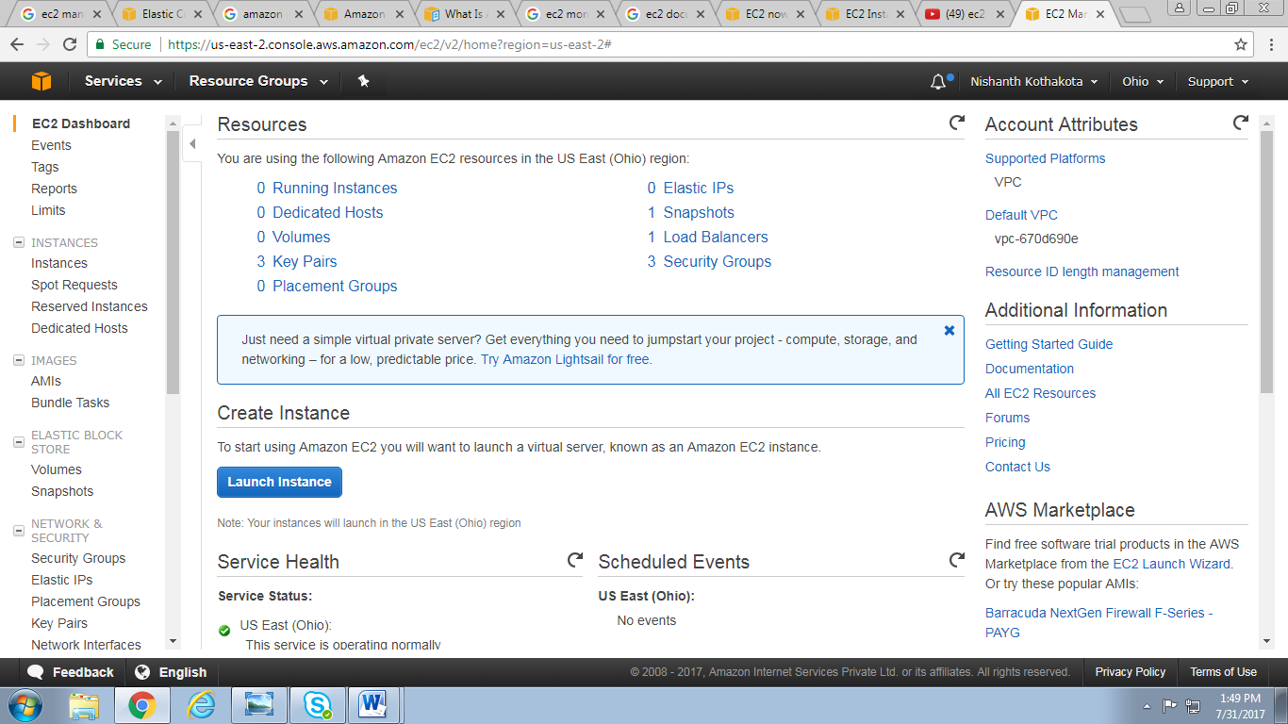

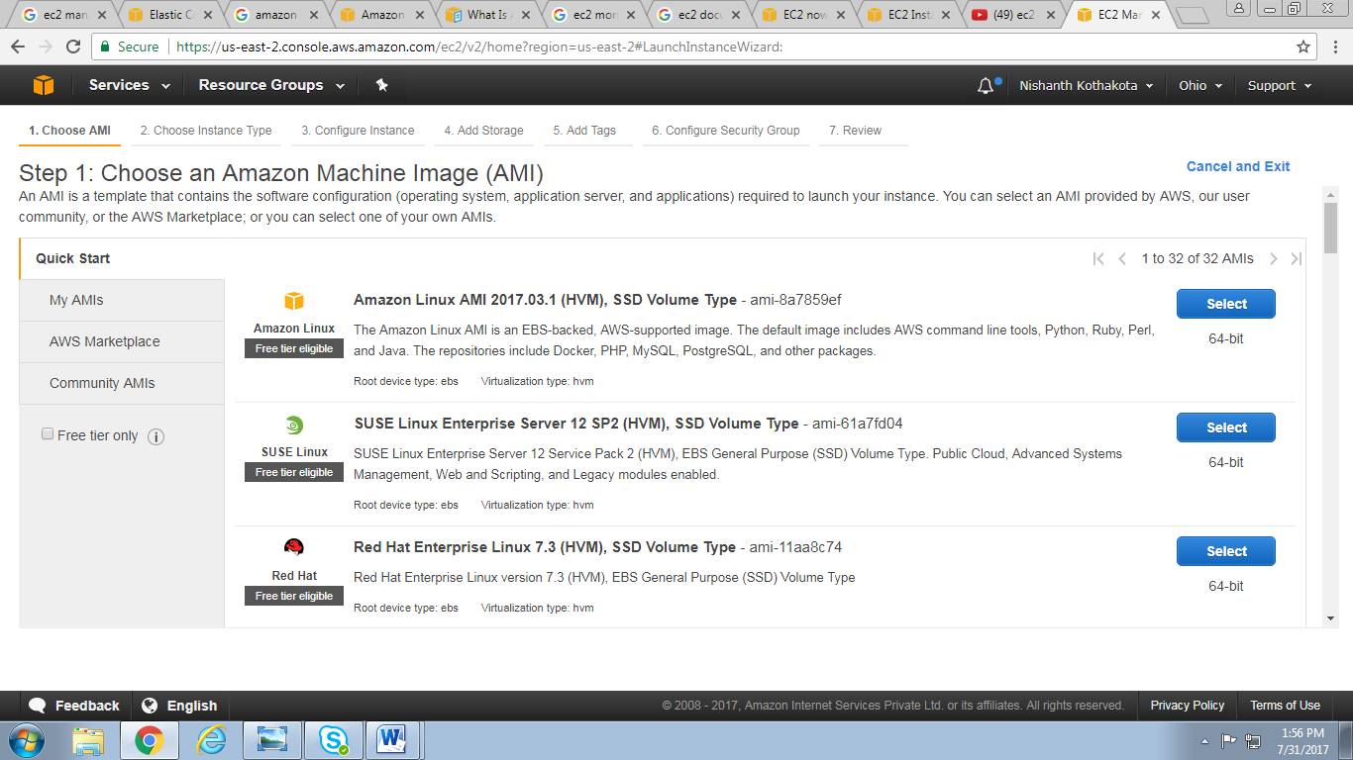

1. Select the Instance type as per the requirement and click on Next to start Configure Instance Details

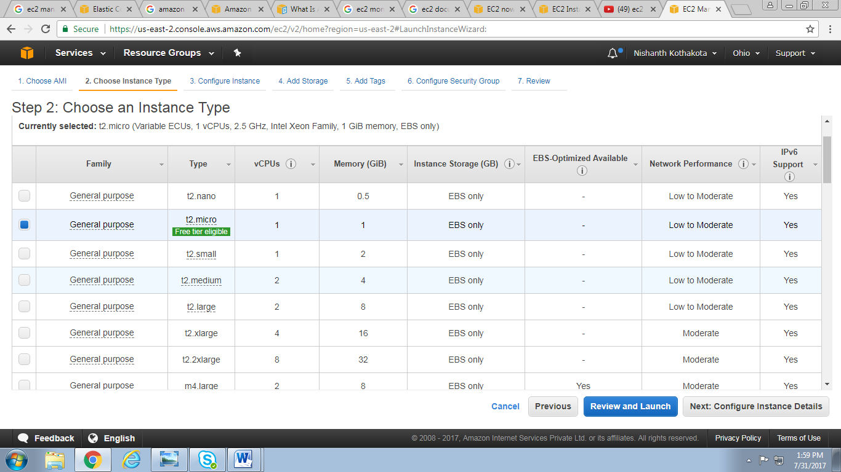

1. In Configure Instance tab select Network (Sample: VPCKumolus) .

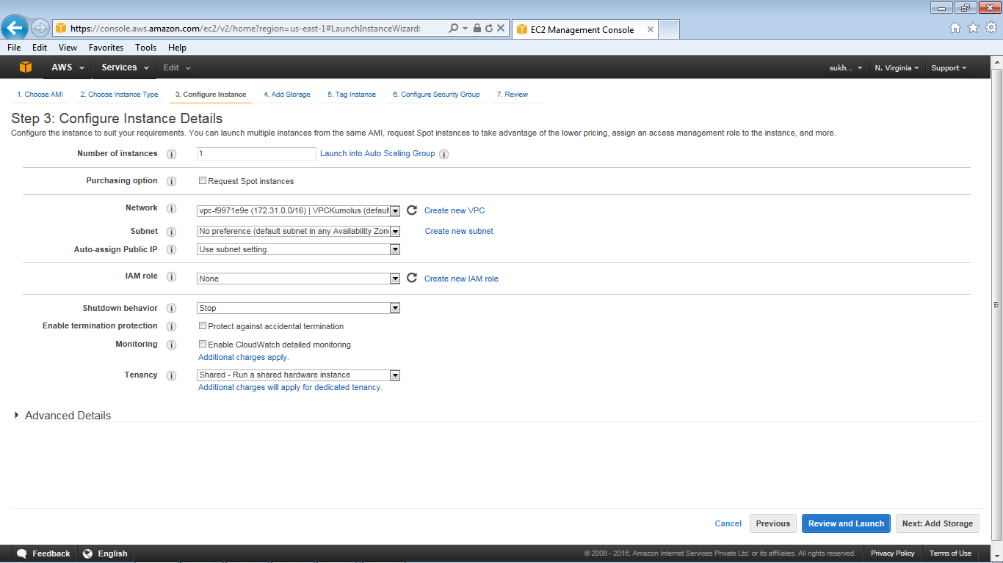

1. Select the default Subnet / Subnet as per available IP to be assigned

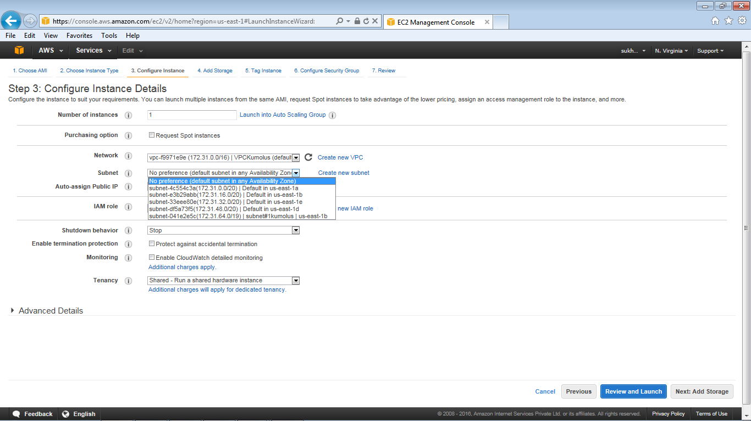

1. Select Auto-assign Public IP (Enable / Disable). This is required for services offered in AWS to work with the Instance.
2. Check option Protect against accidental termination under Enable Termination protection option.

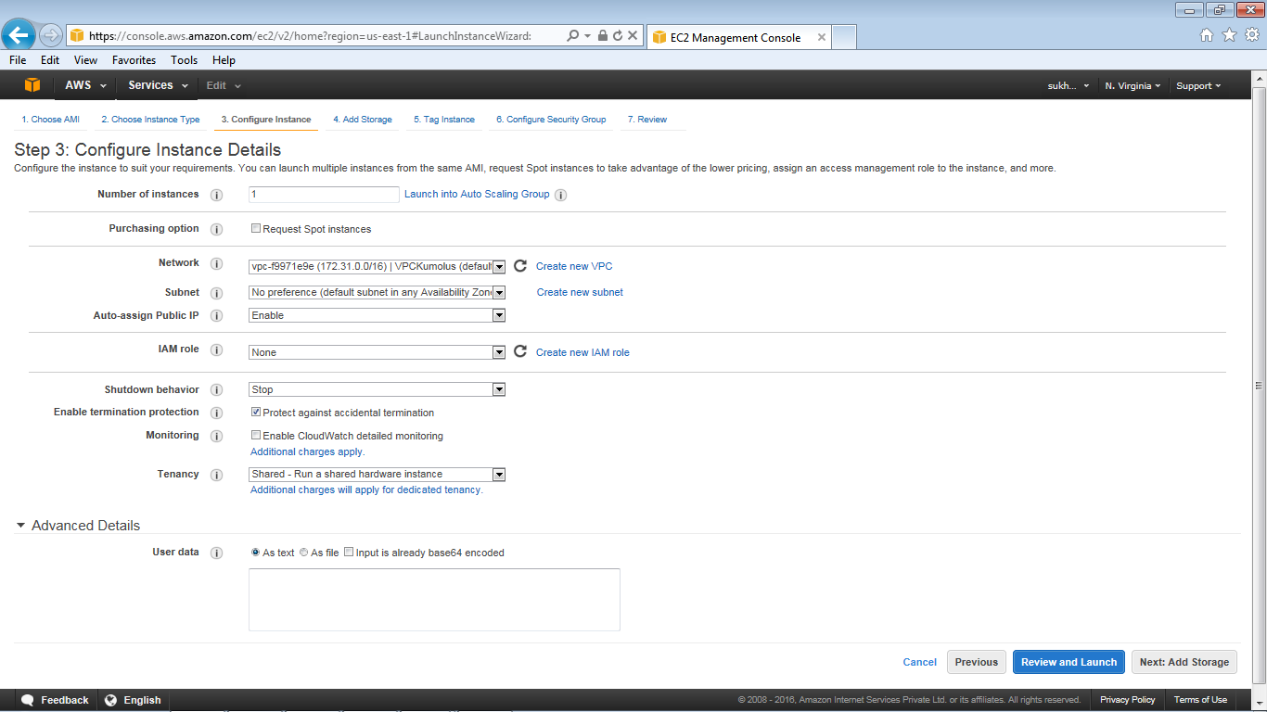

1. Proceed to next step to add Storage.
2. Select Volume type(General Purpose) as per the requirement and proceed to next step to add Tags to an instance. Other EBS Volume Type are EBS Provisioned IOPS (SSD) & EBS Magnetic

*http://aws.amazon.com/ebs/details/*

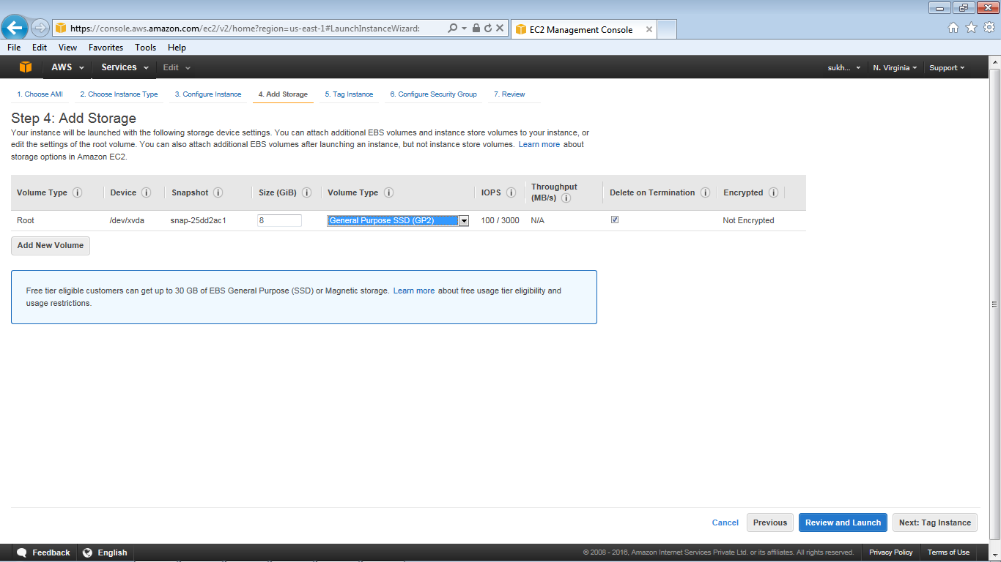

1. Tag Instance – provide the Key Value of the server and proceed now to next step to Configure Security group.

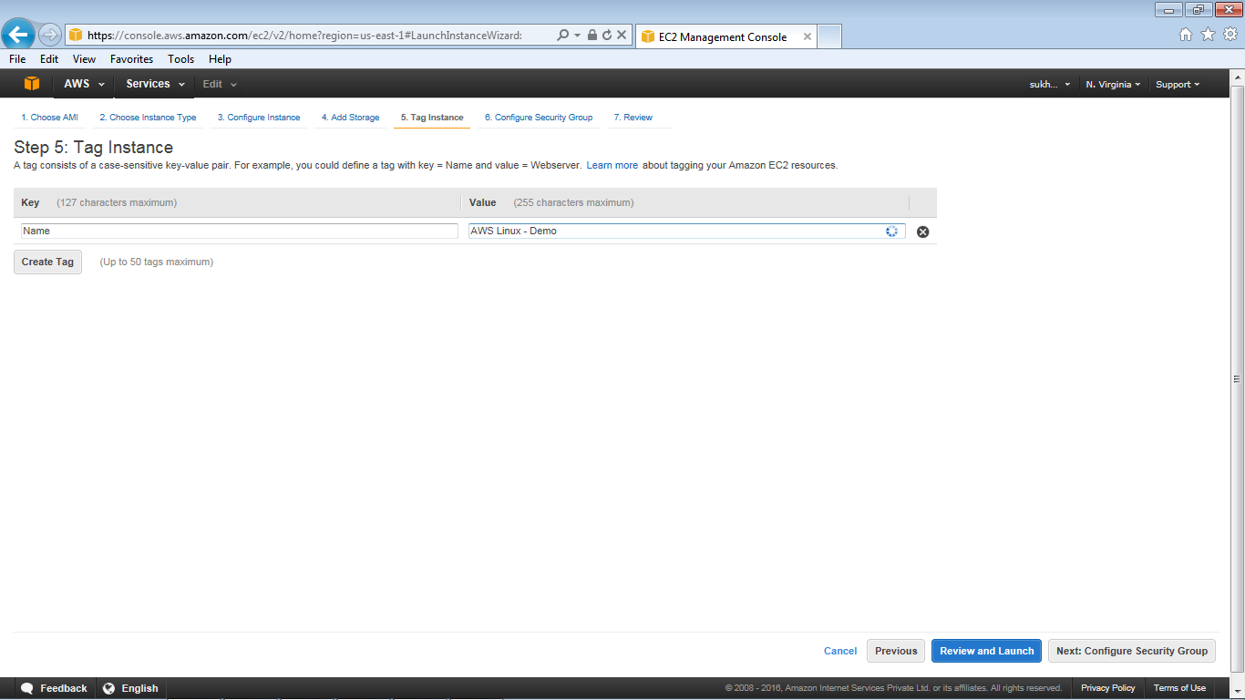

1. Create a new security group, provide the required protocals and proceed with Review and Launch.

(Note: if SG is already defined earlier then use option as Select existing security group)

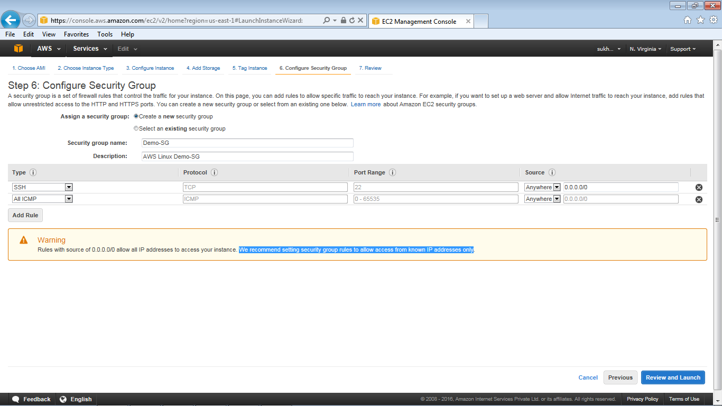

1. Review the instance details

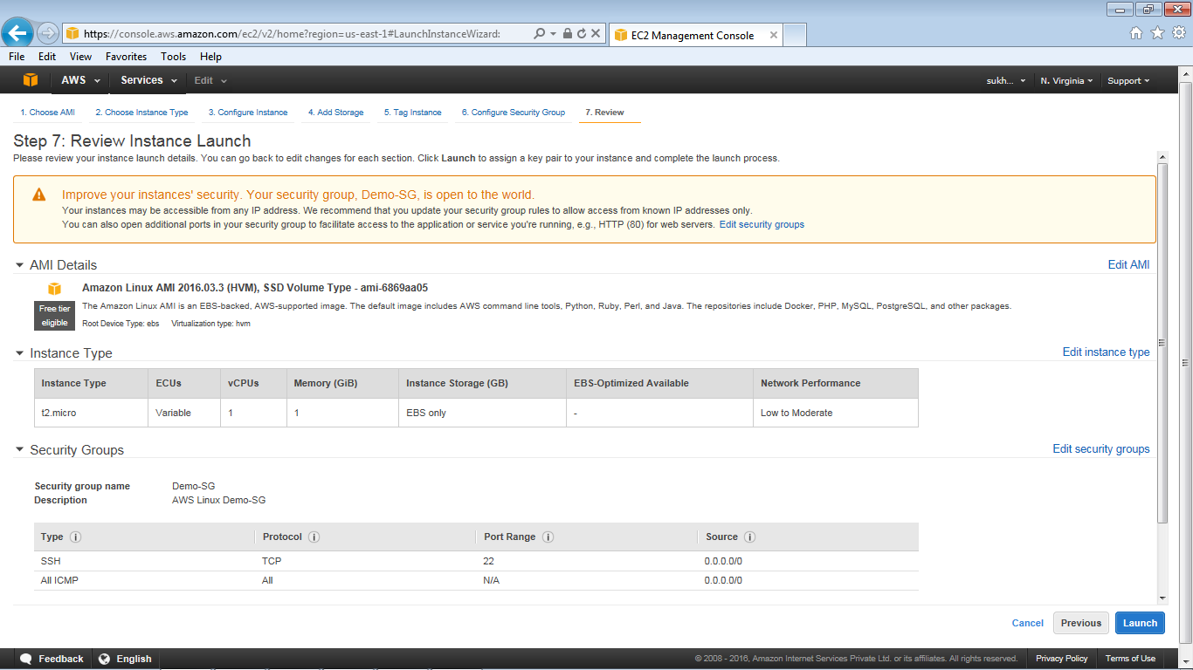

1. Select the option ‘choose an existing key pair’.

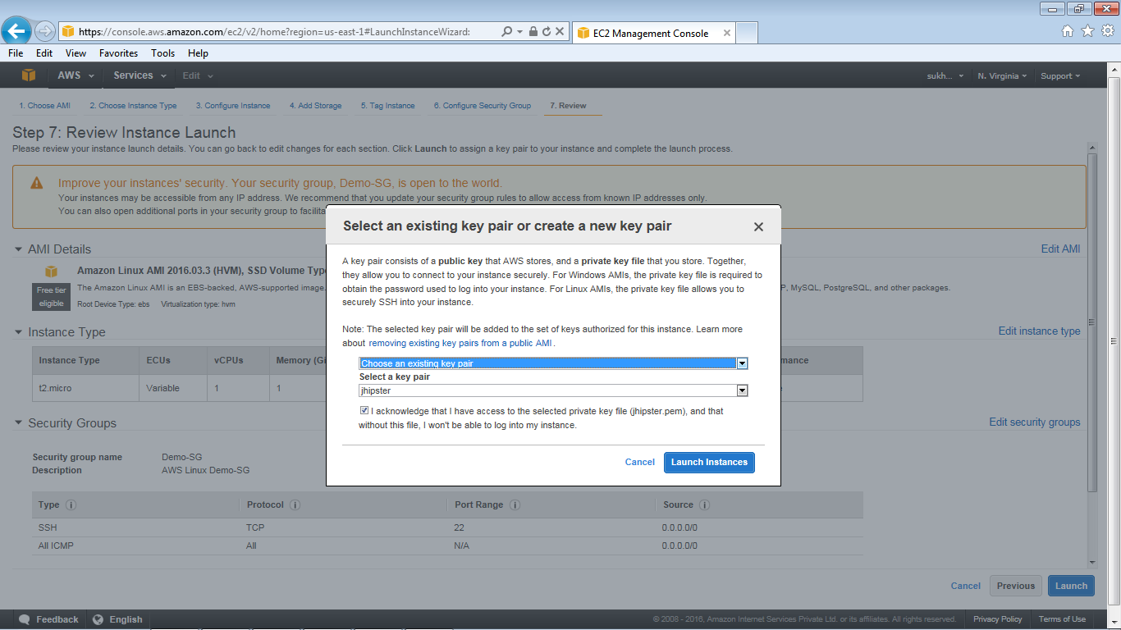

1. Select the existing key pair (Sample: Jhipster), Select I acknowledge checkbox and click on Launch instances.
2. The dashboard will show the Instance launch is in progress.

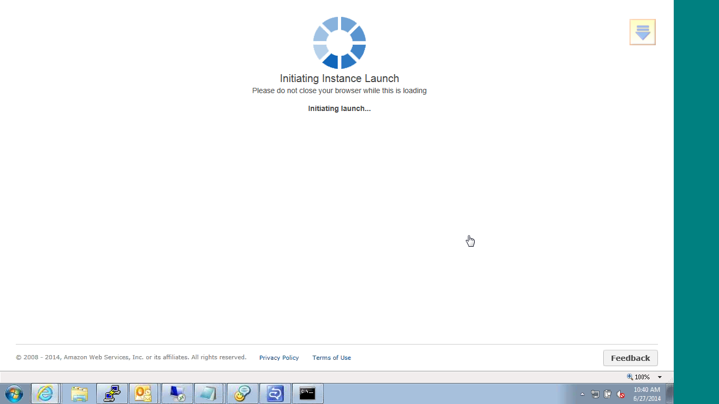

1. Click on view instances.

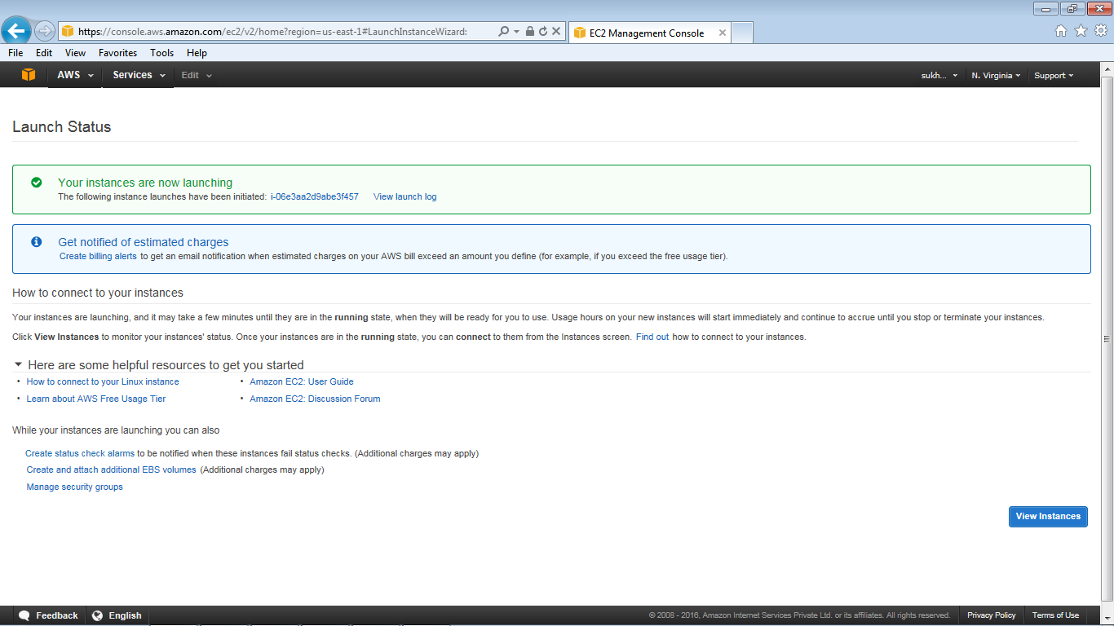

1. Initially the instance state is pending . It will change to running state once the VM build is complete and then the instance is ready to be accessed.

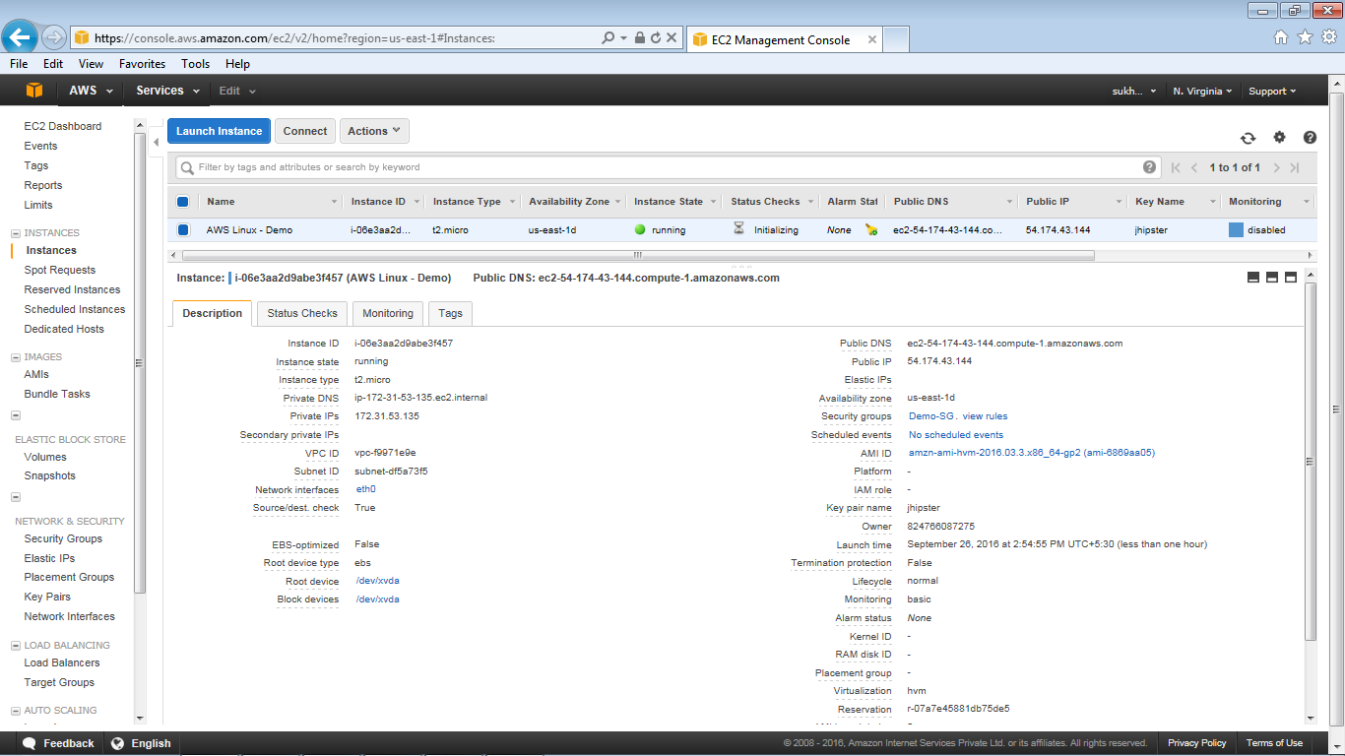

1. Select the instance which is created and verify the details. [Status code: 2/2 checks]

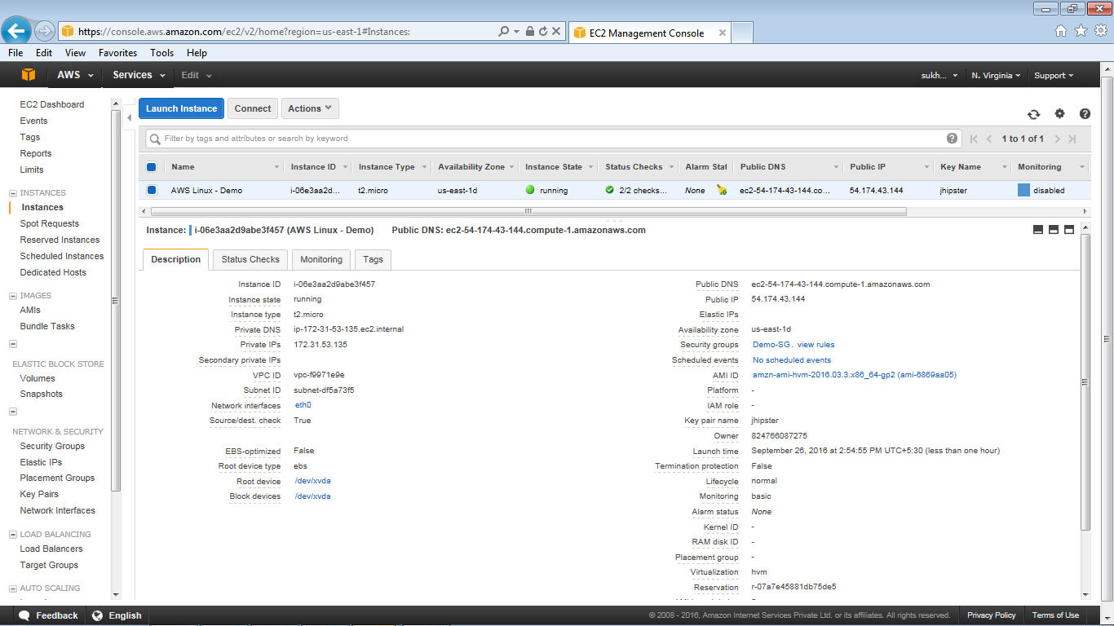

1. Access the instance using putty and login using Public DNS and ppk file.

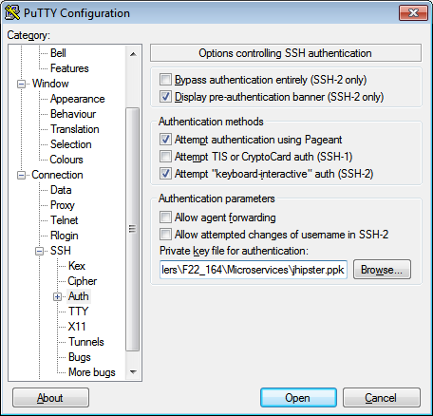

1. Login as ec2-user and press enter and check the disk space using “df -h”

Note: For security reason you can assign password while generating the ppk file using puttygen tool

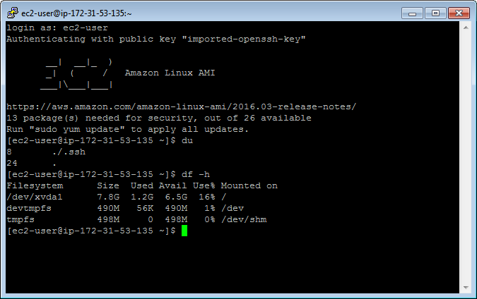

### Resizing the EC2 instance

1. Go to the EC2 Dashboard and select the intances
2. Choose **Actions**, select **Instance State**, and then choose **Stop**
3. In the confirmation dialog box, choose **Yes, Stop**. It can take a few minutes for the instance to stop

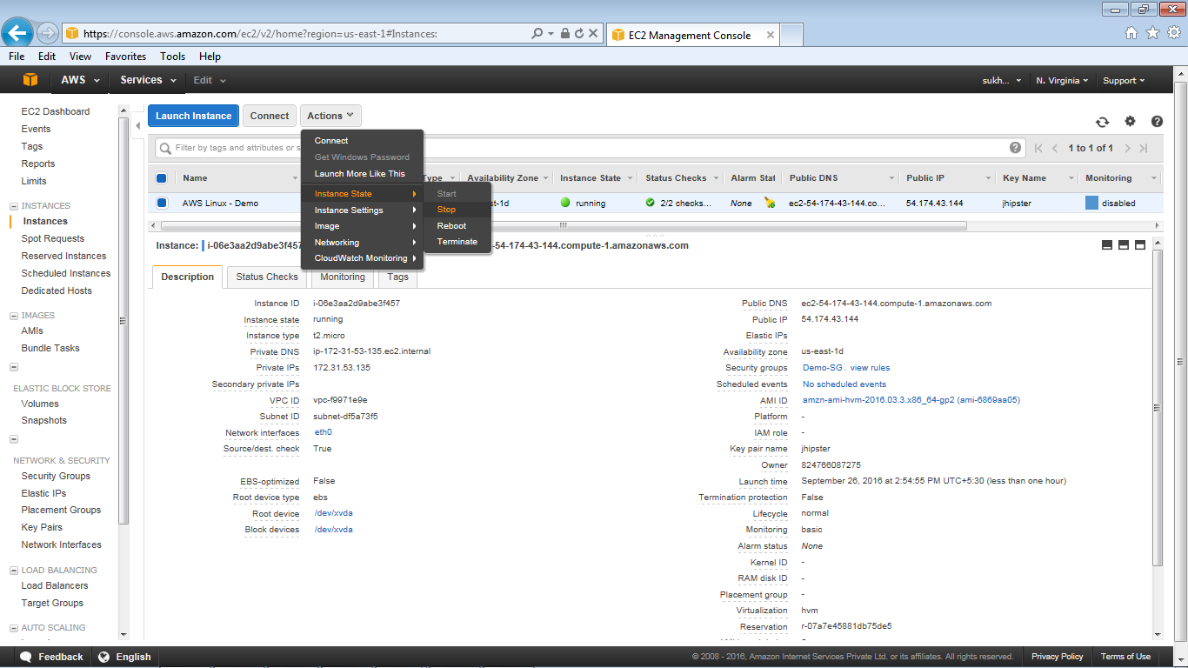

1. Instance status code is shown as “stopped”

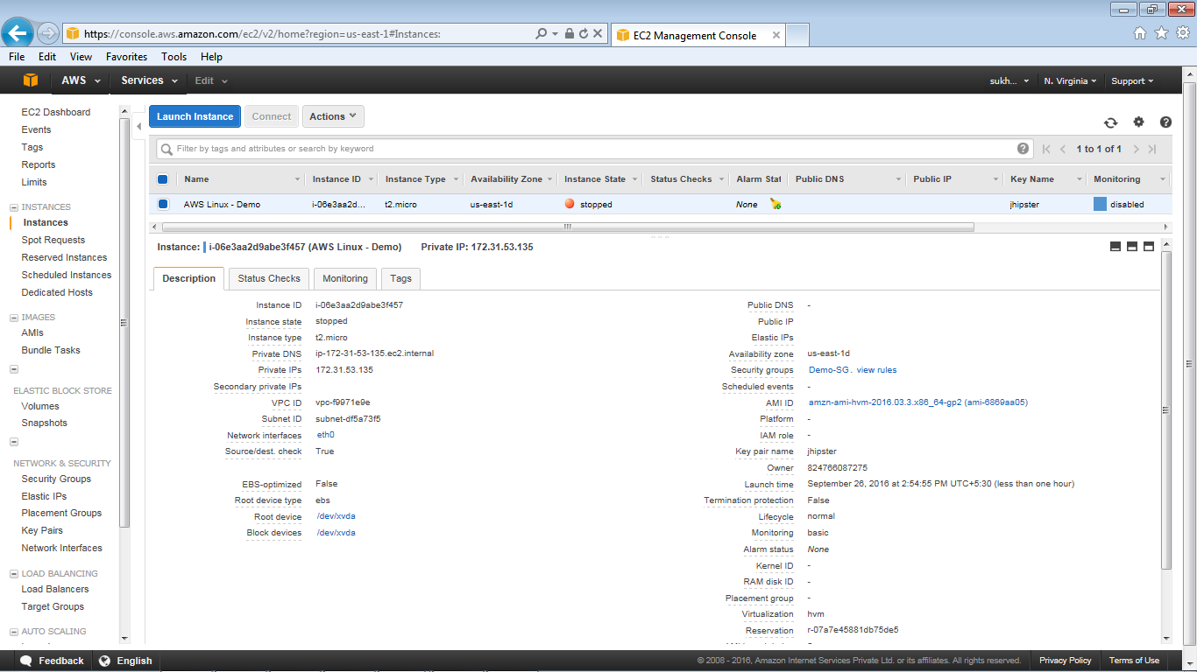

1. With the instance still selected, choose Actions, select Instance Settings, and then choose Change Instance Type. Note that this action is disabled if the instance state is not stopped

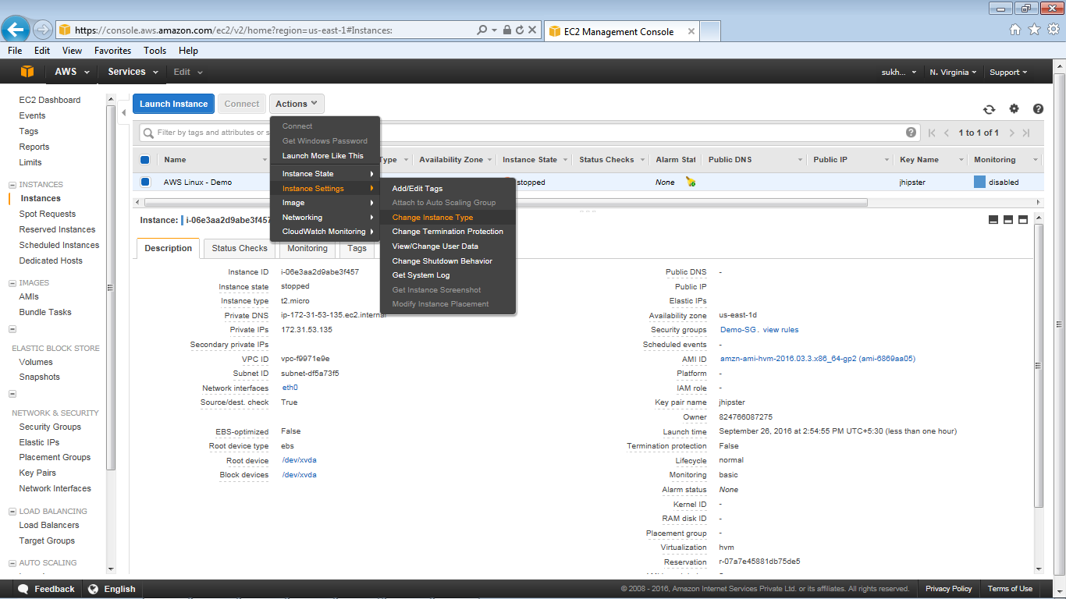

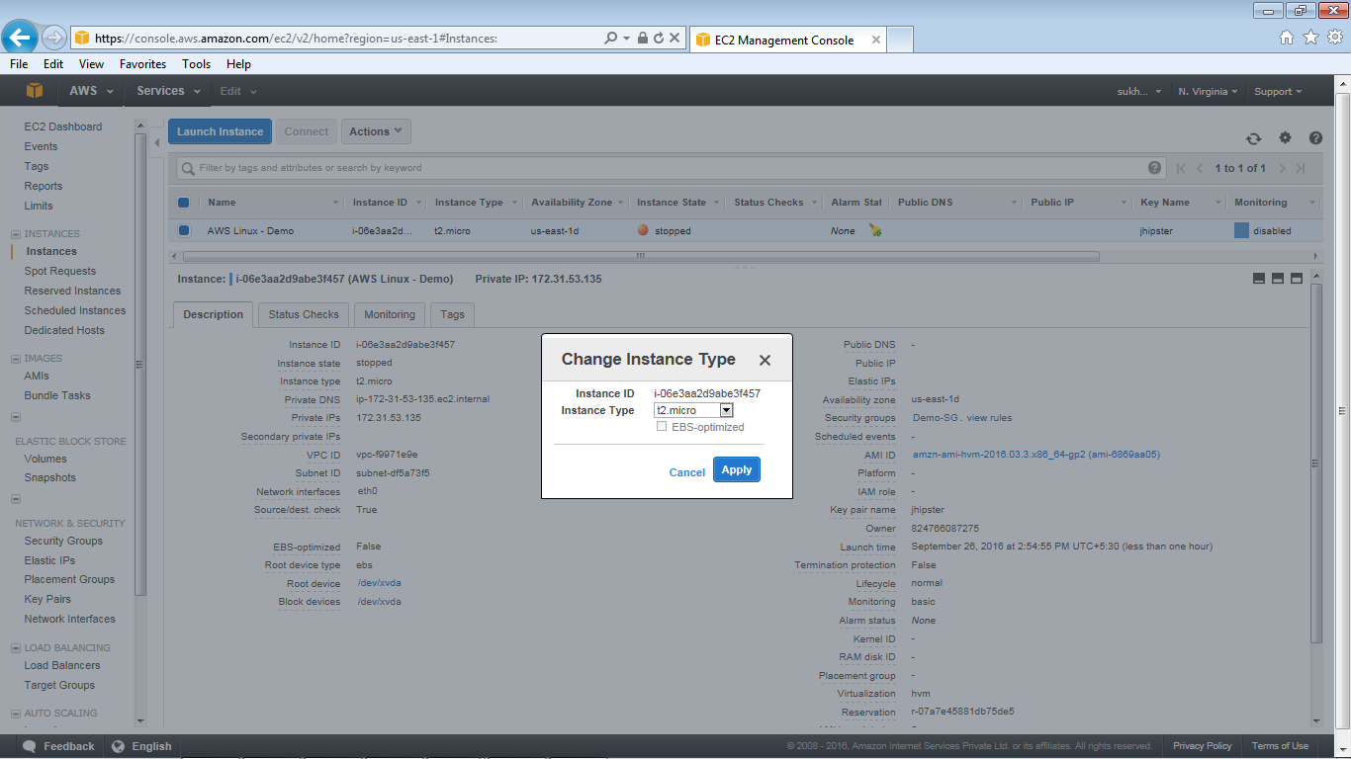

1. Click on apply button

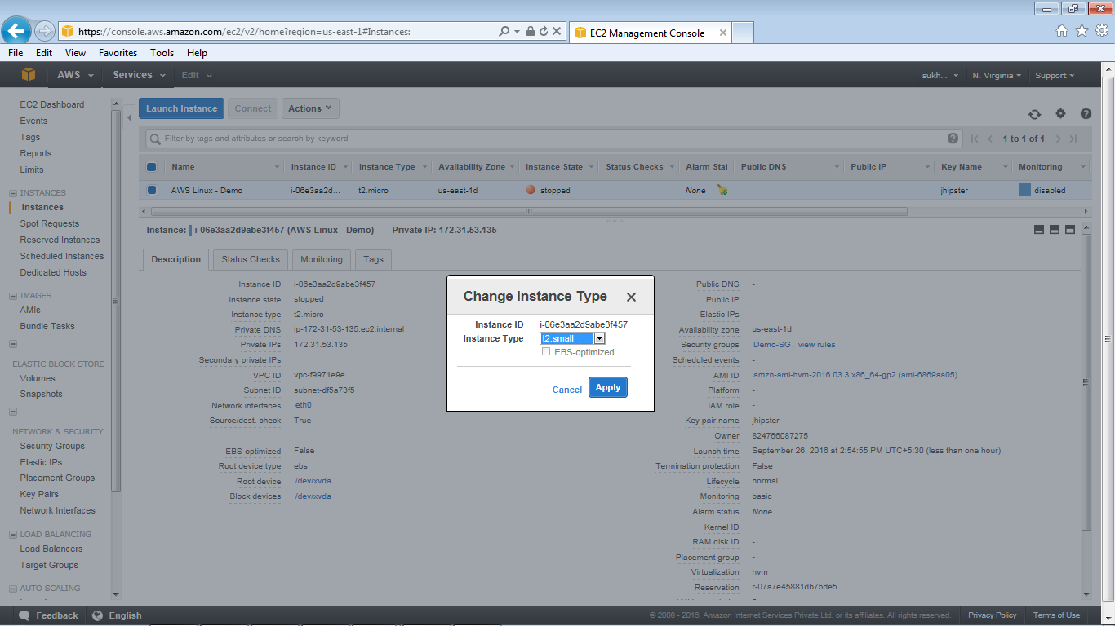

1. Choose Apply to accept the new settings. This resize the instance from (t2.micro to t2.small)

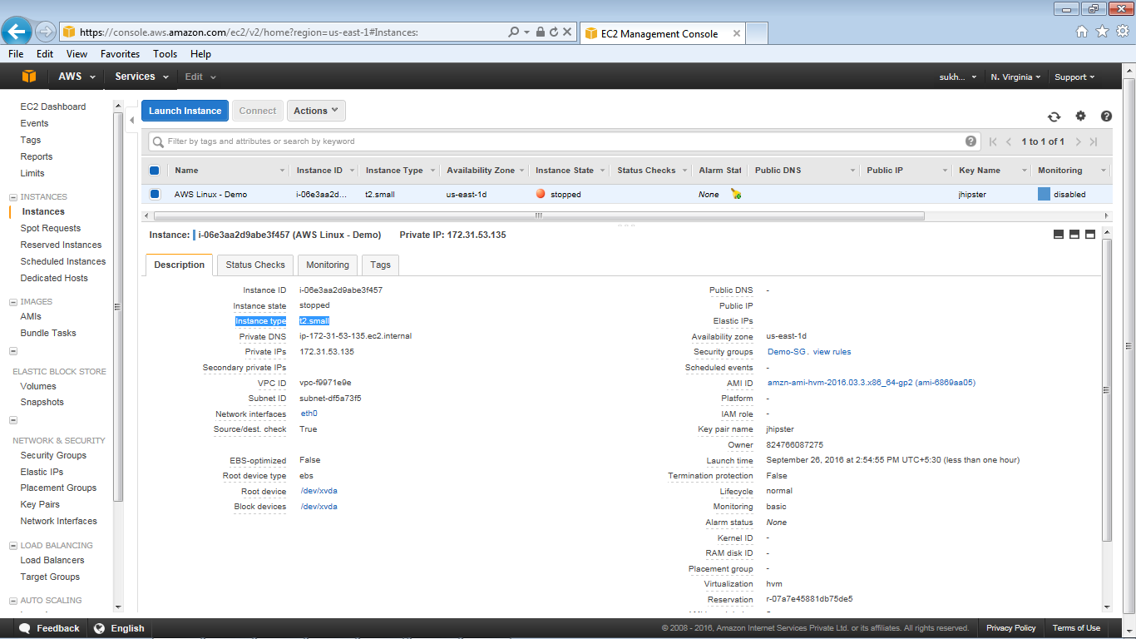

1. From Action option start the instance, login using putty and view the instances details

### Modify EC2 instance

1. Go to the EC2 Dashboard and select the intances
2. Start the instance (incase stopped)

Note: If EIP is not associated with the instance it will generate the new Public IP address)

1. Add/ Edit the Tags – Action – Add/Edit Tags

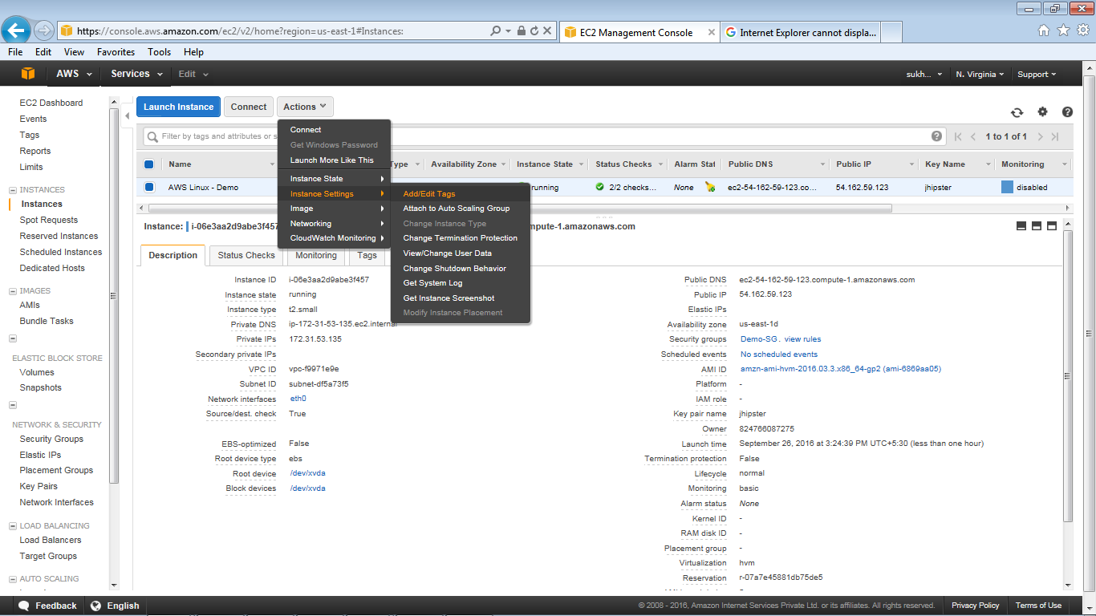

1. Add/ Edit the Tags of the instance and press save

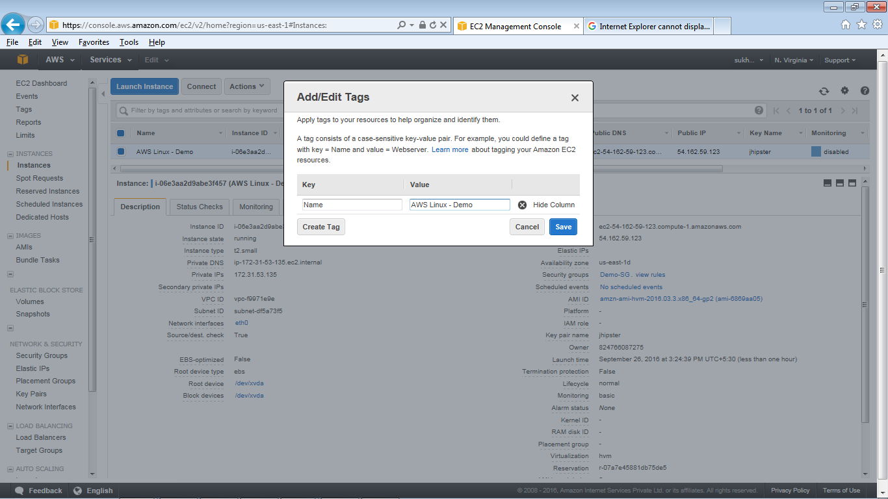

1. Reset the change Termination protection of the instance using “Yes Enable” button

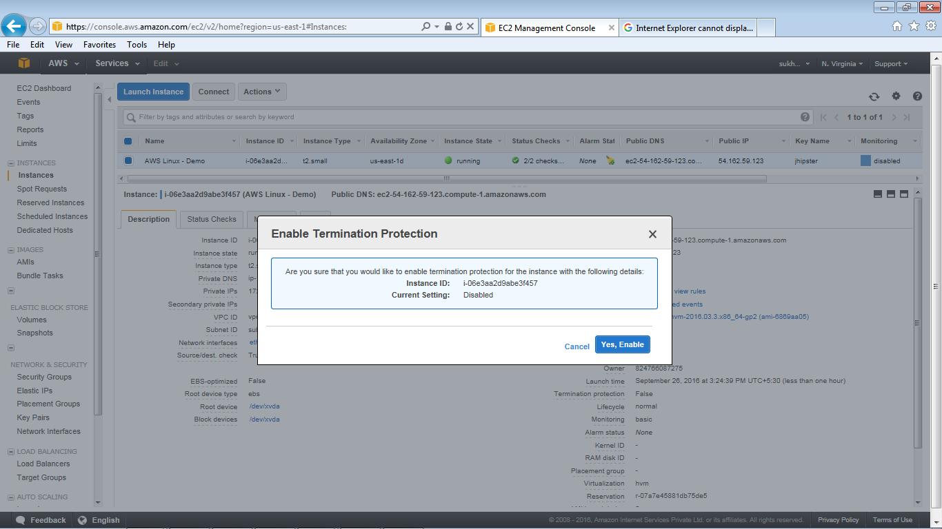

1. Reset the change the shutdown behavior of the instance selecting option “ Stop/Terminate”

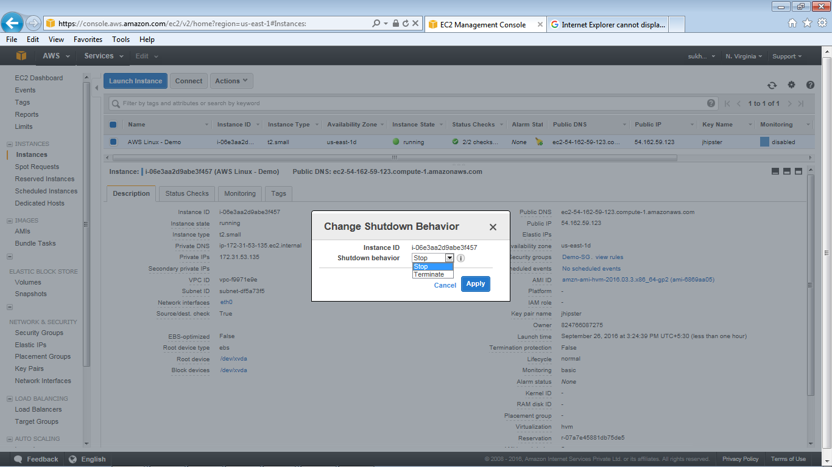

### Terminating EC2 instance

1. Go to the EC2 Dashboard and select the intances
2. From Action select Terminate option , it will show warning message

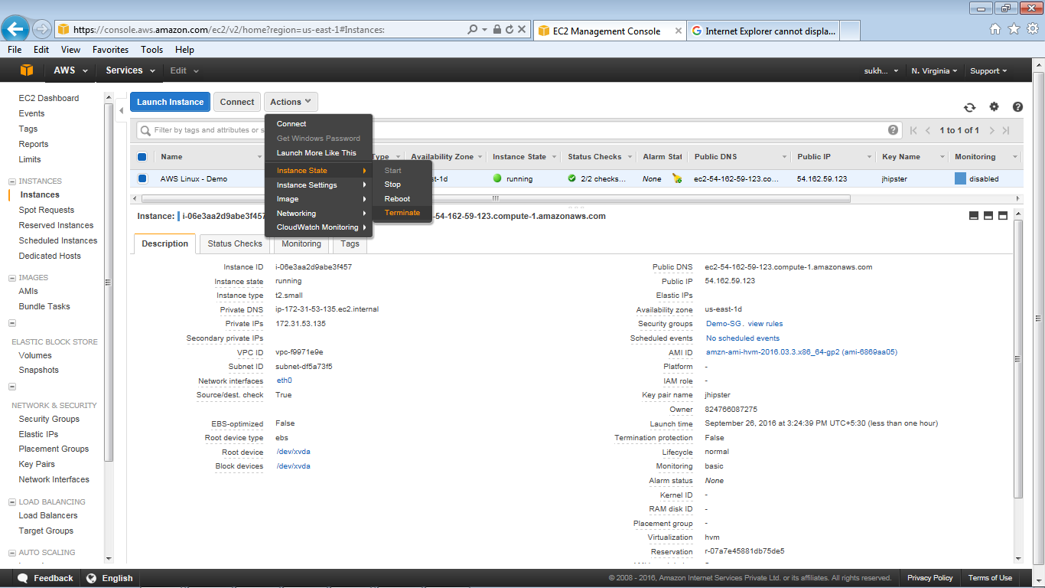

1. Press “Yes Terminate” button

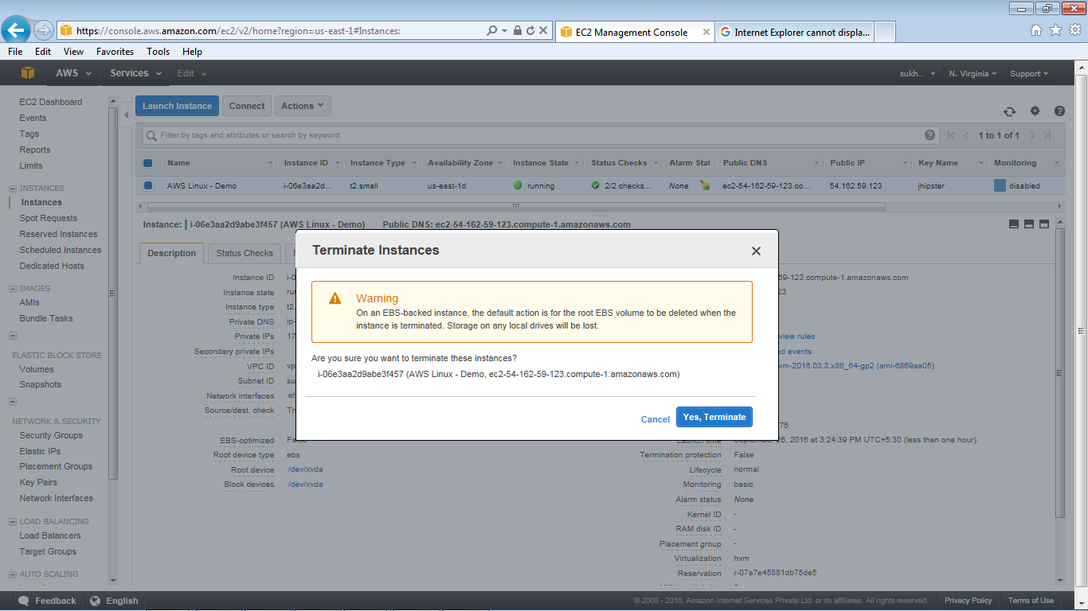

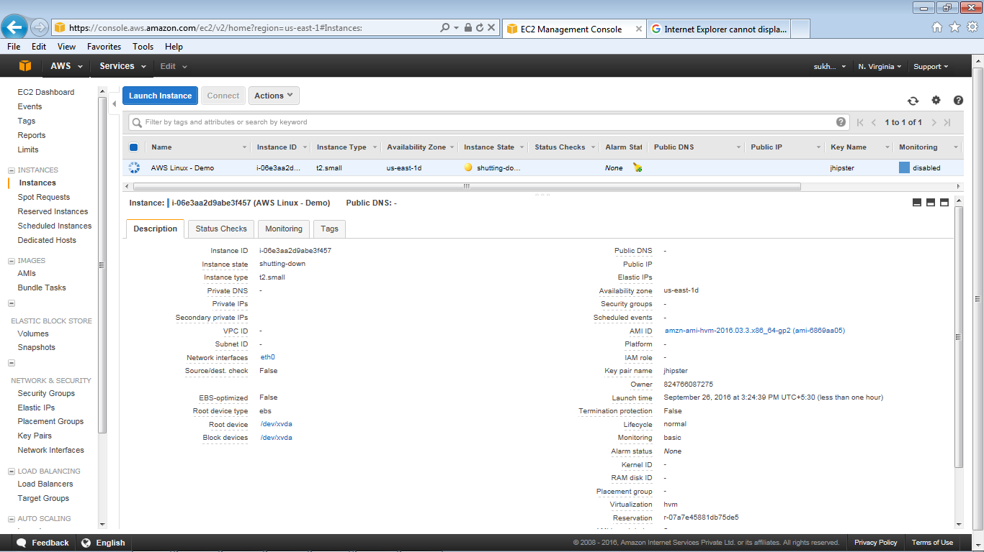

1. The Instance status code is changed to Terminated

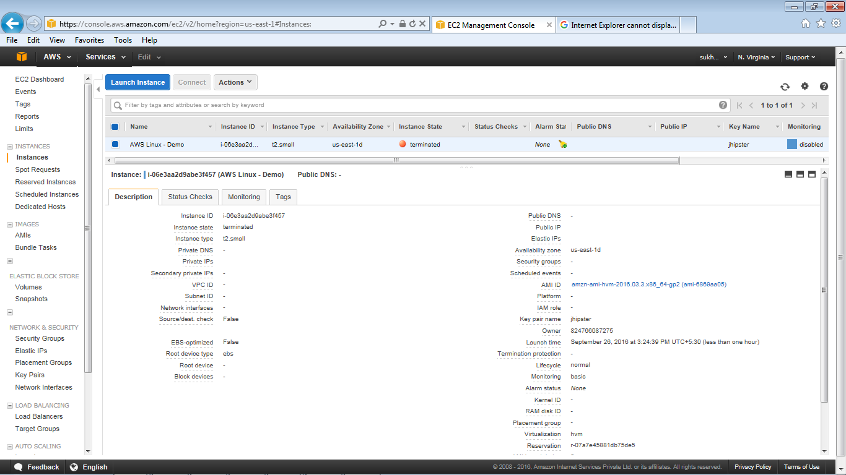

### MONITORING EC2 INSTANCE

1. Log on the AWS console page and click on cloud watch

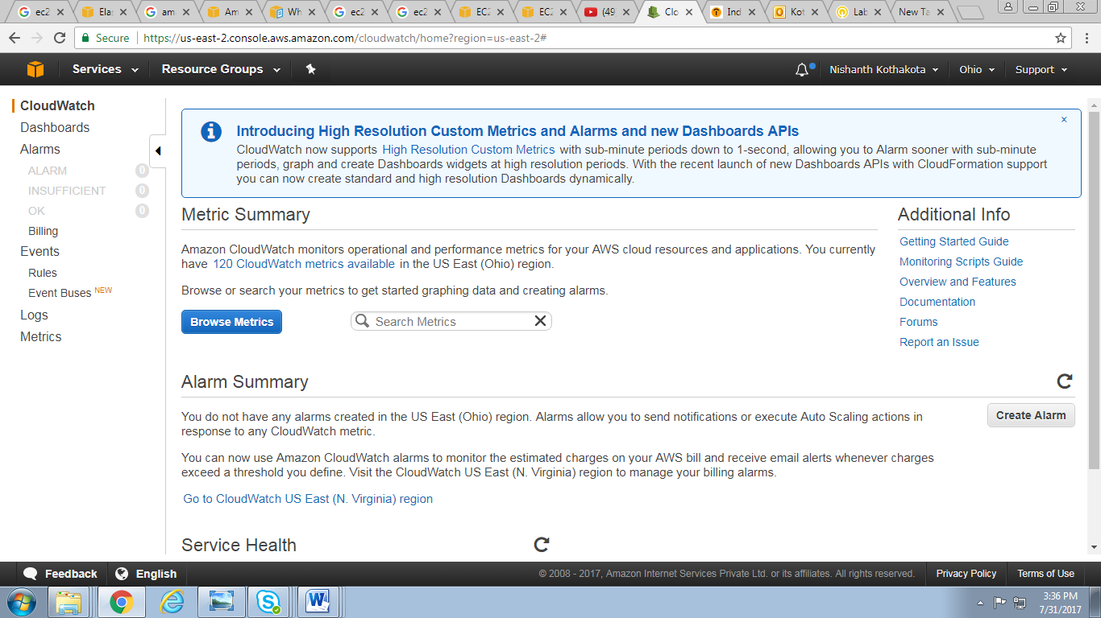

1. Click on Browse Metrics

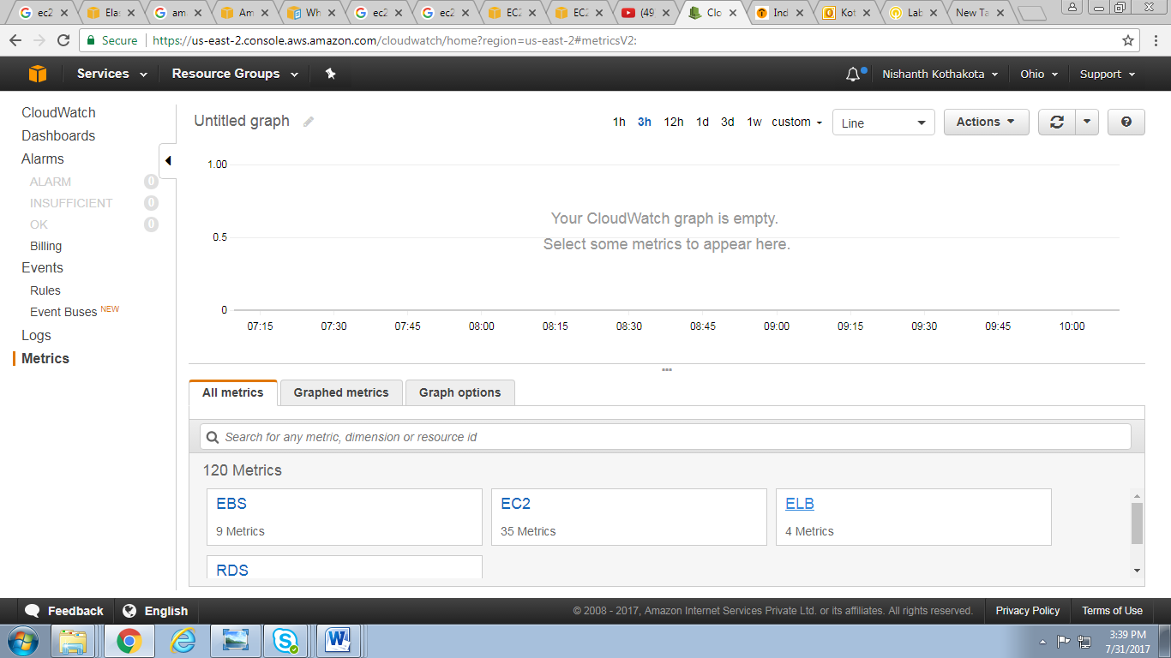

1. Click on Dash Board and create new Dashboard

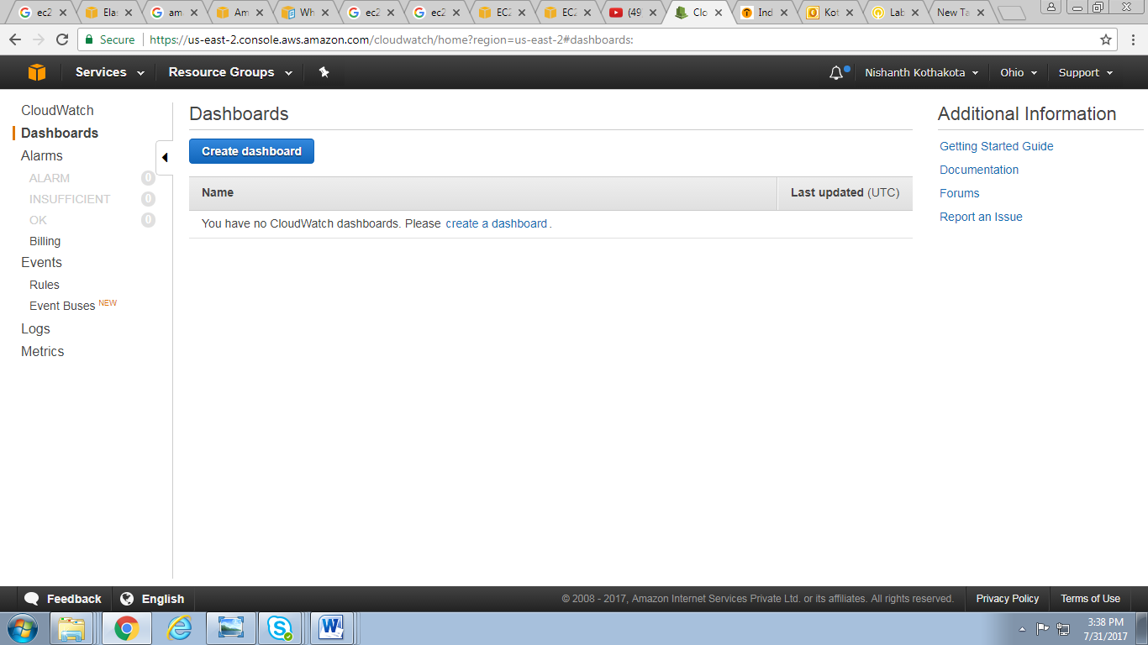

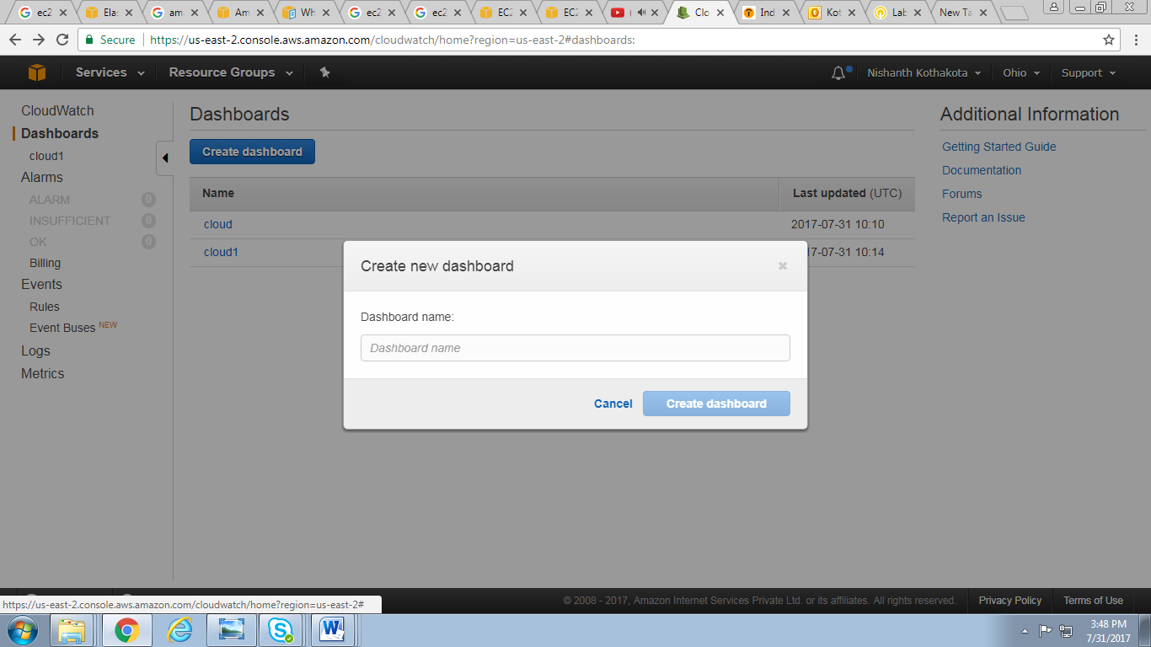

1. After that configure the metric graph and selct the instance

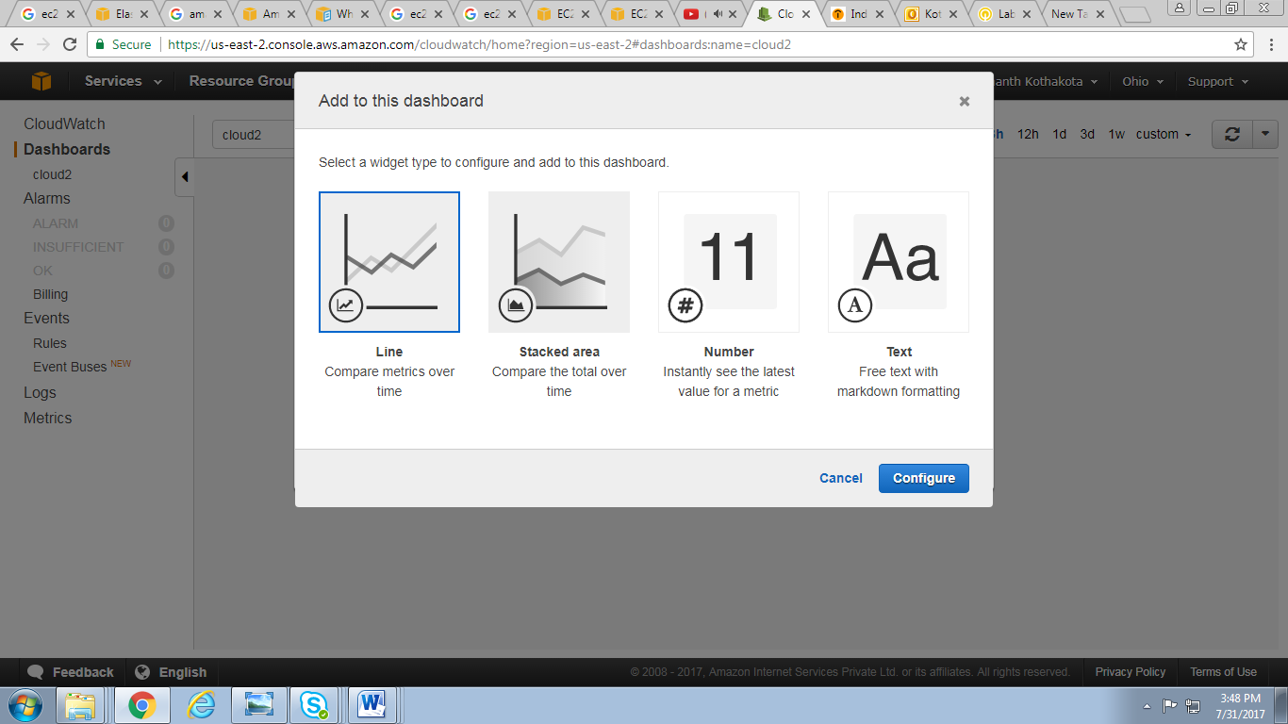

1. After adding the instance it shows utilization of instance

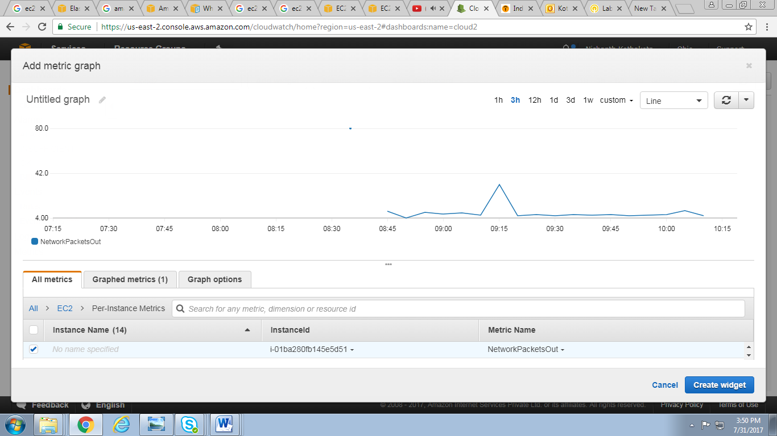

# VPC MANAGEMENT

## Objective

To provide the high level guidance’s to setup the AWS Virtual Private Cloud (VPC) on AWS Cloud.

## Assumptions

* AWS Account is available with AWS Identity access Management (IAM) or Amazon management console
* VPCs and Subnets. A virtual private cloud (**VPC**) is a virtual network dedicated to your AWS account. It is logically isolated from other virtual networks in the AWS cloud

The below diagram shows AWS VPC Architecture.

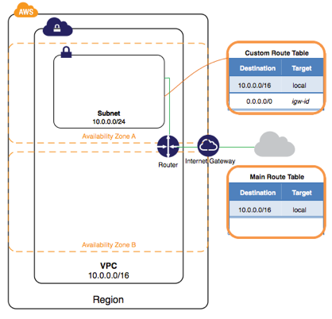

## Procedure

To set up a VPC, you need to complete the following steps:

* Step 1: [Create](http://docs.aws.amazon.com/AmazonVPC/latest/UserGuide/VPC_VPN.html#vpn-create-cgw) a new VPC
* Step 2: [Configuration and management of subnets and network ACLs and Configuration and management of security groups](http://docs.aws.amazon.com/AmazonVPC/latest/UserGuide/VPC_VPN.html#vpn-create-vpg)
* Step 3: Configuration of AWS VPN devices and on premise VPN devices

### 2.3.1 Creation of new VPC

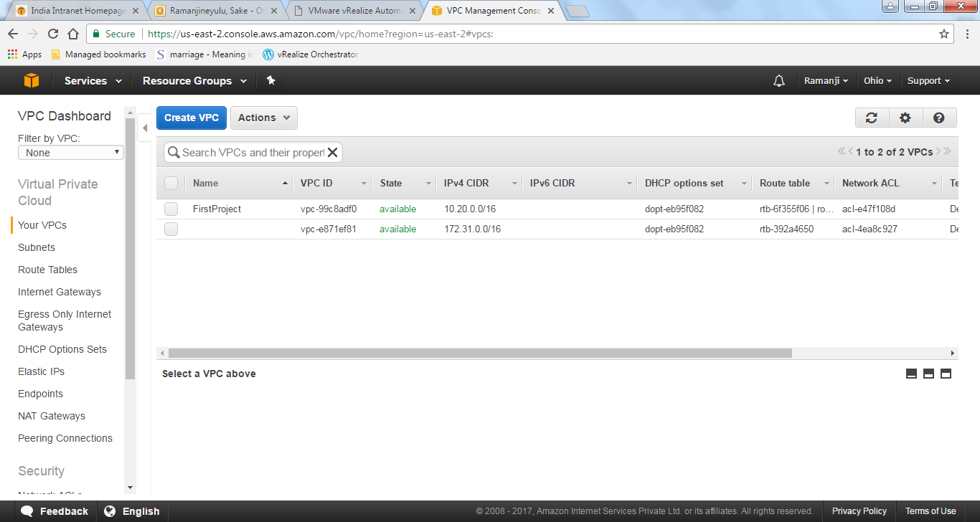

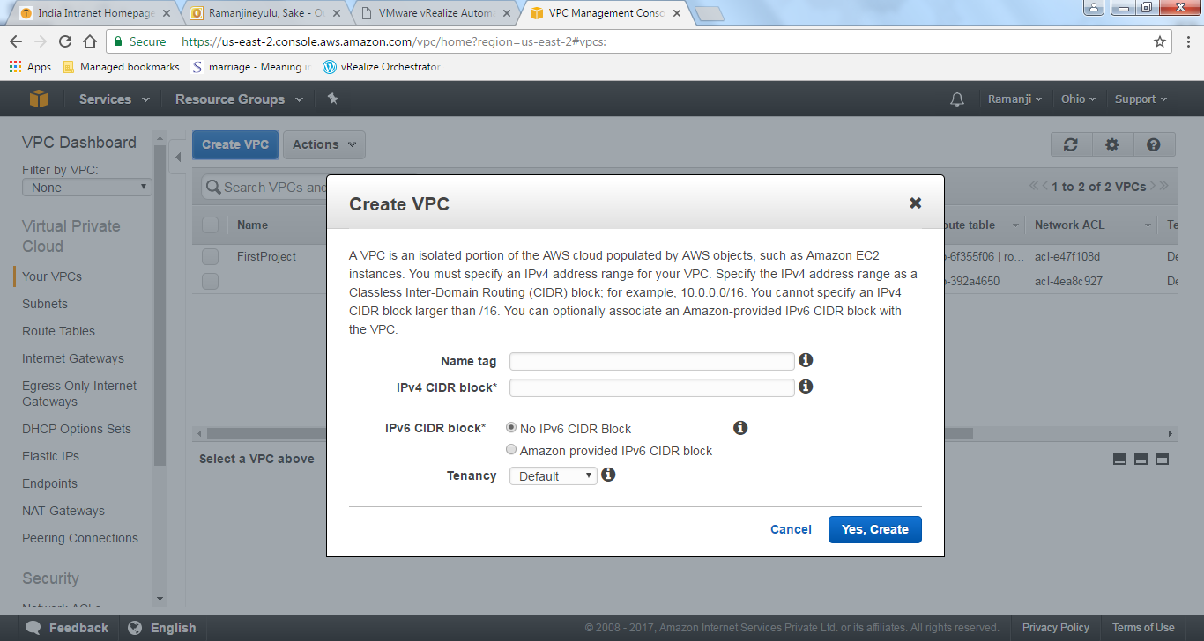

* Give your name for your VPC.
* Specify the range for your VPC in the form of CIDR block.

**Configuration and management of subnets and network ACLs and Configuration and management of security groups**

### Subnets

* Subnet is certain Range of IP address.
* When your creating subnets you have to specify the range for your subnet.
* You can create public subnets as well as private subnets.
* 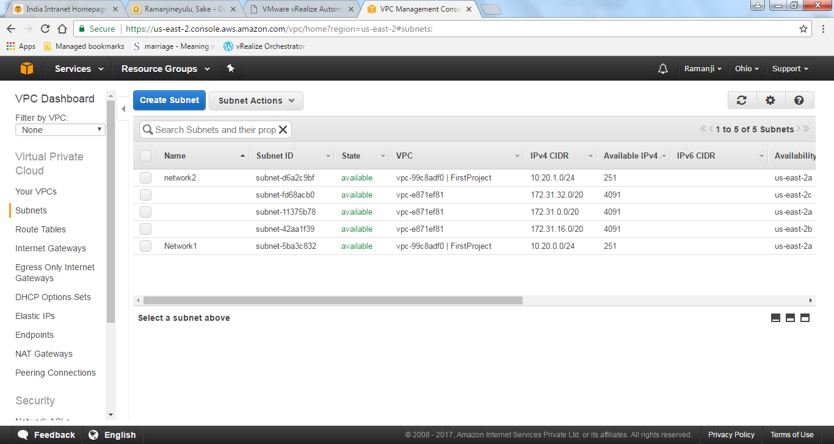

Click on Create Subnet

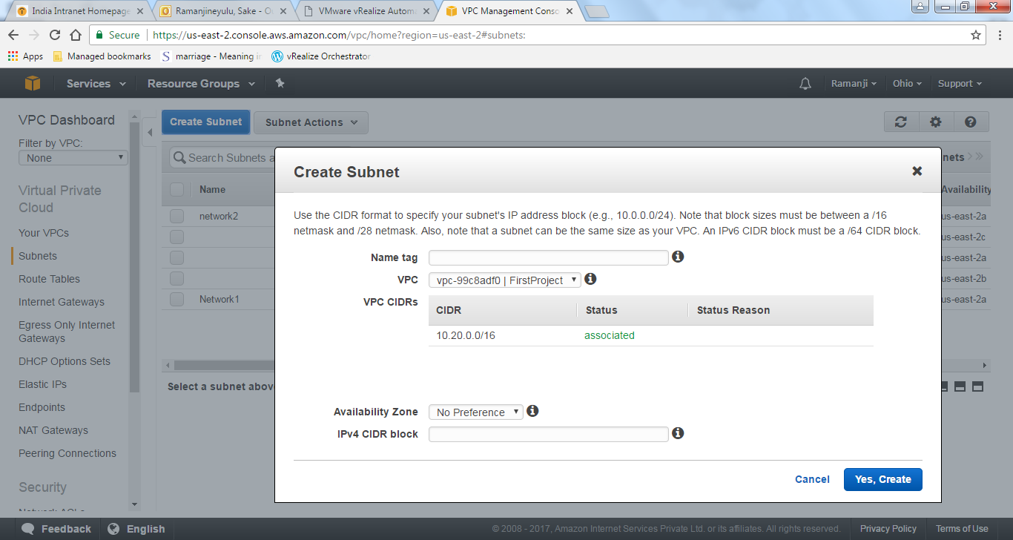

* Give your name for your subnet
* Select VPC
* Select availability zone
* Specify IP address range for your subnet.

### NAT Gateway

* It is used to enable the instances in a private subnet to connect internet or public cloud.

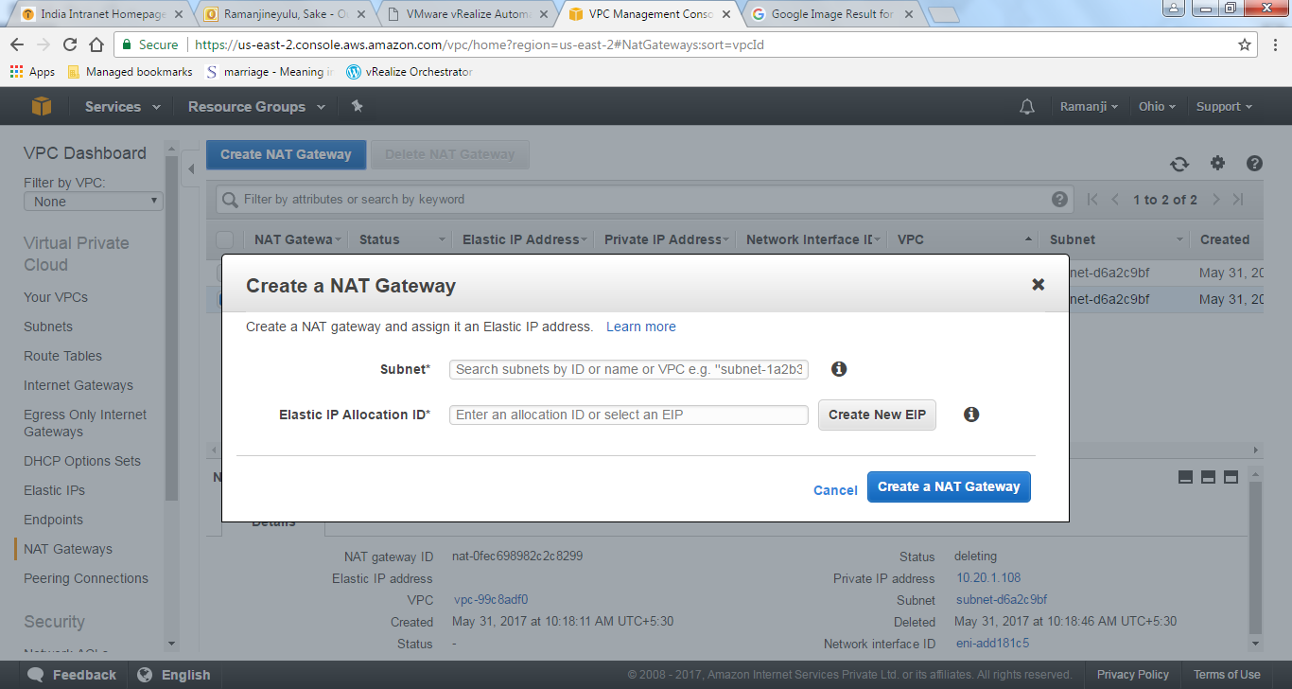

* Select the subnet which you want connect your NAT gateway
* Select Elastic IP if it is already created or you can create new one from here.

**NACL (Network Access control list)**

* This list control the traffic at the VPC level.
* You have to specify the inbound and outbound rules for VPC in the form of three digits rule numbers.

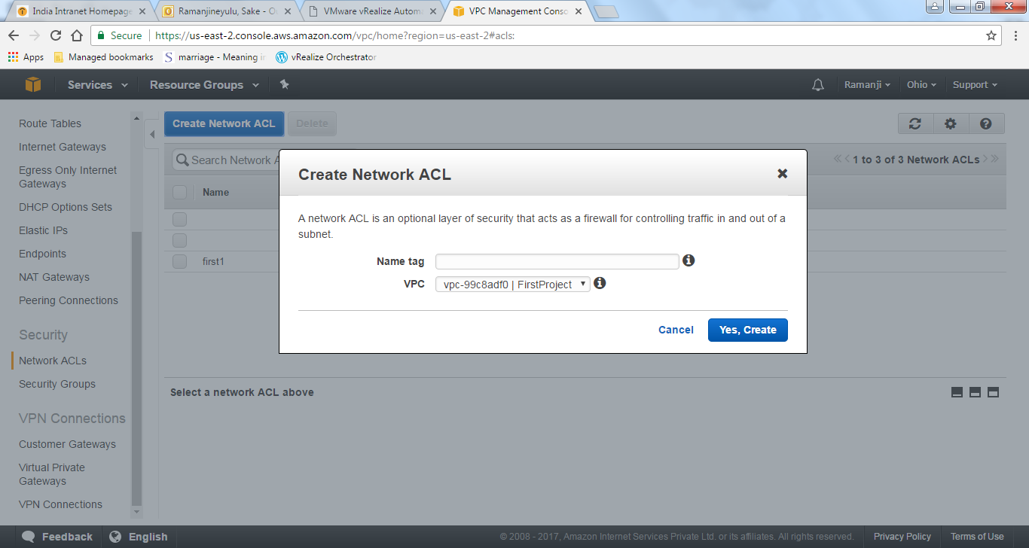

* Give name for your ACL
* Select your VPC.
* After clicking on Yes, create

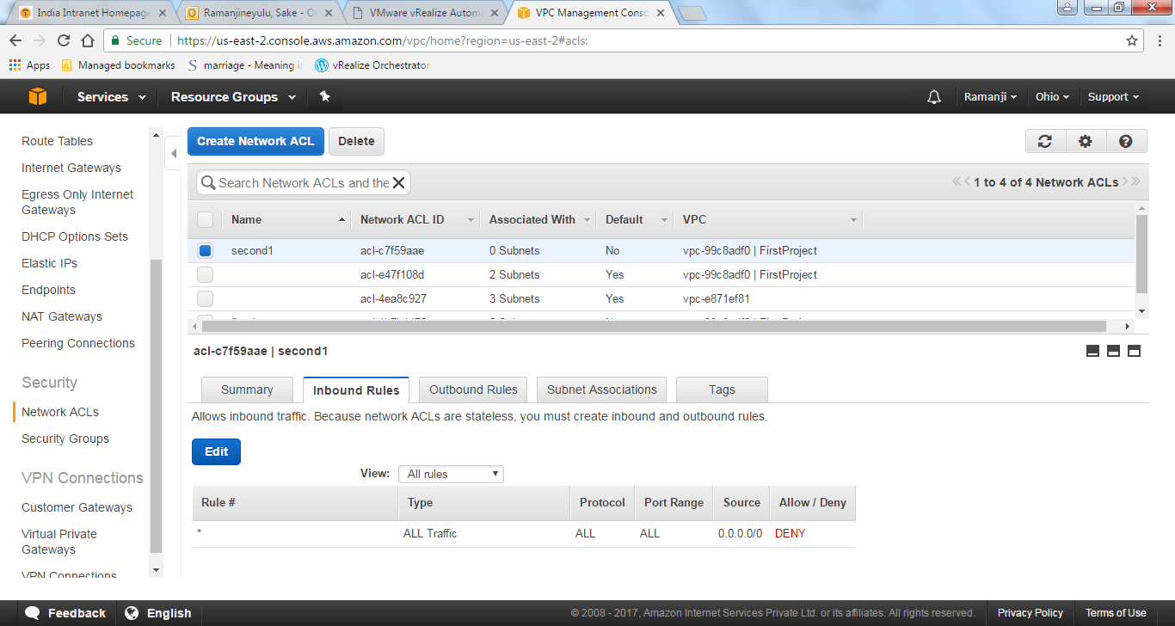

* Click on edit and give inbound rules for your VPC which control the incoming traffic to your VPC.

### 2.3.4 Configuration of AWS VPN devices and on premise VPN devices

To set up a VPN connection, you need to complete the following steps:

* Step 1: [Create a Customer Gateway](http://docs.aws.amazon.com/AmazonVPC/latest/UserGuide/VPC_VPN.html#vpn-create-cgw)
* Step 2: [Create a Virtual Private Gateway](http://docs.aws.amazon.com/AmazonVPC/latest/UserGuide/VPC_VPN.html#vpn-create-vpg)
* Step 3: [Enable Route Propagation in Your Route Table](http://docs.aws.amazon.com/AmazonVPC/latest/UserGuide/VPC_VPN.html#vpn-configure-routing)
* Step 4: [Update Your Security Group to Enable Inbound SSH, RDP and ICMP Access](http://docs.aws.amazon.com/AmazonVPC/latest/UserGuide/VPC_VPN.html#vpn-configure-security-groups)
* Step 5: [Create a VPN Connection and Configure the Customer Gateway](http://docs.aws.amazon.com/AmazonVPC/latest/UserGuide/VPC_VPN.html#vpn-create-vpn-connection)
* Step 6: [Launch an Instance into Your Subnet](http://docs.aws.amazon.com/AmazonVPC/latest/UserGuide/VPC_VPN.html#vpn-launch-instance)

**Steps to follow**

Go to the VPC and click on the VPN option to create the **Create Customer Gateway**

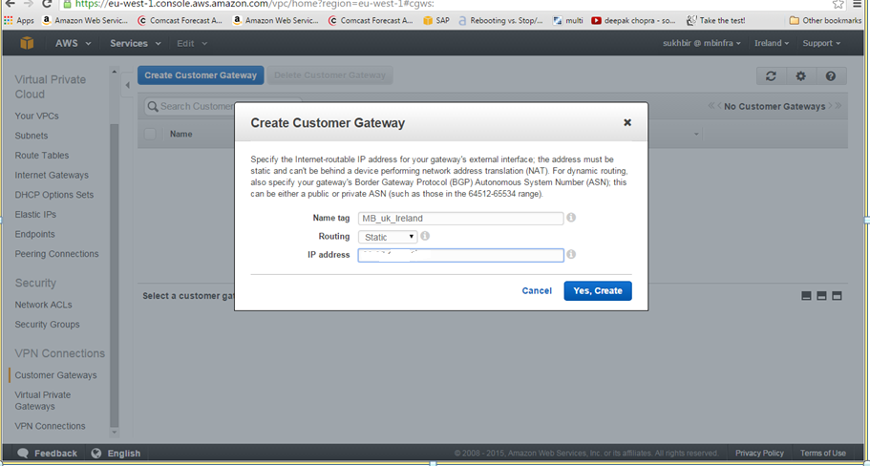

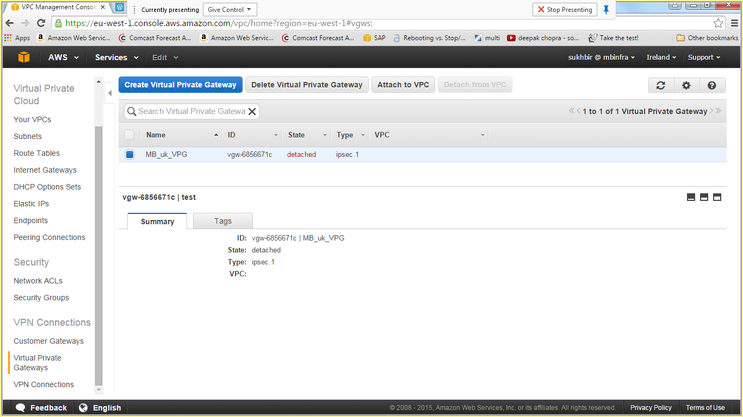

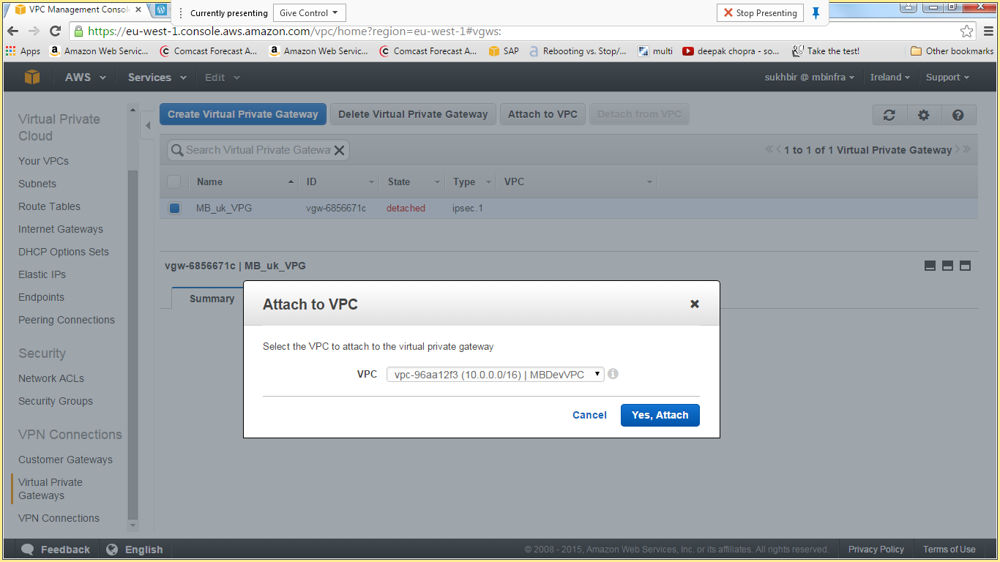

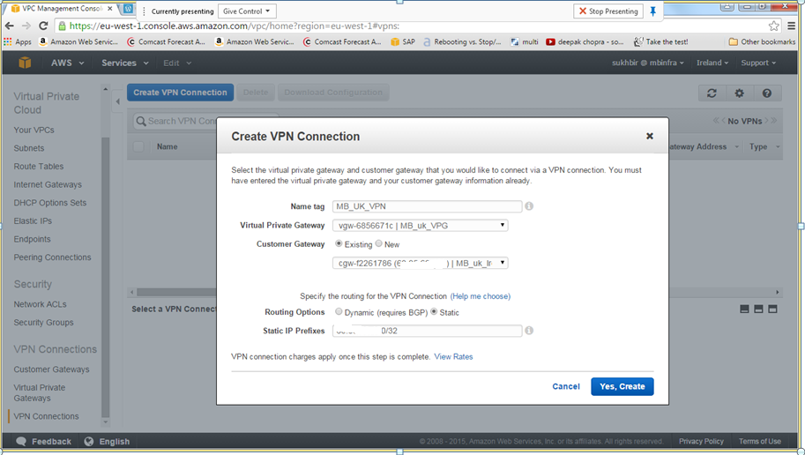

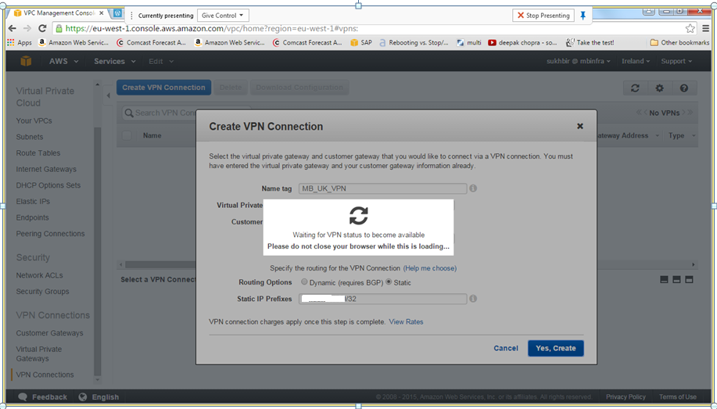

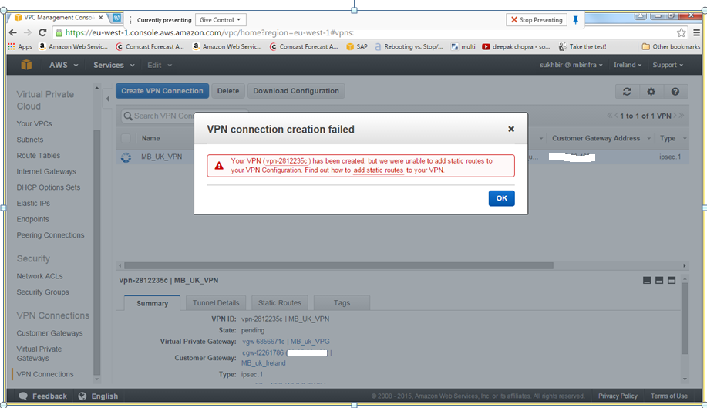

Wait till it is available

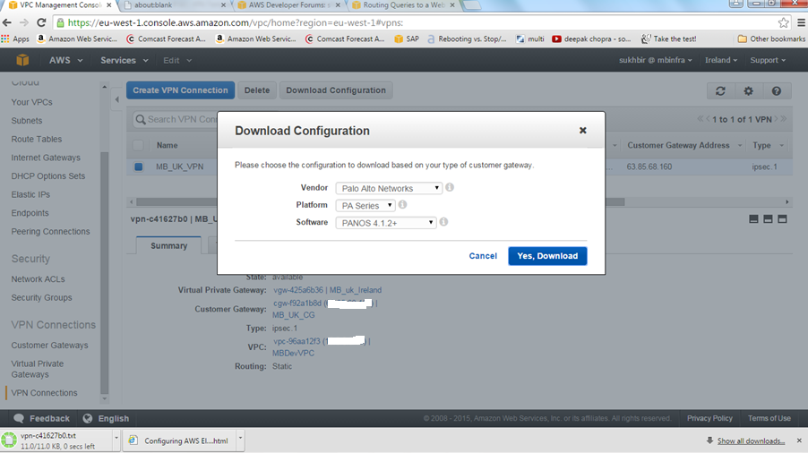

Download the VPN configuration (Ex: vpn-c415670_GUI.txt) and provide to the Networking team to establish the connection

You can launch the AWs instance and test the connectivity to on premise.

# IDENTITY AND SECURITY MANAGEMENT

AWS Identity and Access Management (IAM) is a web service for securely controlling access to AWS services.

## Objective

To understand the access control creation of users and roles using AWS IAM.

## Assumption

* AWS Account is available with AWS Identity access Management (IAM).

## Procedure

Step 1: Create an Administrator group and give permission to access all of your AWS account’s resources.

Step 2: Create a user for yourself add that user to the Administrators group.

Step 3: Create a password for your user so you can sign in to the AWS Management Console.

Step 4: Create Group and add users to the group.

Step 5: Create Policy and Roles.

Step 1**:**

Go to the Security, Identity and Compliances and click on the option IAM.

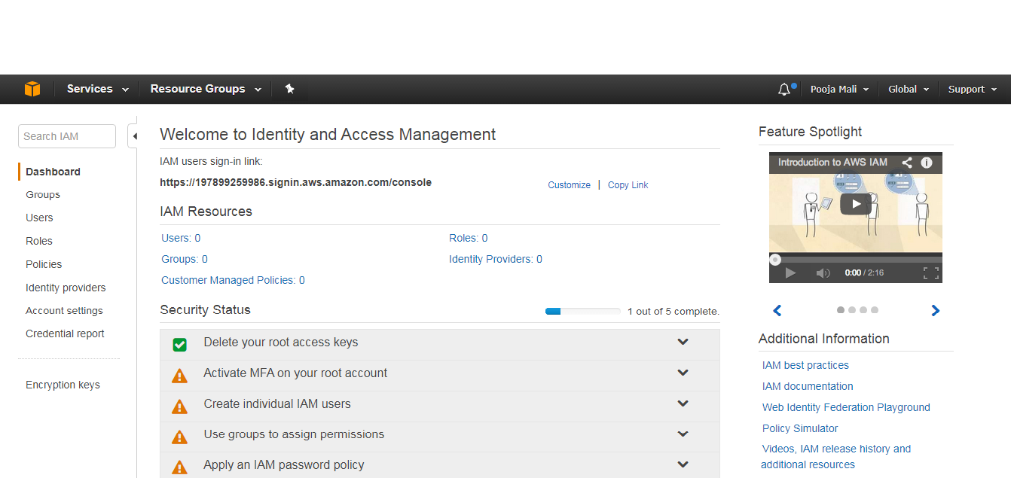

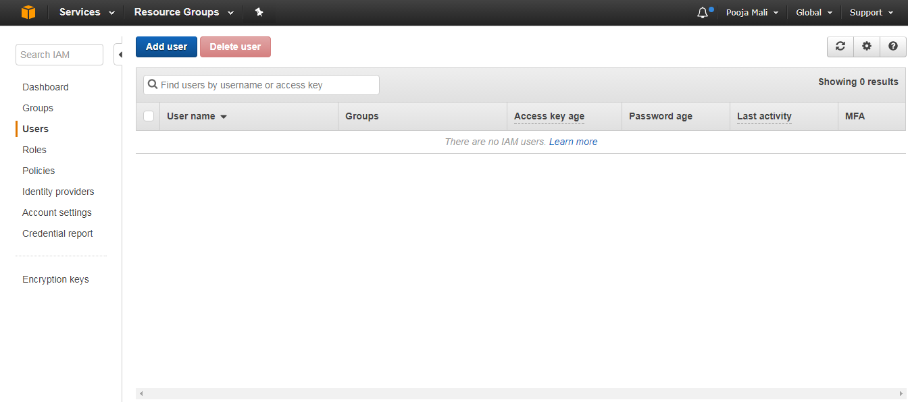

Step 2:

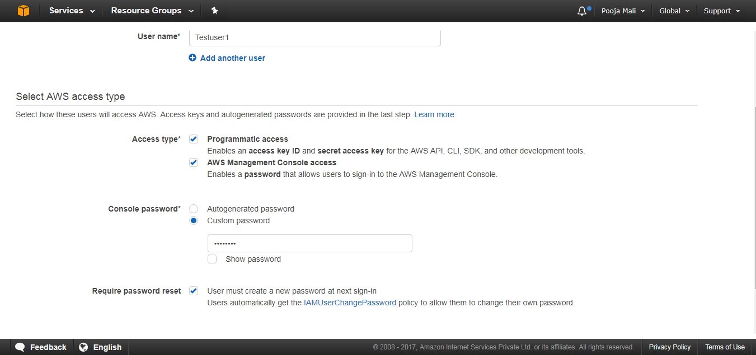

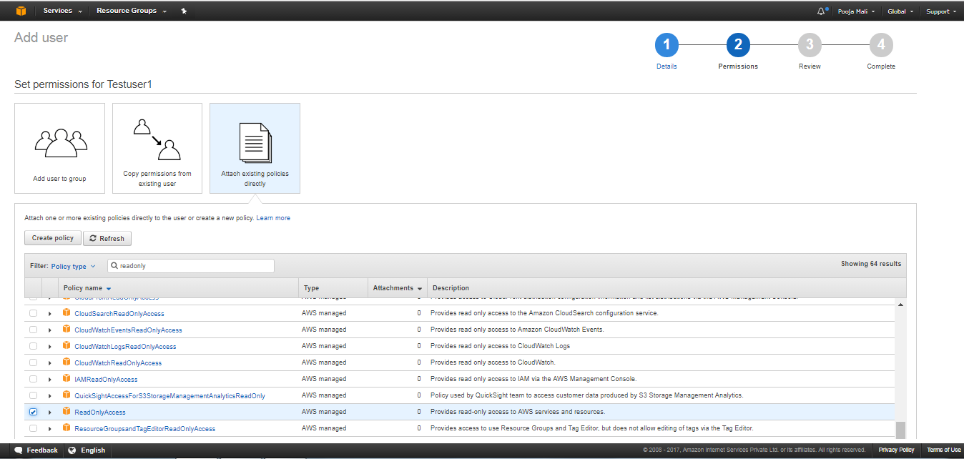

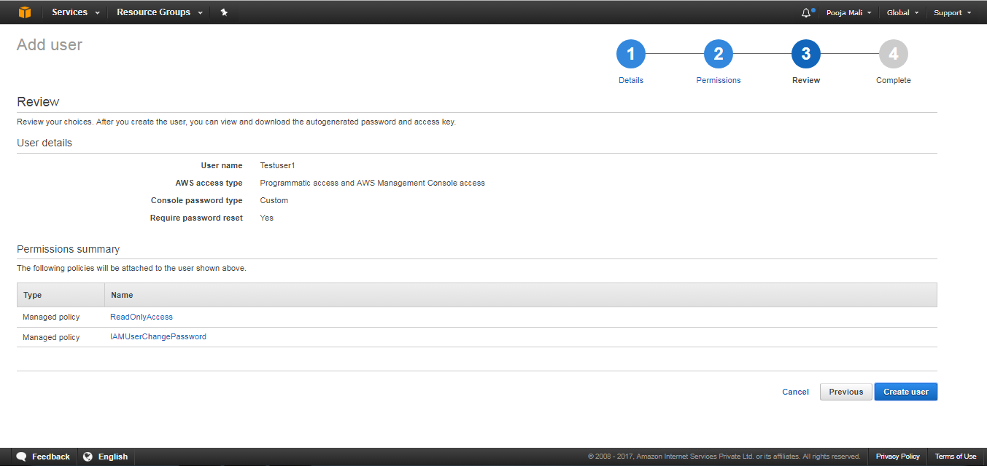

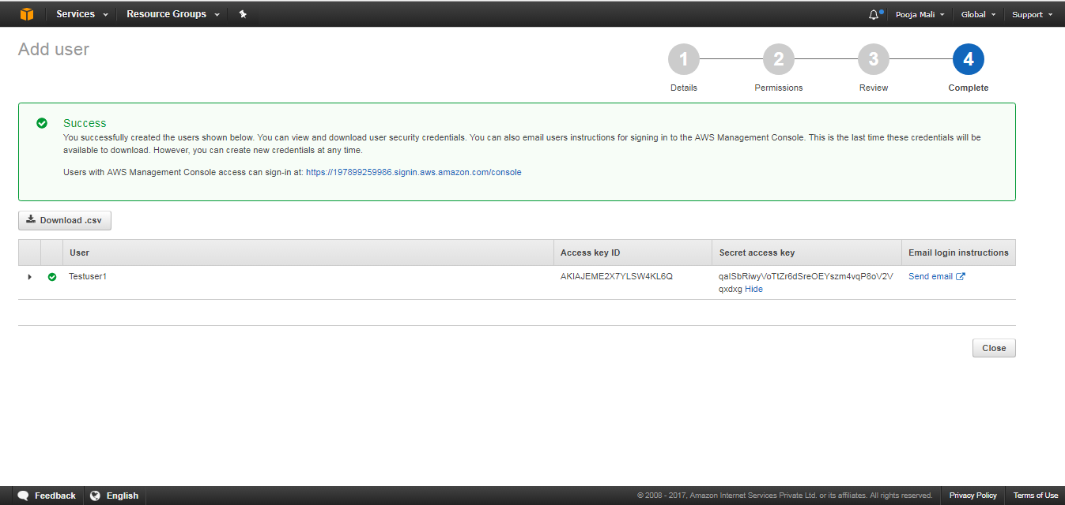

Go back to dashboard, copy the link and open it in new web browser.

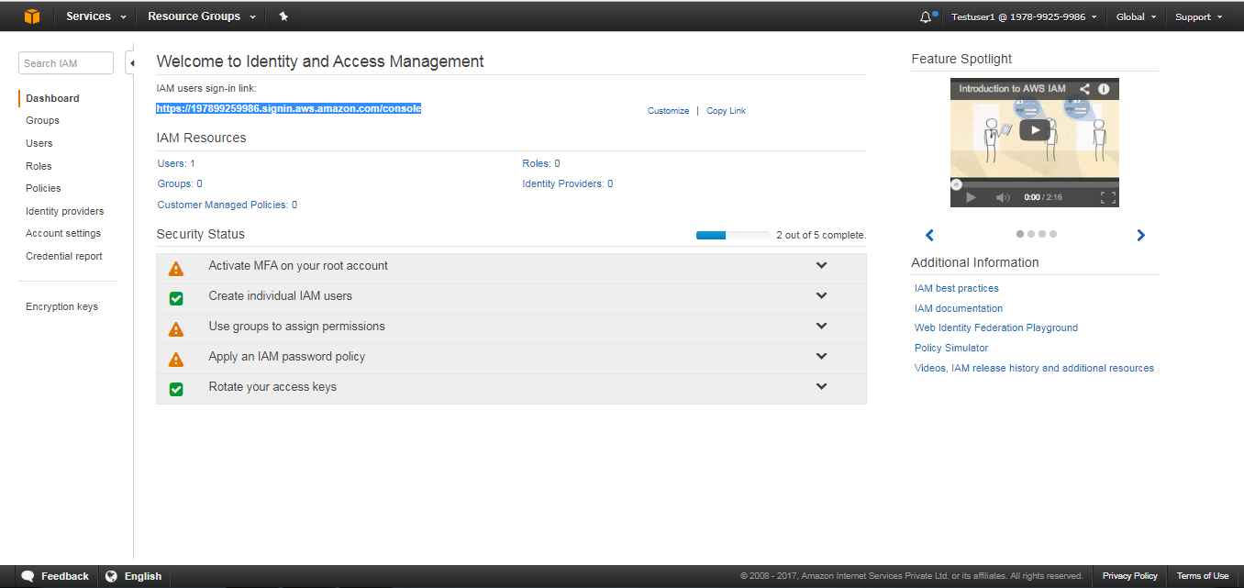

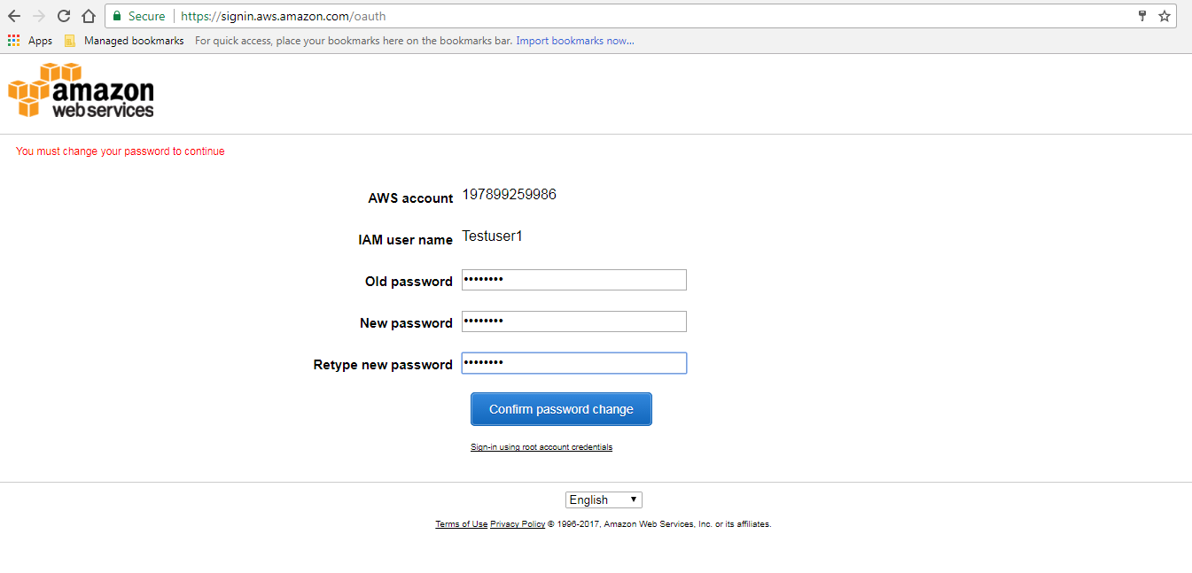

In home page of IAM, Go to User click on the option “add inline policy” next click on “select” option.

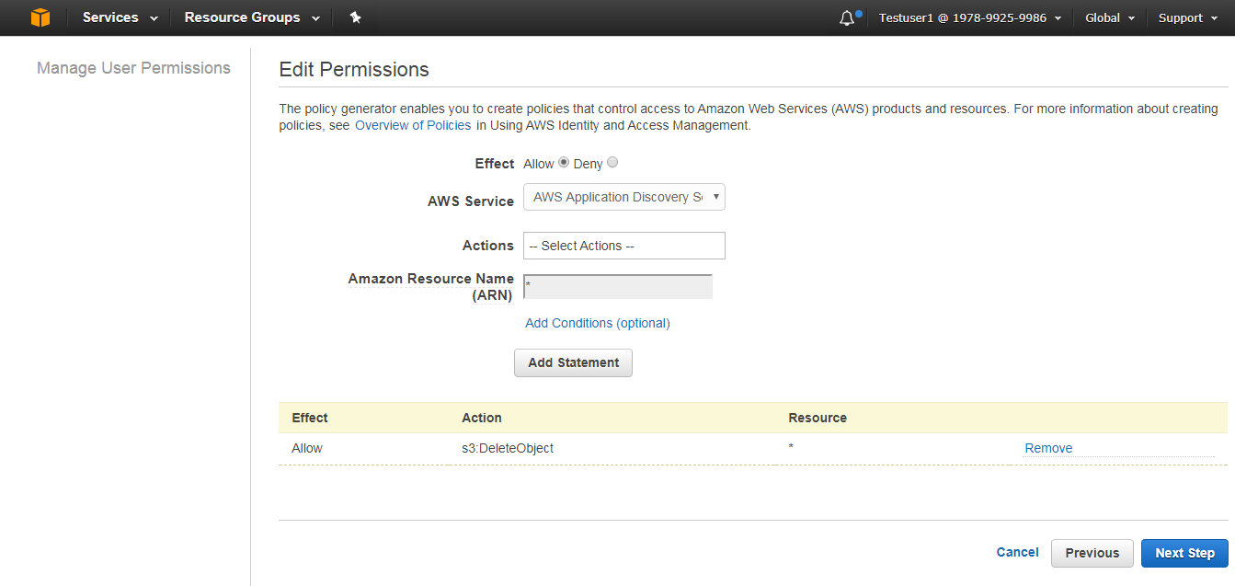

In above, “ * ” is to give all permissions on action selected. Otherwise to give specific permission on action selected then click on Amazon Resourse Name afterwards we get like below one.

<!-- Object in an Amazon S3 bucket -->

arn:aws:s3:::my_corporate_bucket/exampleobject.png

Validate and Apply policy

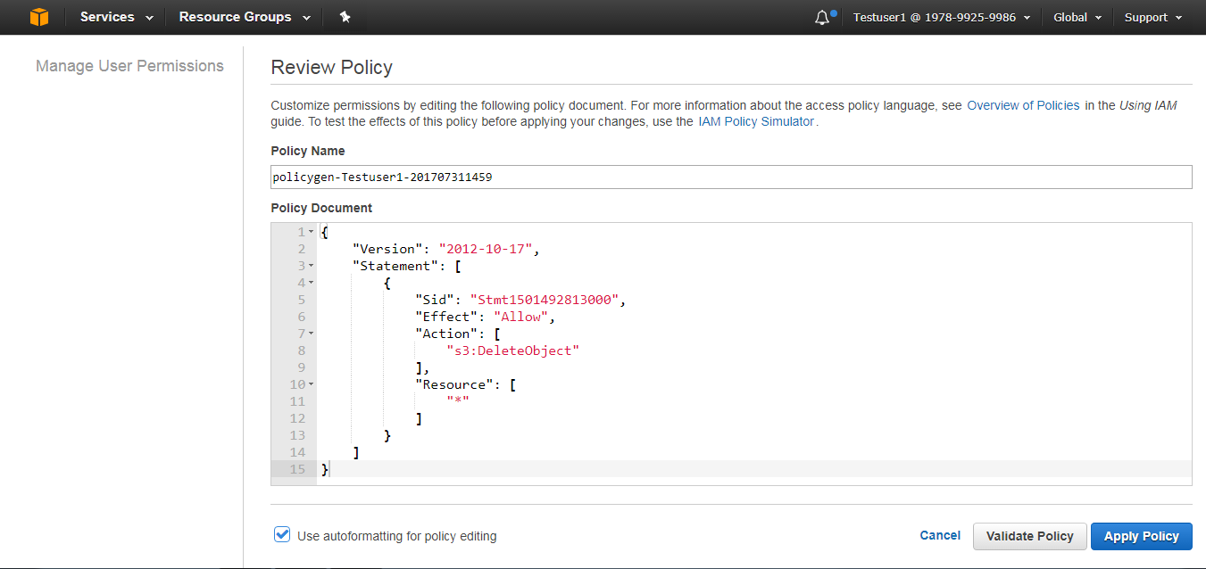

Step 3:

Go to Groups, Click on Group Actions Thus we will add user to the Group Created.

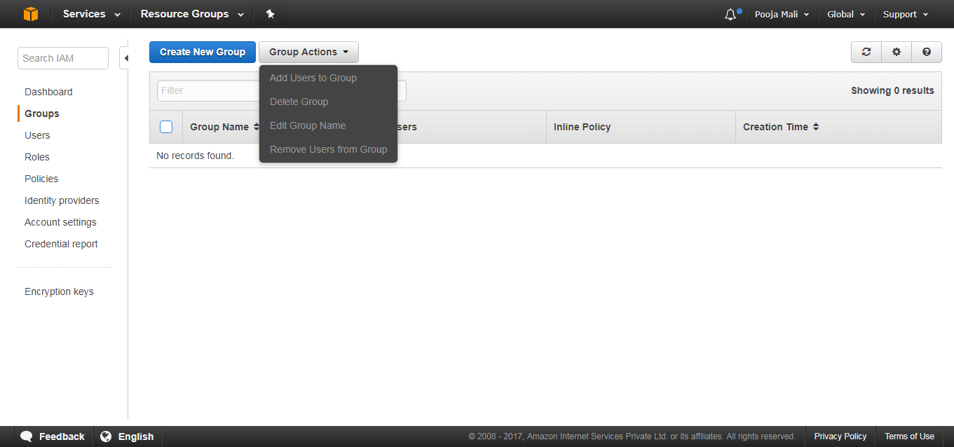

Step 5:

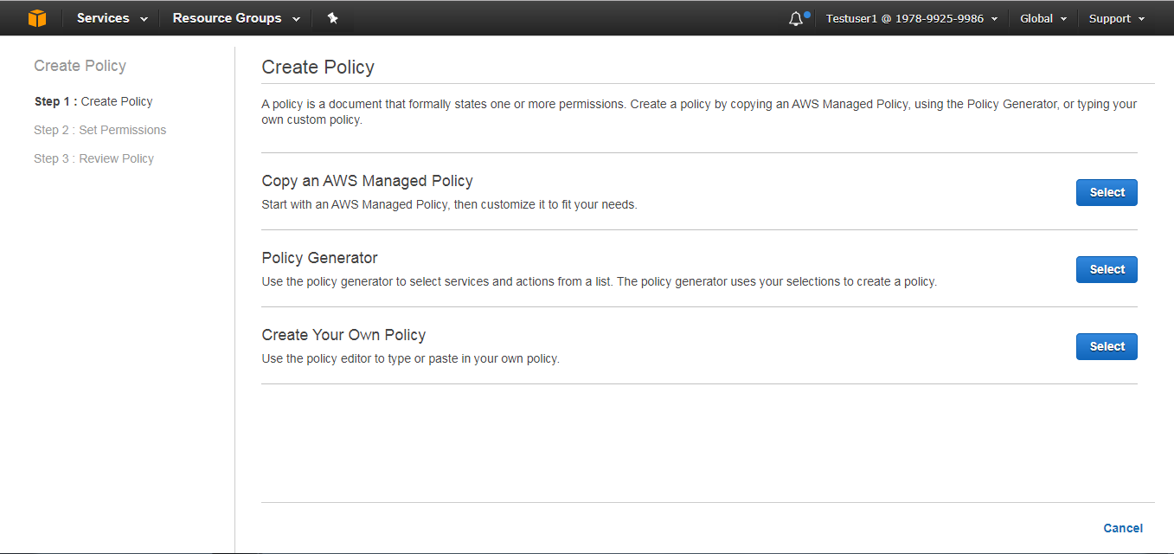

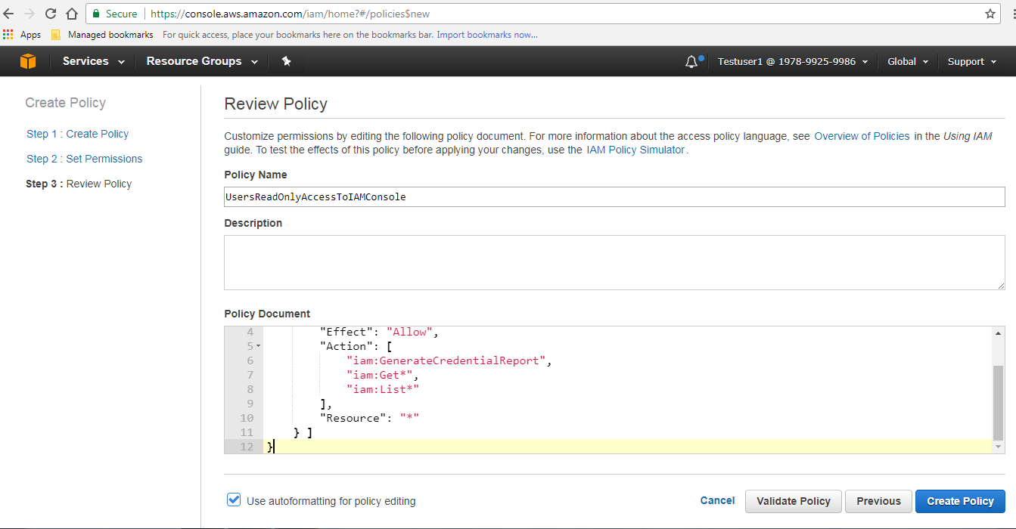

Now validate and create a policy.

Step 5 Creating IAM Roles:

Before an IAM user, application, or service can use a role that you created, you must grant permissions to switch to the role. You can use any policy attached to one of an IAM user's groups or to the user itself to grant the necessary permissions. This section describes how to grant users permission to use a role, and then how the user can switch to a role using the AWS Management Console, the Tools for Windows PowerShell, the AWS Command Line Interface (AWS CLI) and the AssumeRole AP.

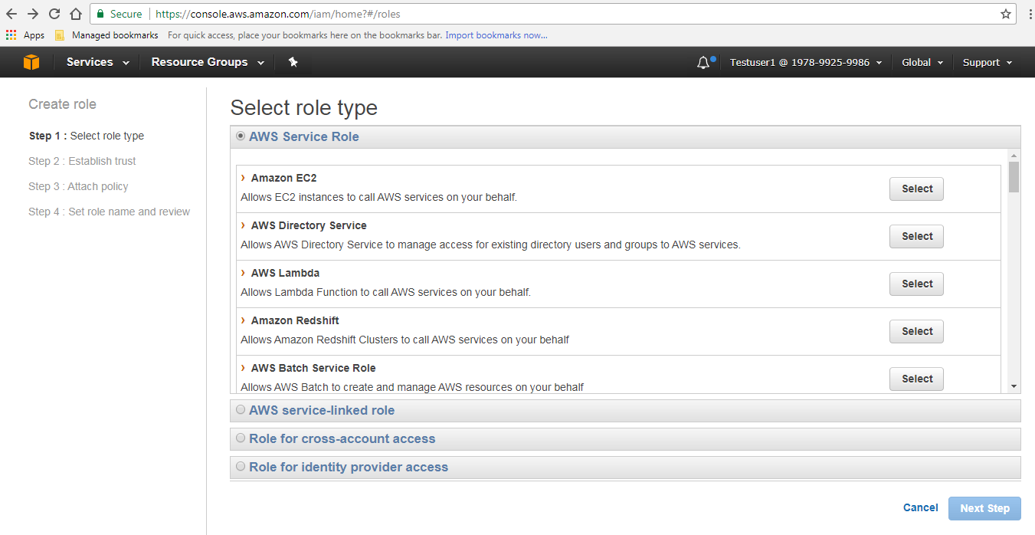

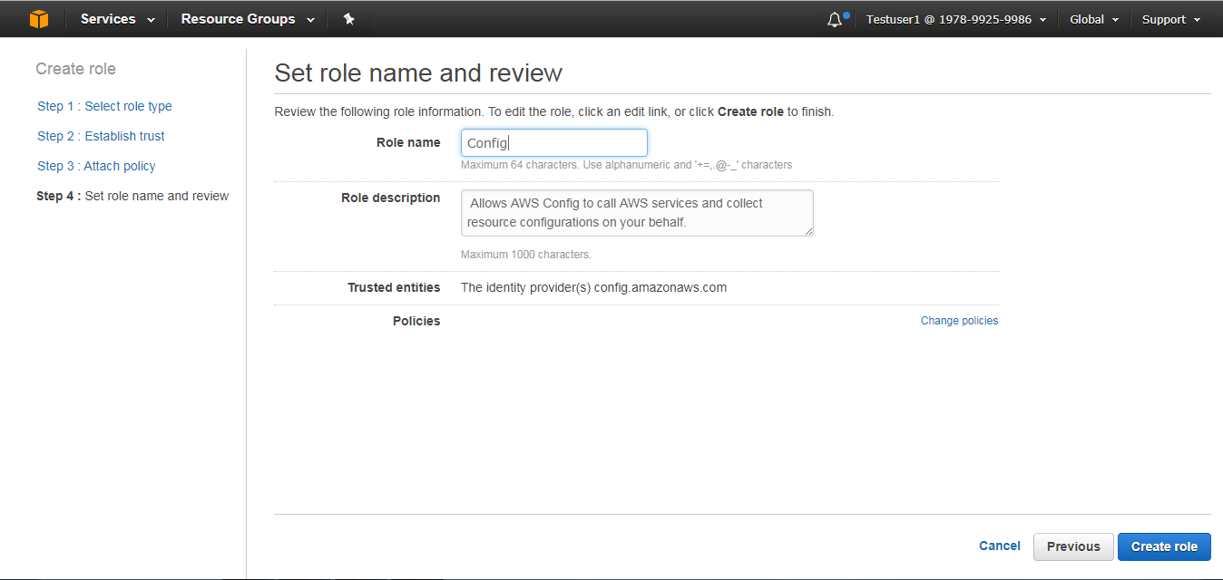

# RDS SUPPORT

Amazon Relational Database Service (Amazon **RDS**) is a web service that makes it easier to set up, operate, and scale a relational database in the cloud.

## Objective

To provide the high level guidance’s to Monitoring usage, health and Provisioning of RDS Instances.

## Assumption

* Amazon RDS is available on several database instance types, optimized for Memory, Performance and I/O, and Provides with six familiar database engines to choose from Amazon Aurora, PostgreSQL, MySQL, MariaDB, Oracle and Microsoft SQL Server.

The below diagram shows how the AWS RDS is connected:

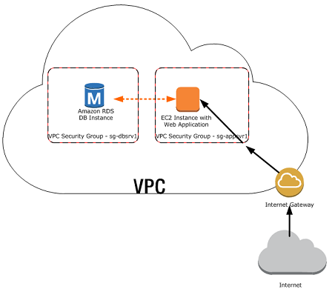

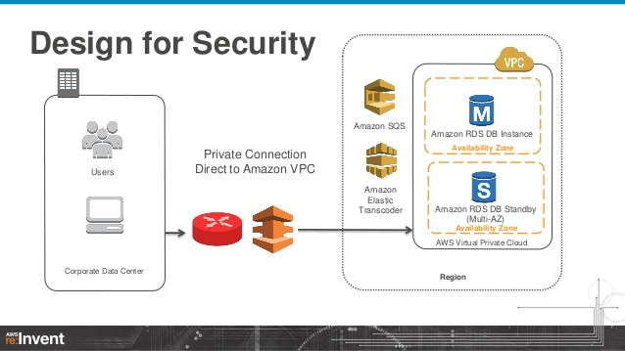

## Procedure

Go to the RDS and click on the DB Instance and follow the below steps:

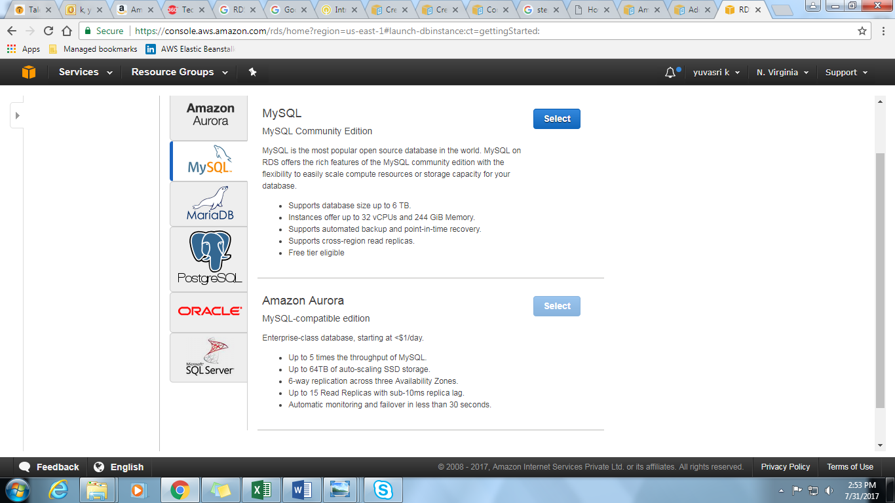

Select the type of the database to be used for the launching the RDS Instance.

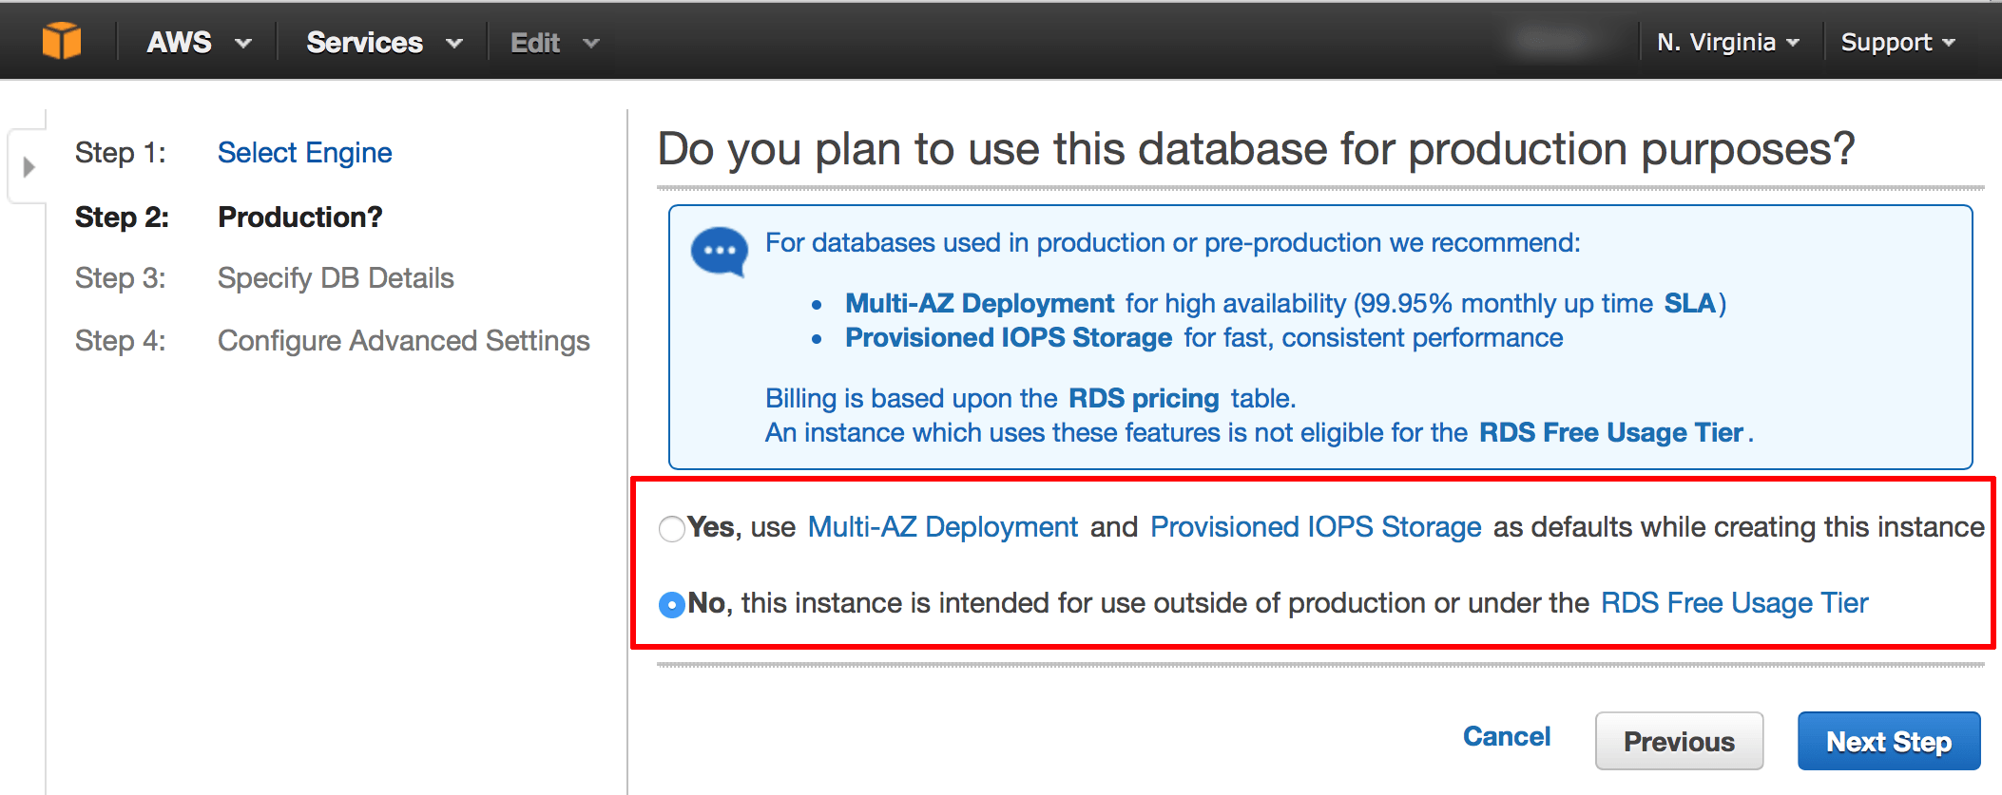

Specify the production type, so that we will come to know weather database is used for production purpose or outside the production.

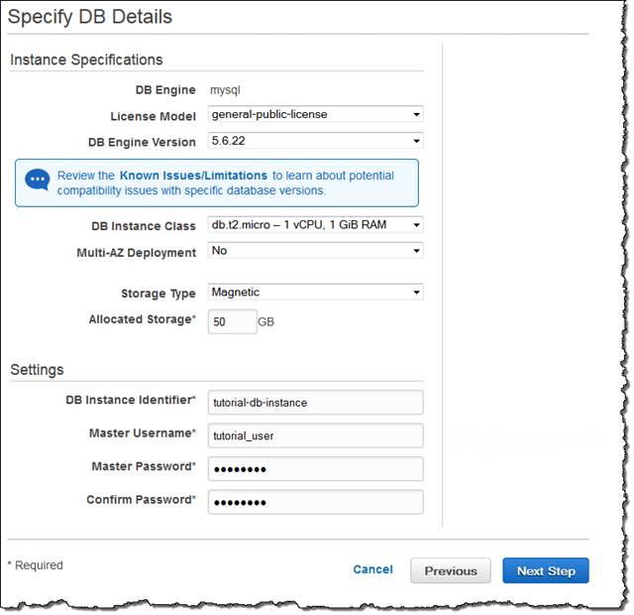

Specifying the DB details asks for the instance class and we can make the Instance Identifier can be identified by Master Username and Password.

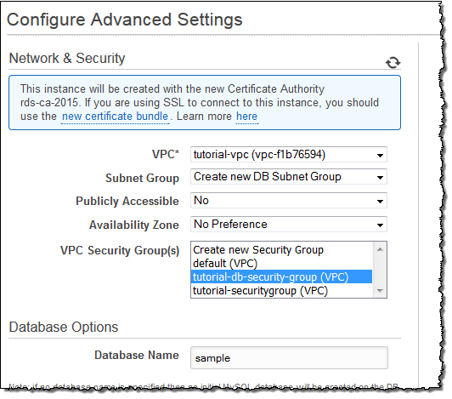

Configuring the Advanced Settings helps to specify the network and security settings for the Database and launch the Instance.

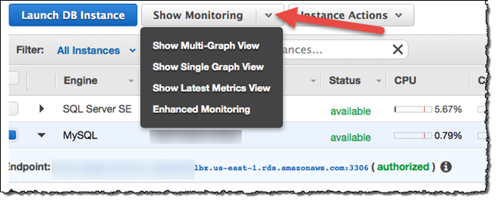

Monitoring the usage of the Memory utilization of the RDS Instance.

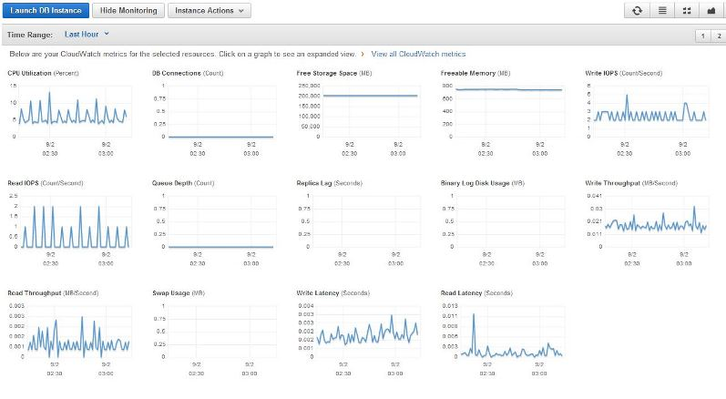

You can launch the AWs instance and test the connectivity to on premise.

## 

# ELASTICACHE MANAGEMENT

## Monitoring usage and health of ElastiCache instances

## Configuration and management of available settings

## Setup and Configuration of clustering

# SES MANAGEMENT

## Configuration and management of domains/senders

## Email reputation management

# SQS MANAGEMENT

Amazon Simple Queue Service (SQS) is a fully managed [message queuing service](https://aws.amazon.com/message-queue) that makes it easy to decouple and scale microservices, distributed systems, and serverless applications.

## Objective

To understand the process of creating, modifying and managing SQS queues in AWS.

## Procedure

### Create New Queue

1. Sign in to AWS Management Console 🡪 Application Servics-> SQS

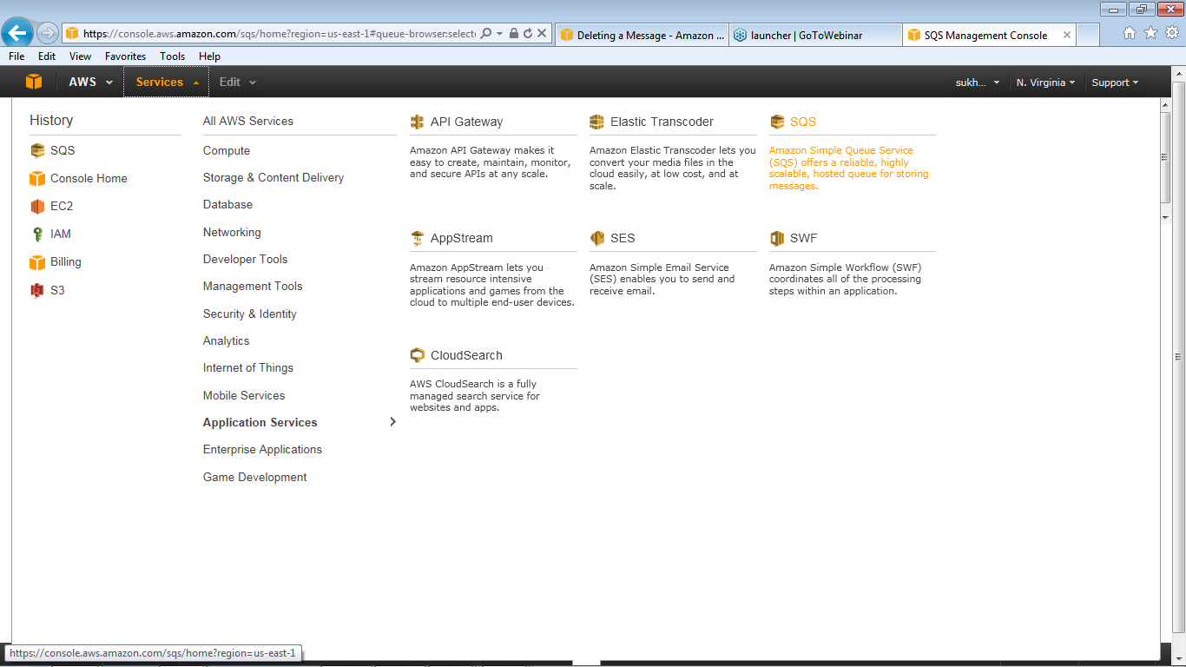

1. In the **Create New Queue** dialog box, enter DemoConnection in the Queue Name field, and leave the default value settings for the remaining fields

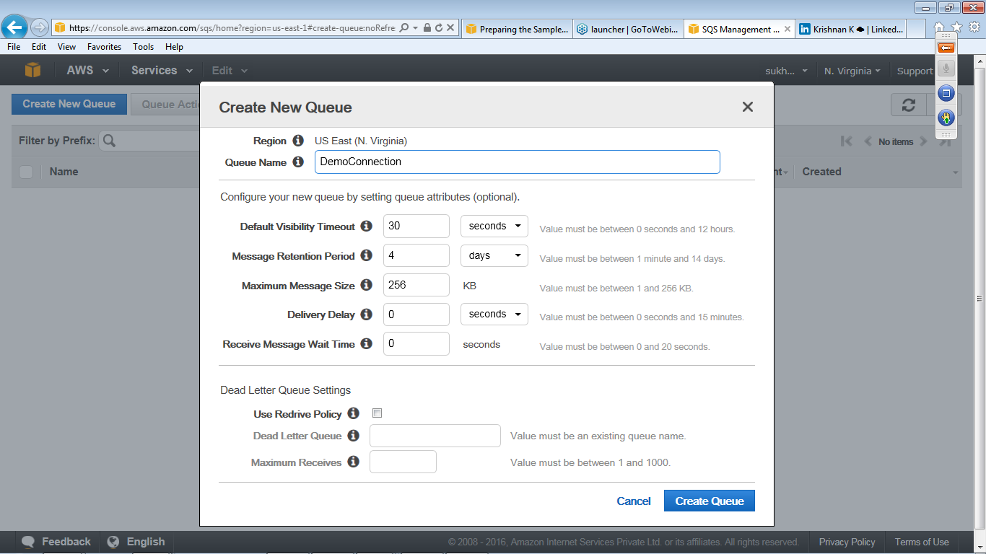

The console displays all of your queues in that region

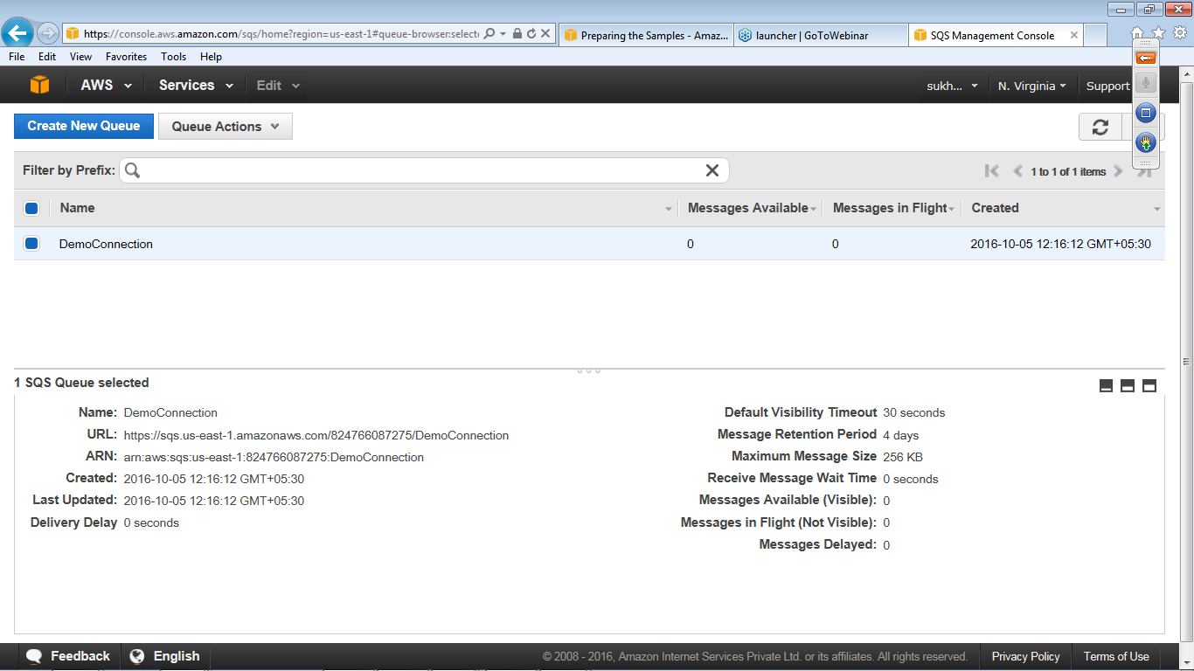

1. Select **Add a Permission** from the **Queue Actions** drop-down list and specify the permission's settings.

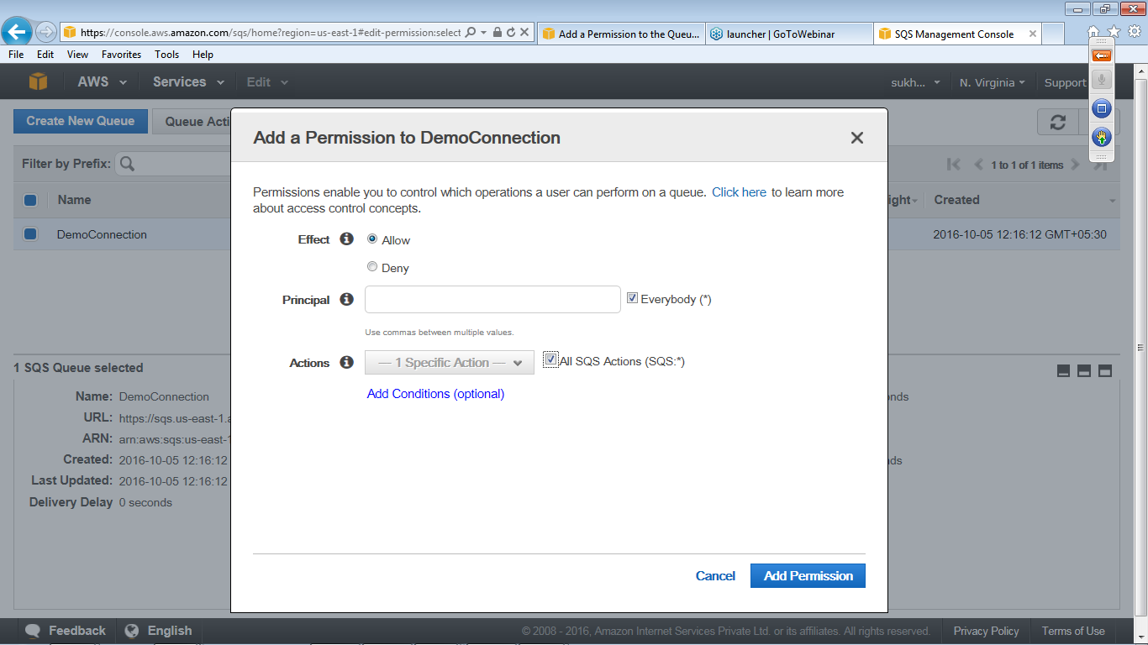

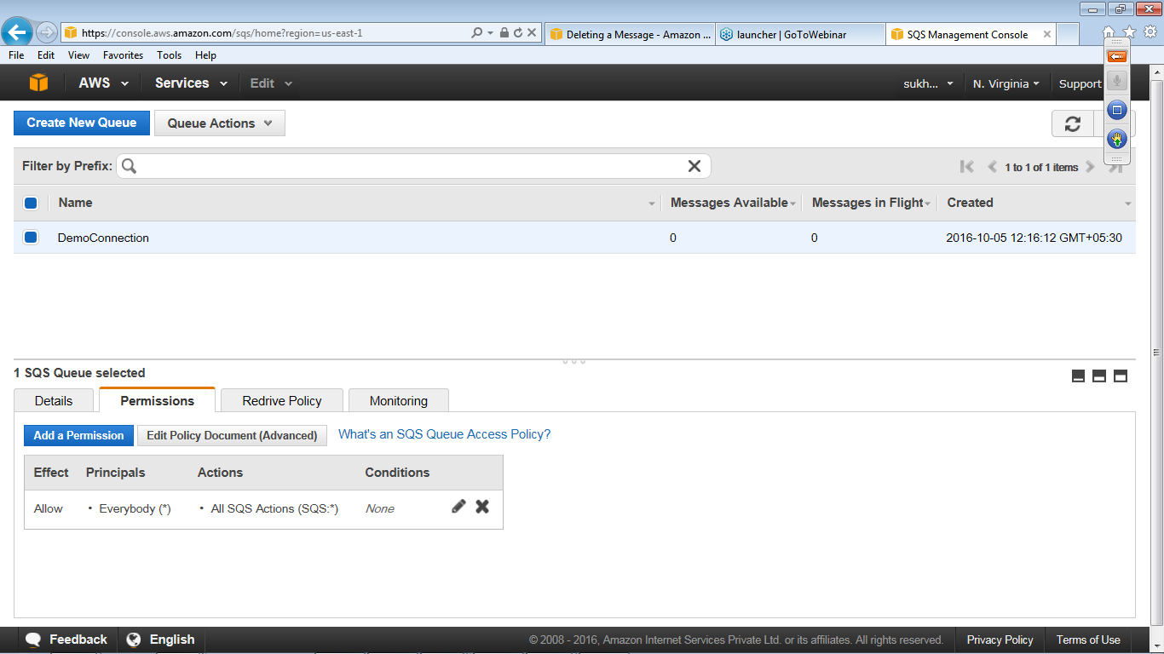

### Sending Message

1. In the AWS Management Console select a queue

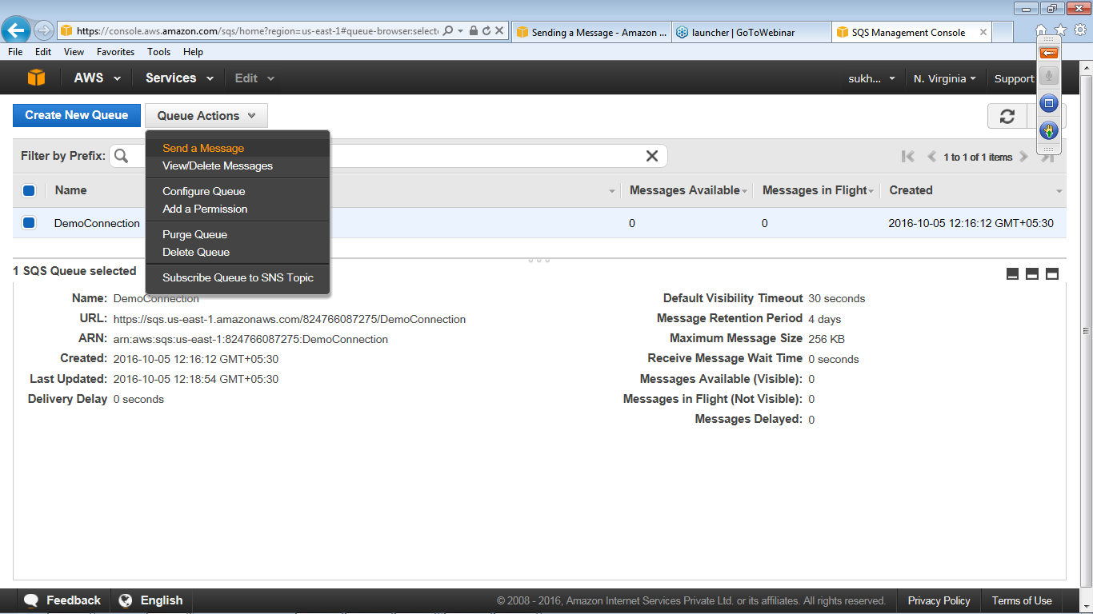

1. In the **Send a Message to** dialog box, enter This is the message text for demo purpose and click **Send** Message

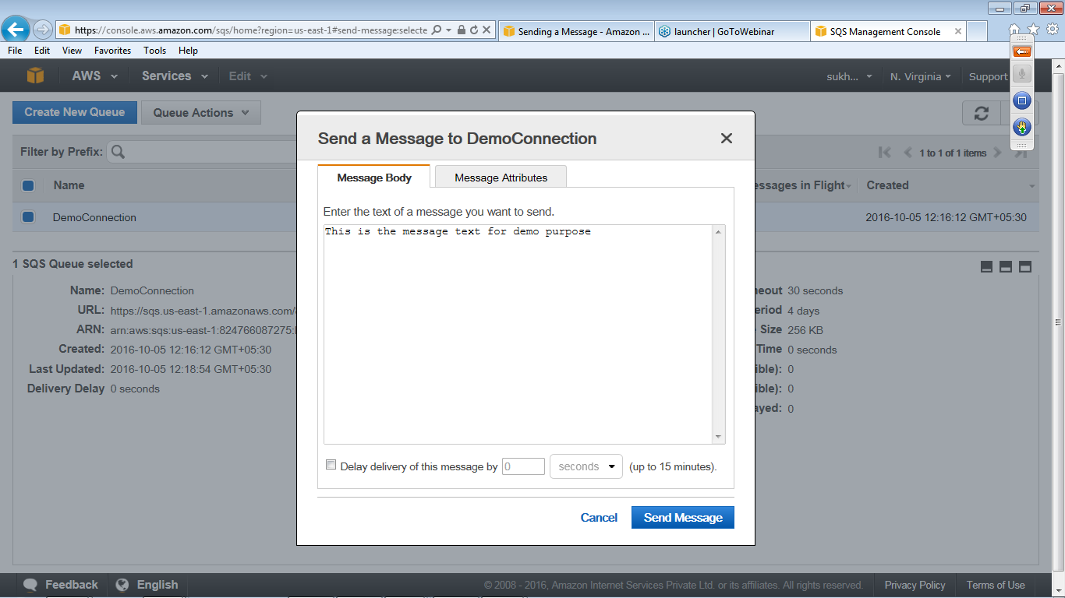

1. In the Send a Message confirm and click Close.

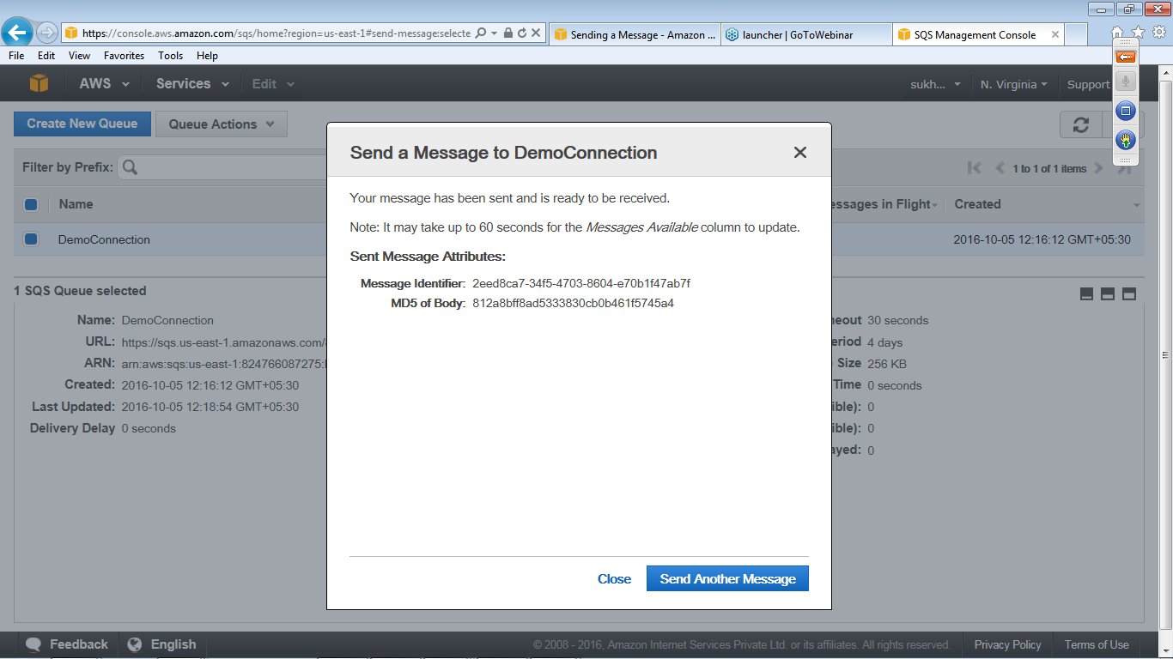

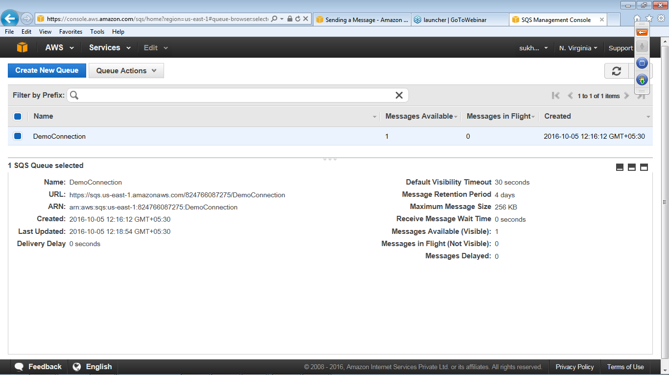

### Receiving Message

1. In the AWS Management Console, select a queue
2. Select View/Delete Messages from the Queue Actions drop-down list

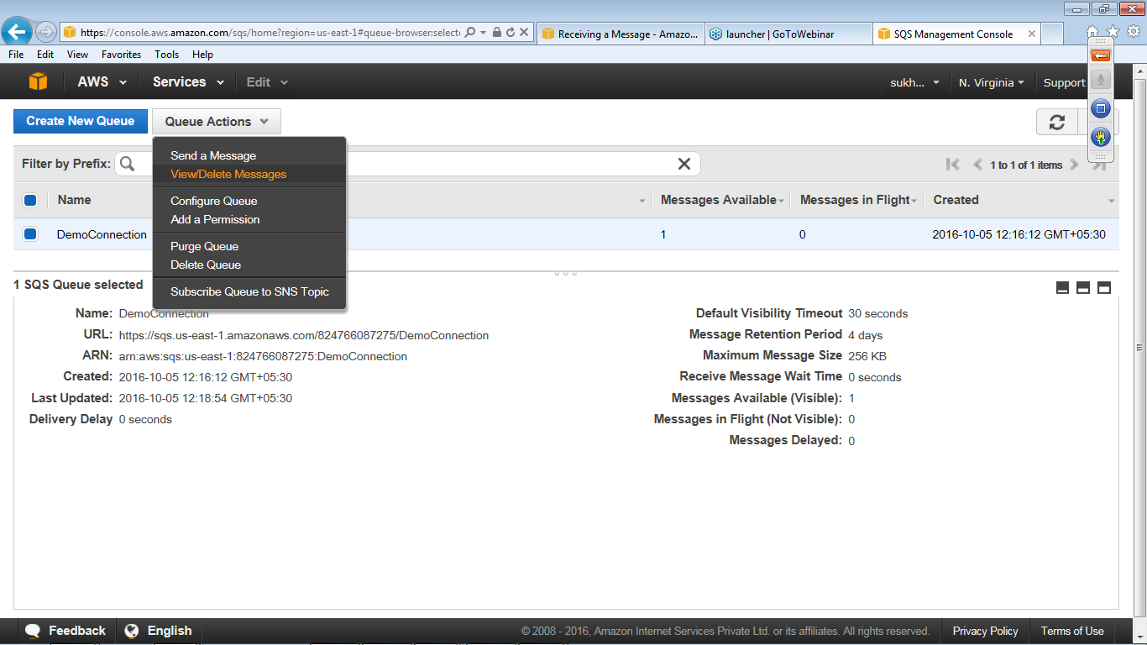

1. Click **Start Polling for Messages** to receive a message from the queue.

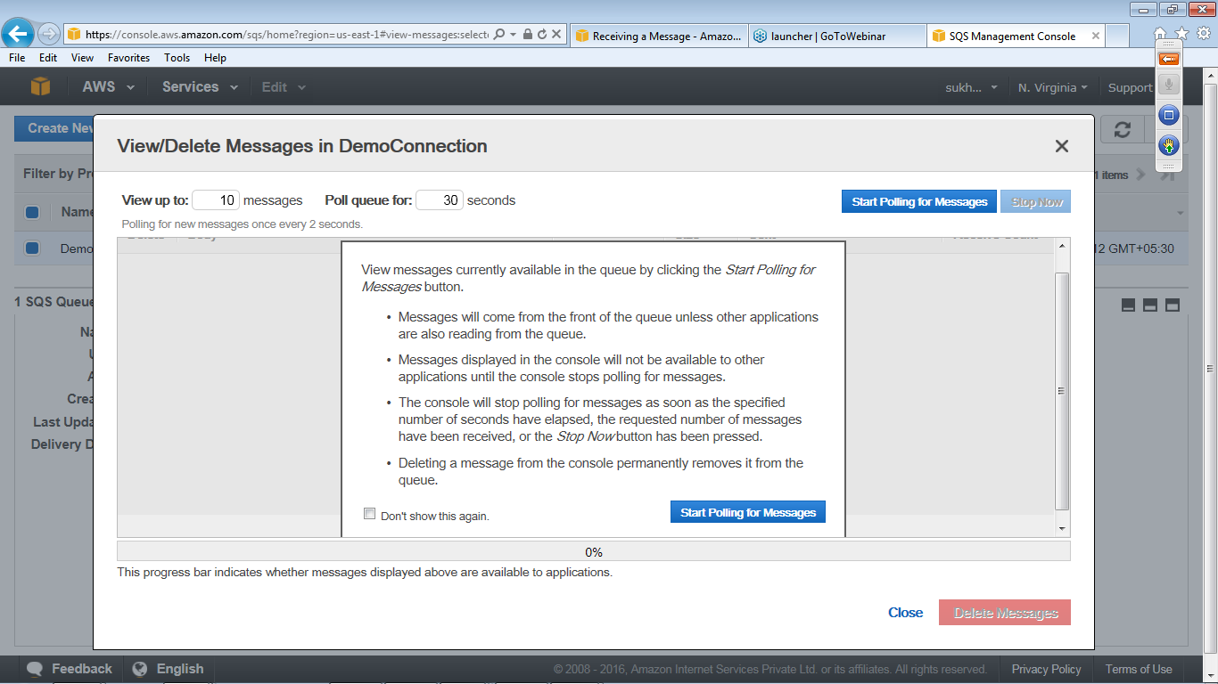

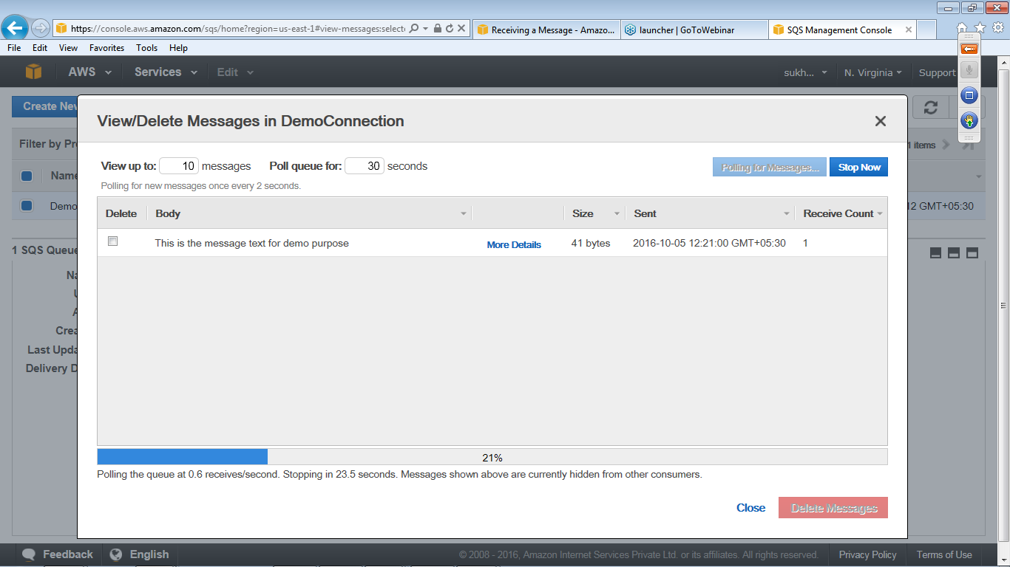

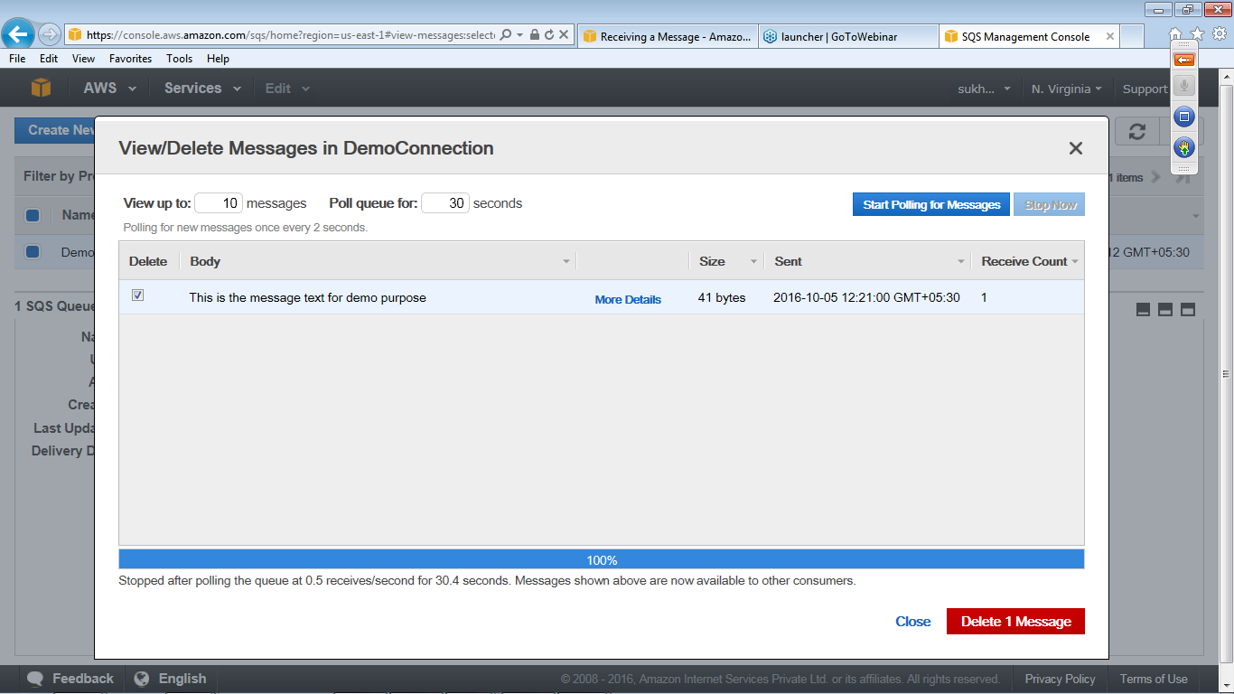

### Modify Queue

1. In the AWS Management Console, select a queue
2. From the **Queue Action** drop down select the option **Configure Queues**

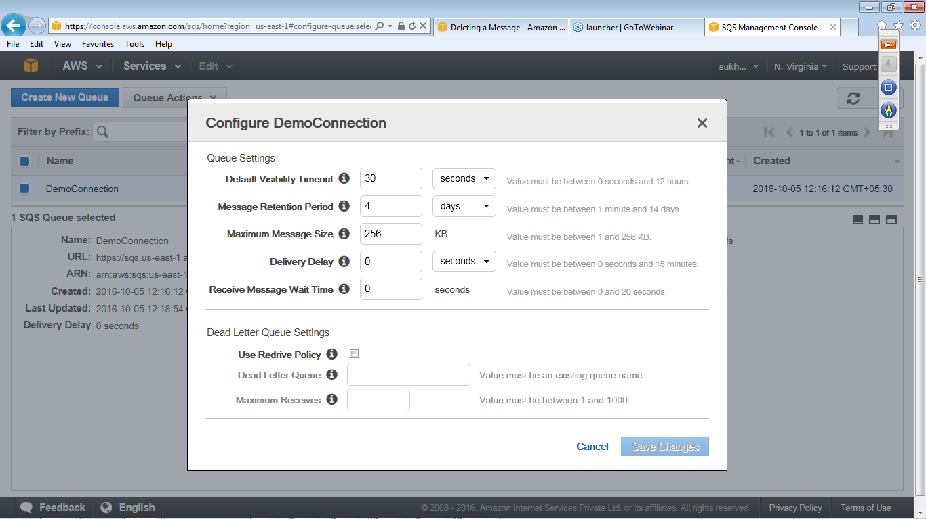

### Monitoring Queue

1. In the AWS Management Console, select a queuClick on the **Monitoring tab** and get the details of SQS Metrics
2. 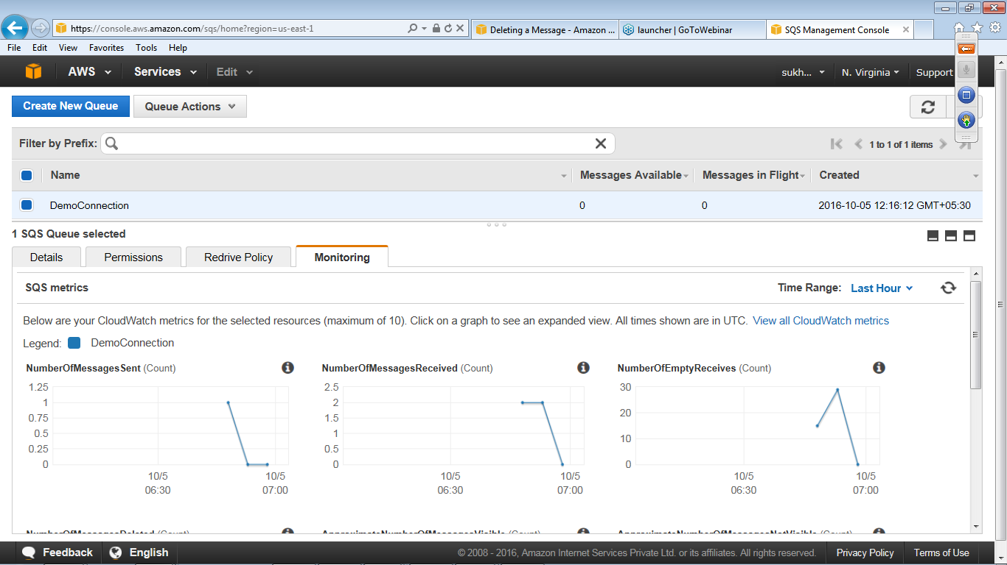

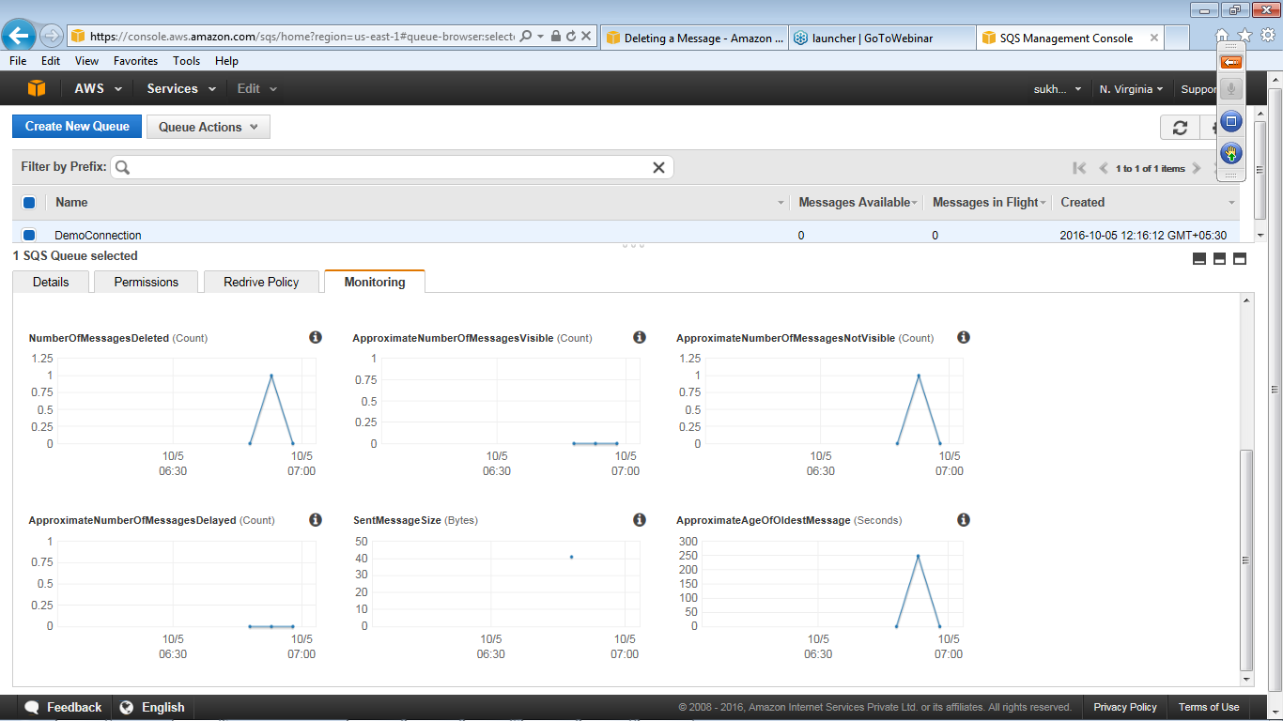

### Deleting a Message

If you want to delete messages from your queue one at a time use Delete option

1. In the AWS Management Console, select a queue
2. Select View/Delete Messages from the Queue Actions drop-down list
3. Select the message you want to delete

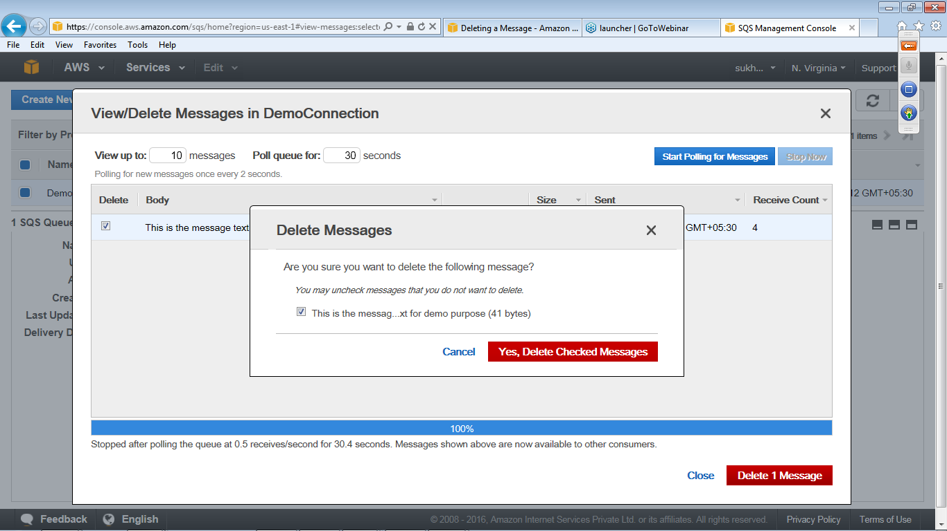

1. Click **Delete 1 Message** to delete the selected message
2. Click Close to close the View/Delete Messages dialog box

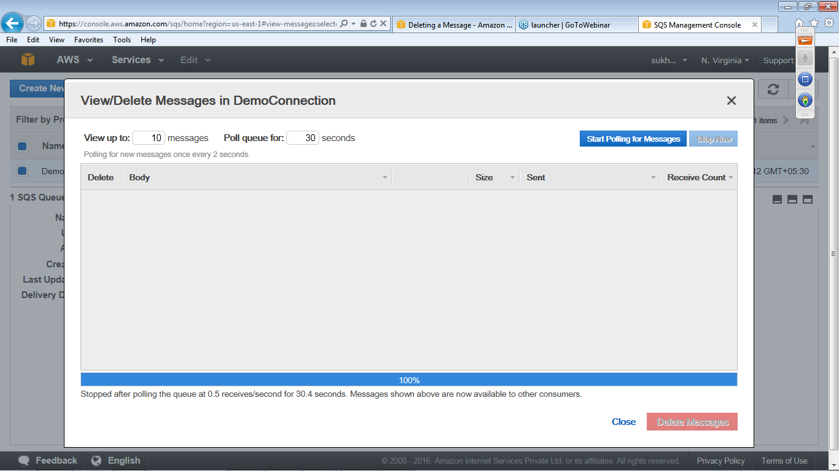

### Purging Queue

If you want to delete many messages from your queue at once use purging

1. In the AWS Management Console select a queue
2. Select Purge Queue from the Queue Actions drop-down list
3. In the Purge Queues dialog box, click Yes, Purge Queue

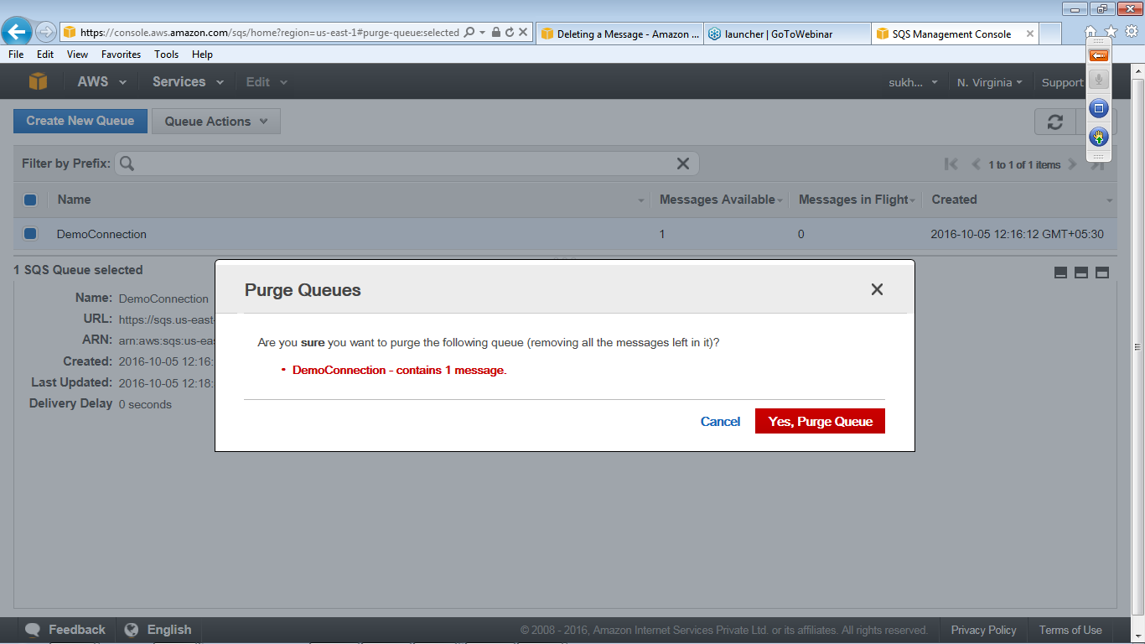

In the Purge Queues confirmation box click OK.

# SNS MANAGEMENT

Amazon Simple Notification Service (SNS) is a simple, fully-managed "push" messaging service that allows users to push texts, alerts or notifications, like an auto-reply message, or a notification that a package has shipped.

## Objective

Understand the process of Creating, modifying and managing SNS (Simple Notification Service).

## Assumptions

* Simple Notification Service(SNS) is available in the AWS console
* You are using any AWS services such as Amazon CloudWatch, Amazon Ec2 instances or Amazon S3.

Now the below diagram shows how subscriber can be notified directly from the publisher through SNS for certain created topic.

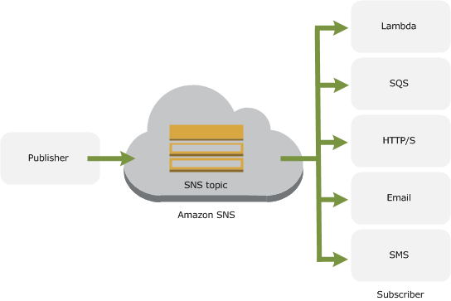

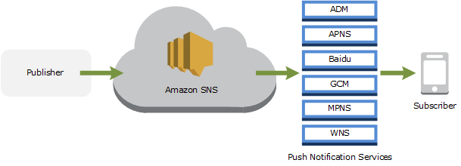

## Procedure

### Create SNS(Simple Notification Service).

1. Sign in to AWS Management Console and select **SNS(Simple Notification Service).** 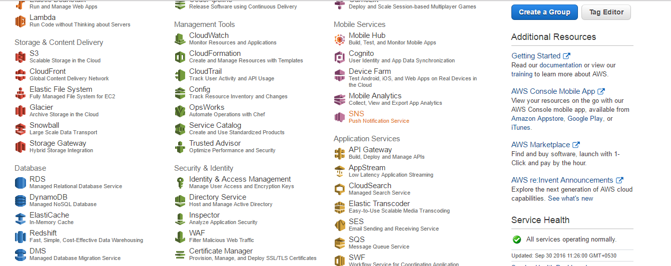
2. Click on Get Started.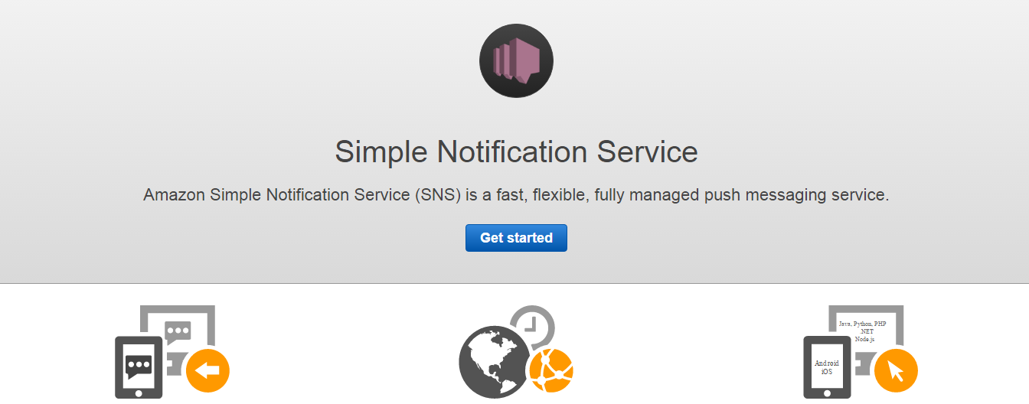
3. Now Click on **Create Topic**.

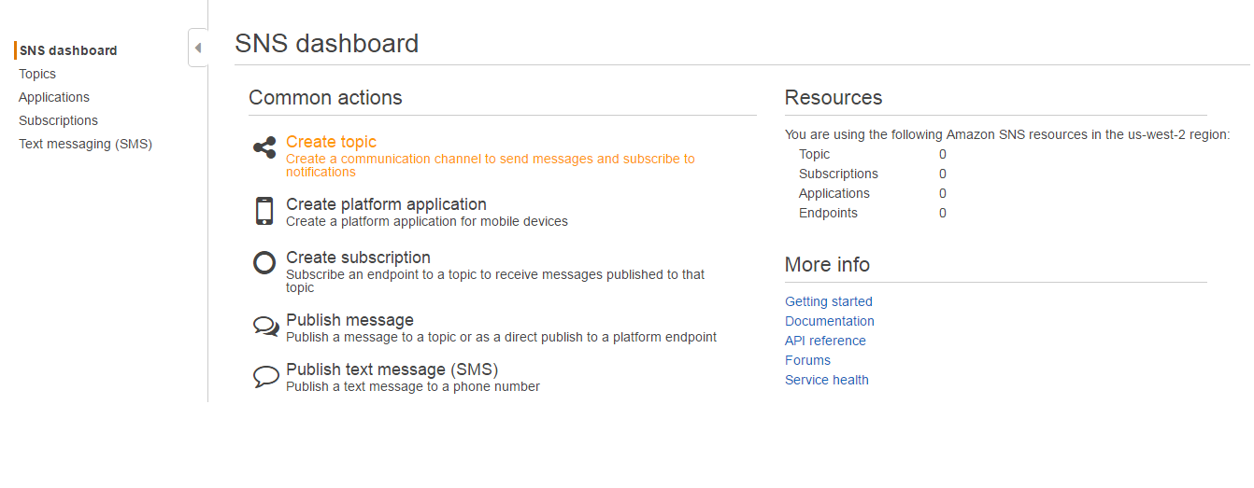

1. In the Create New Topic, Give the **Topic name** and **Displayname** andClick **Create Topic.**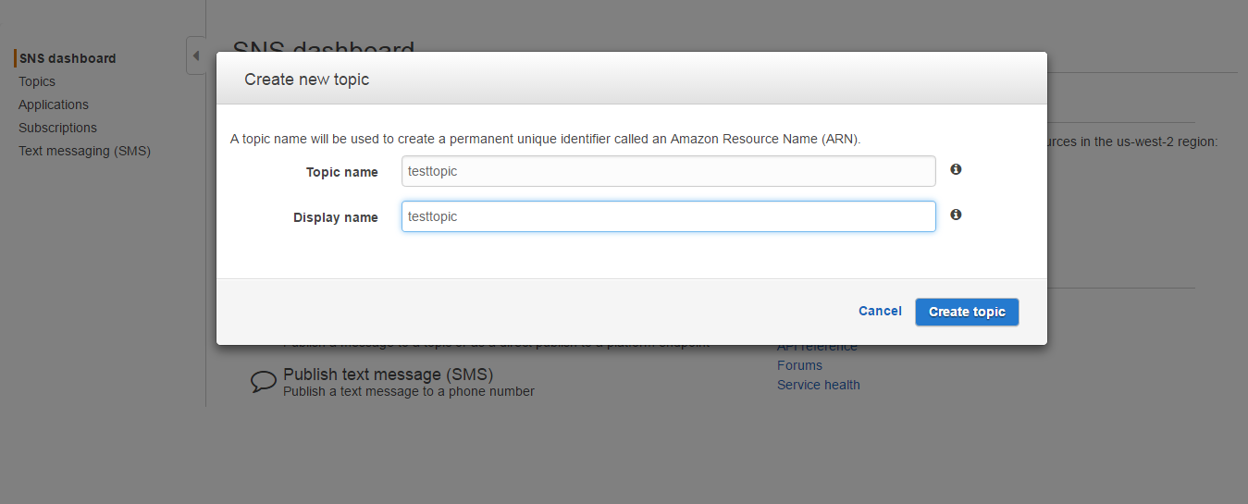
2. In this, copy the **Topic ARN** which will be required in next step.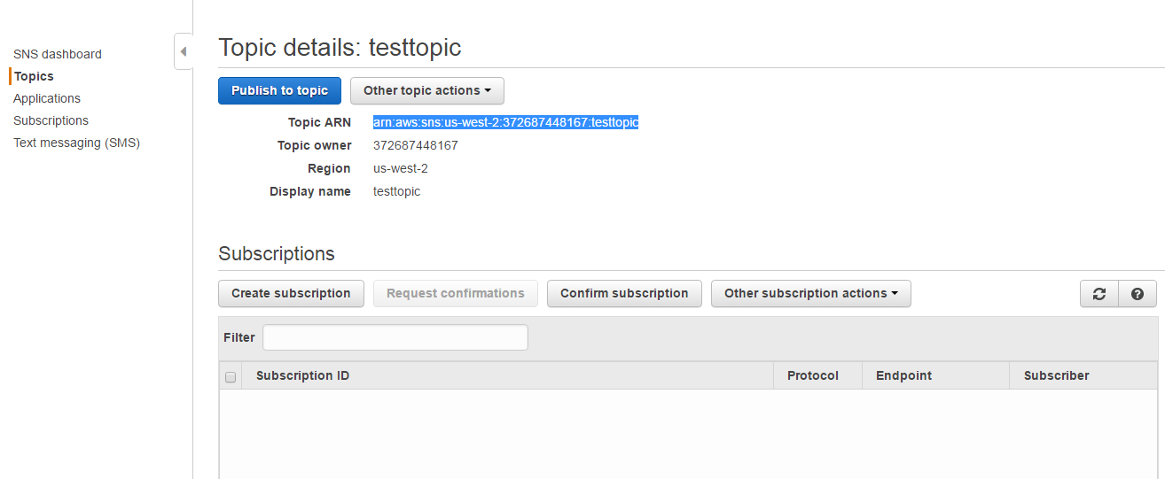
3. In this window Click on **Create Subscription**. 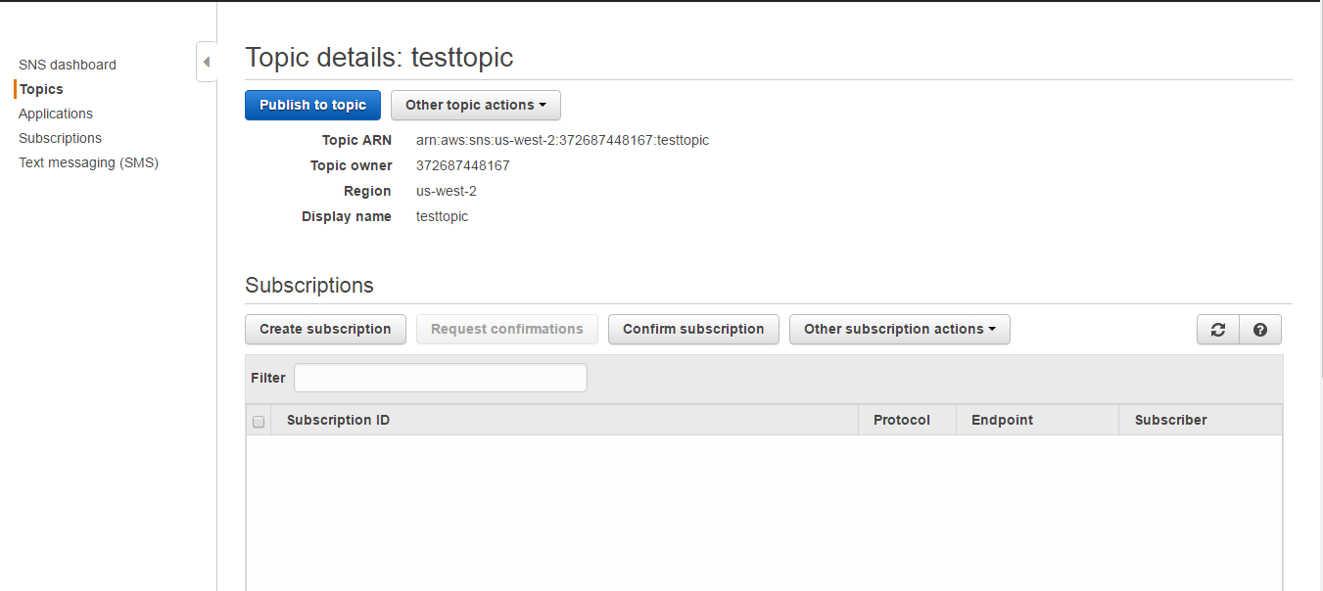

7.After Clicking **Create Subscription**, paste the copied Topic ARN which was copied in earlier step ,in Protocol select Email and in Endpoint Give the Email ID and click **Create Subscription**. 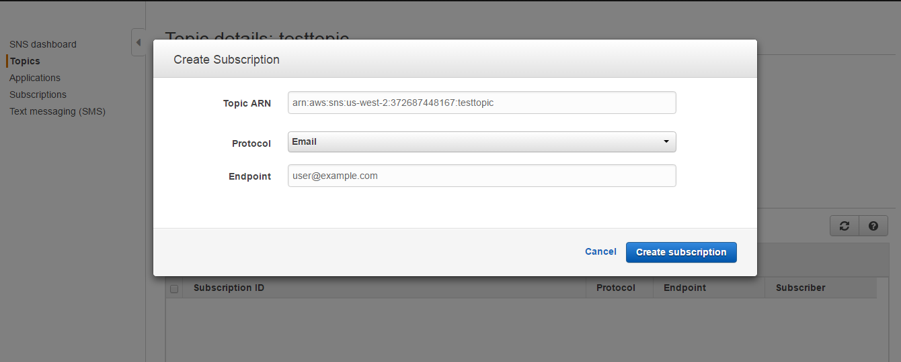

8.After clicking on **Create Subscription** you will receive an email for confirmation just sign in and click on link for confirmation. 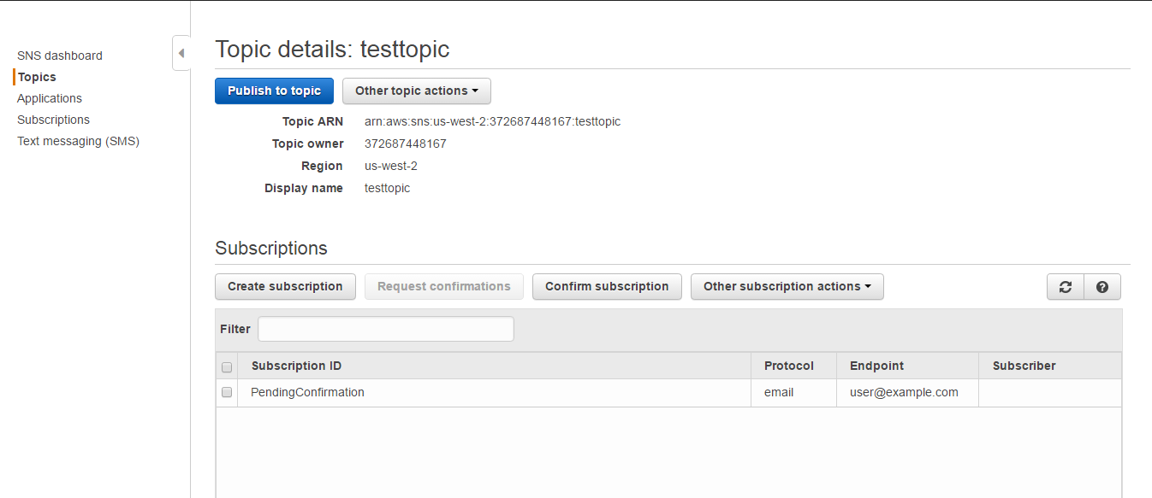

9.In this,click on **Publish to topic.** 

10.In this, type the Subject Name and then click on **JSON message generator**. 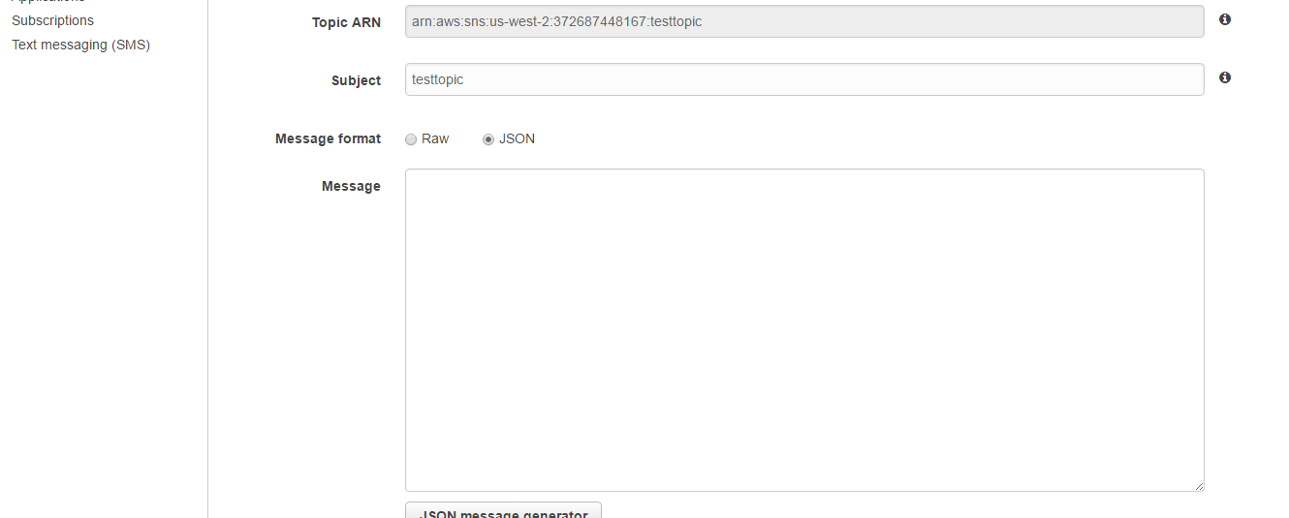

11.In the **Message** Box type the brief message and in **Target Platforms** select **Email,** **SMS** and Select **Windows 8.1+** and then click on **Generate JSON.**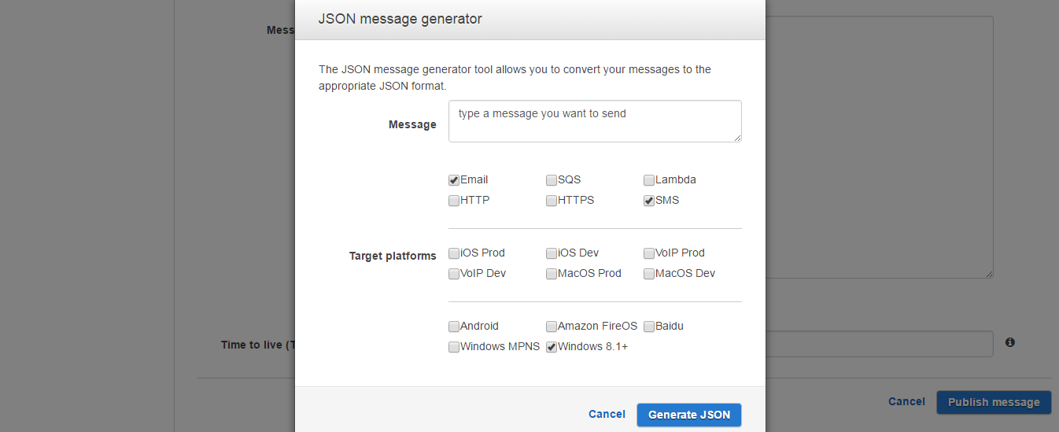

12. After clicking **Generate JSON** following message will be displayed. 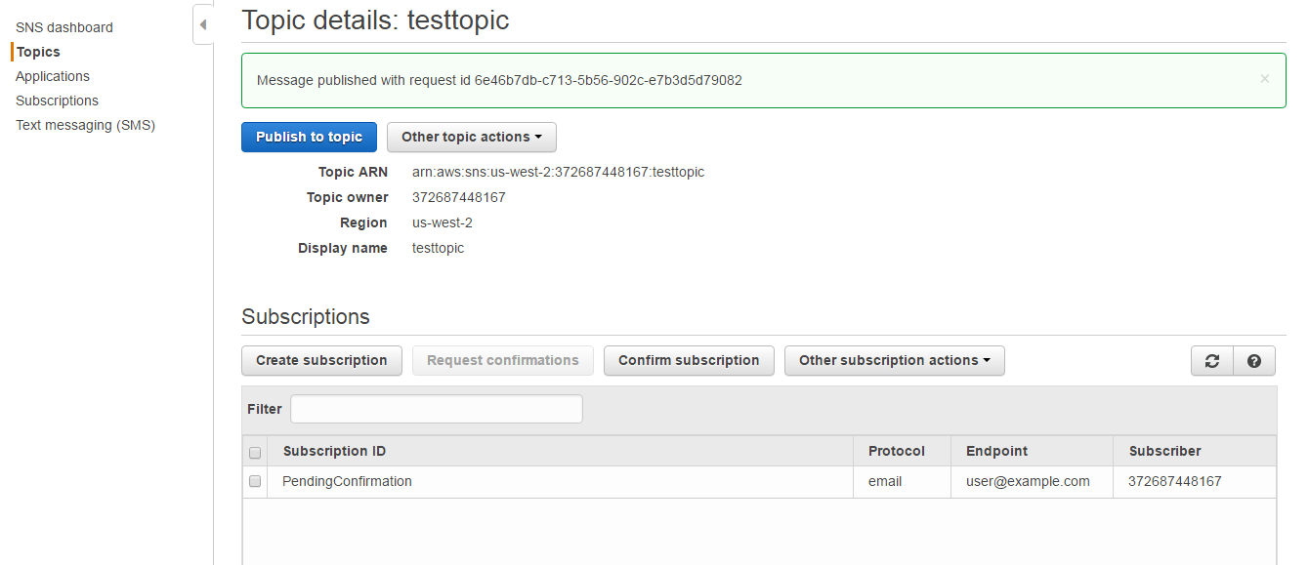

### 8.3.2 Modifying SNS(Simple Notification Service).

1. Click on the topic created then click on **Actions** and select **Edit topic display Name**. 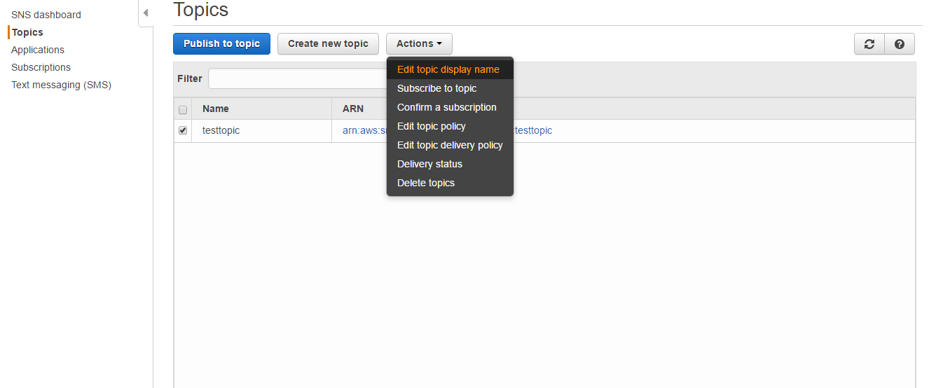
2. Type the name you want to display in **Display Name** and click on **Set display name**.

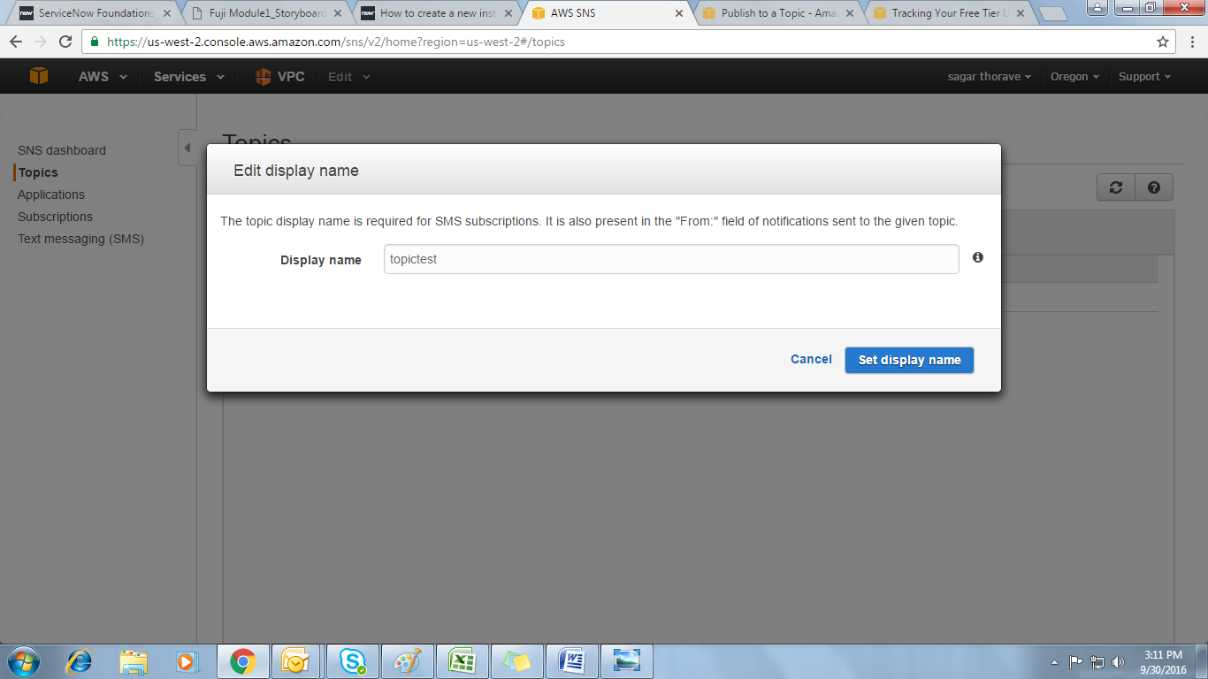

1. Select topic name and click on **Actions** and select **Edit topic policy**. 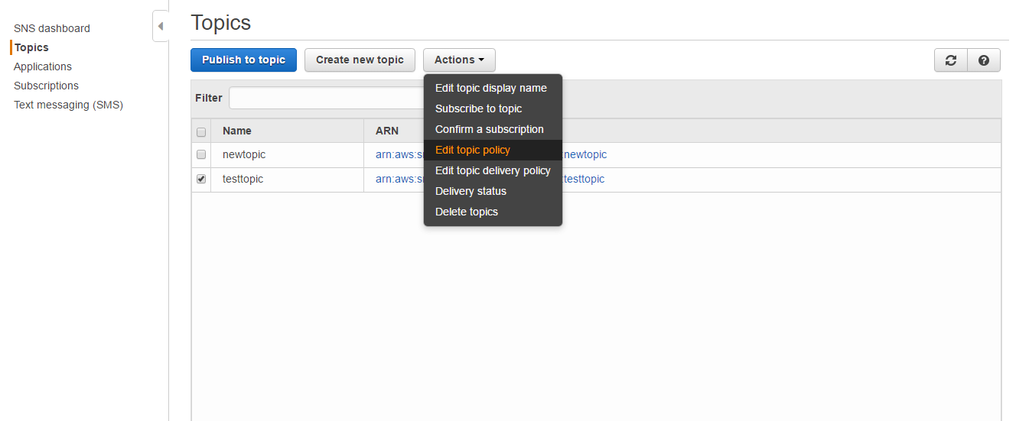
2. In this you can allow user restriction,if you don’t want any other user to publish the messages in this topic then just click on **only me (topic owner)** and then click on **Update Policy**. 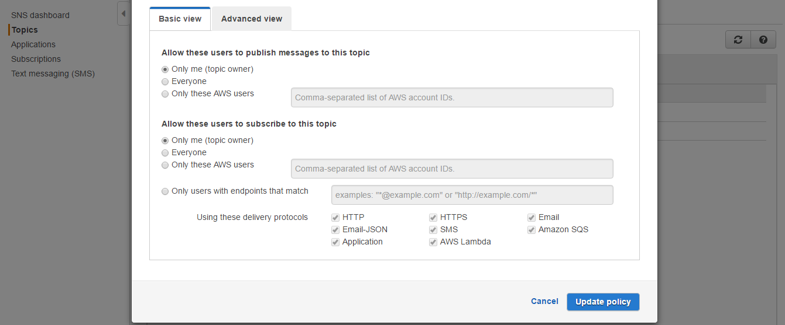

# S3 & GLACIER MANAGEMENT

## Objective

To understand the process of Creating and deleting S3 Buckets and Folders

## Procedure

Sign in to AWS Management Console and select **S3(Simple Storage Service)**

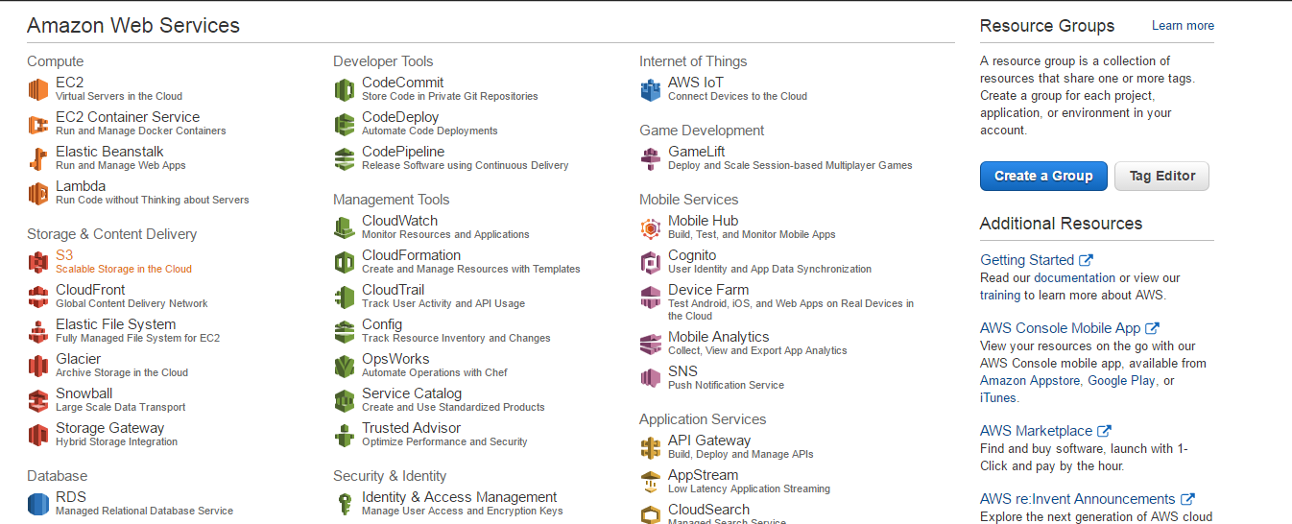

### Create Bucket

Click on **Create Bucket** button.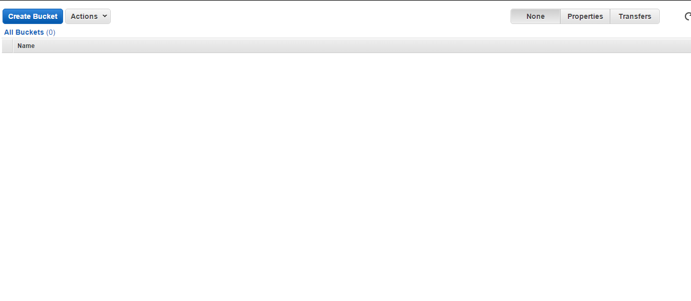

1. After clicking **Create Bucket** Button , give the bucket name and select the region in which you want to create bucket and click **Create**. 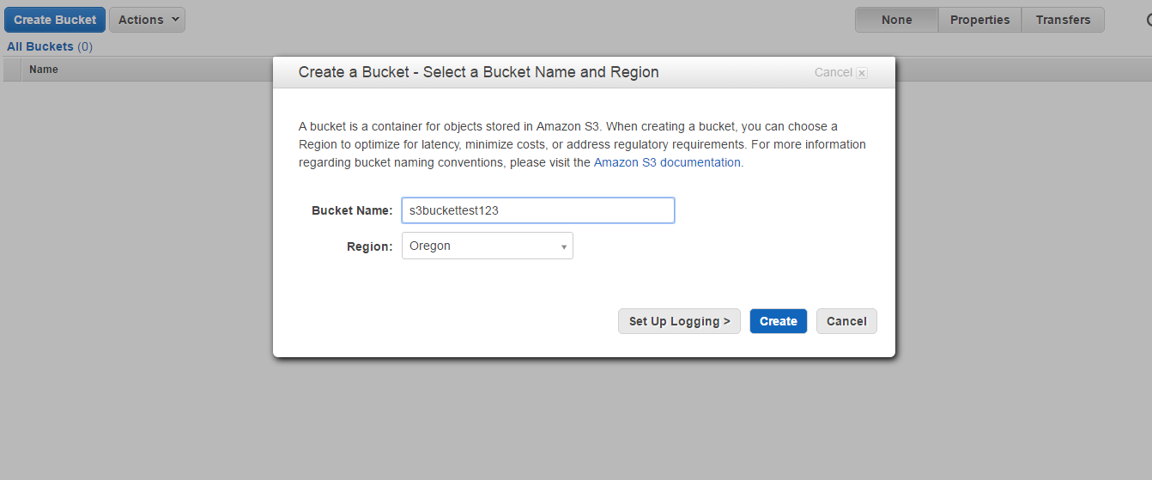
2. Here you can see that the Bucket named as s3buckettest123 has been created.

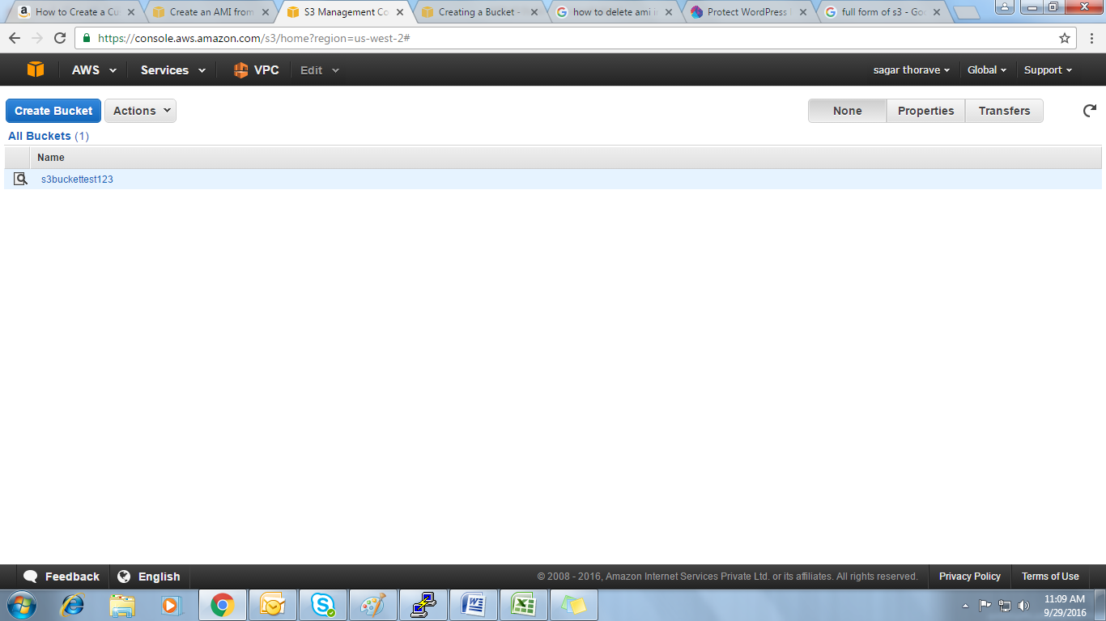

### Delete Bucket

1. Select the bucket you created and click on **Actions** and select **Delete Bucket**.

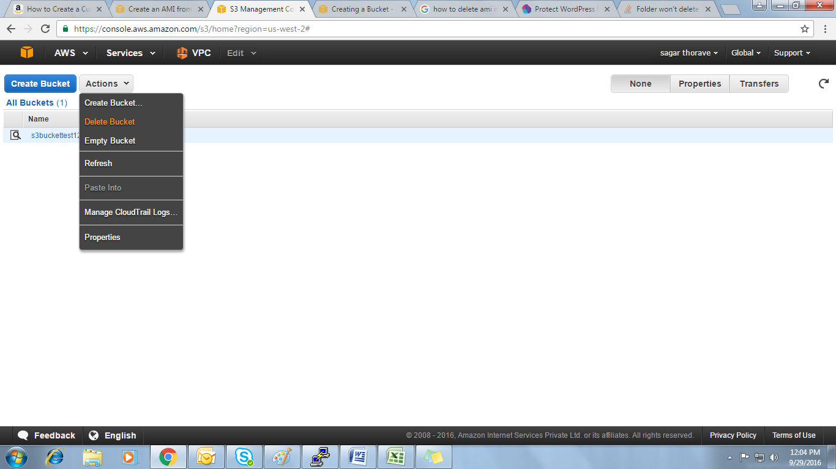

1. After selecting **Delete Bucket** option give the name of the bucket and click **Delete**, the bucket will be deleted.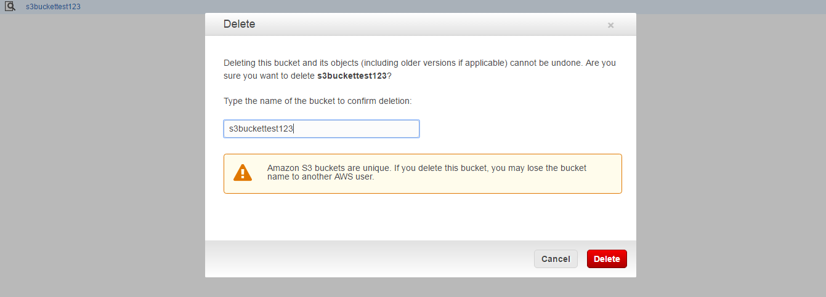

### Create Folder

1. Click on the bucket which you have created and then click on **Create Folder** button.

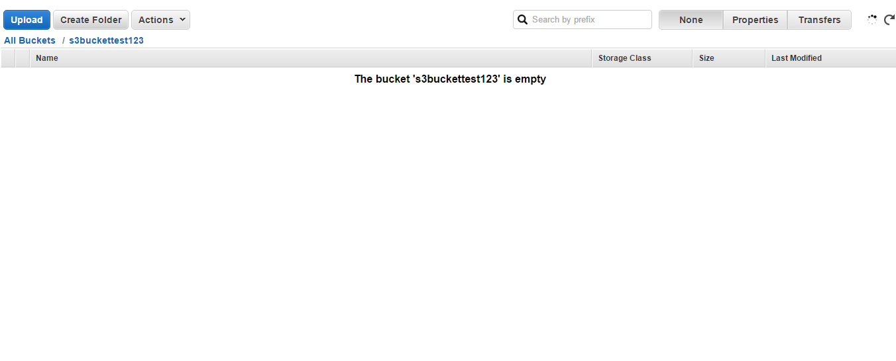

1. After clicking **Create Folder**,give the name of the folder you want to create in my case I have given finance.

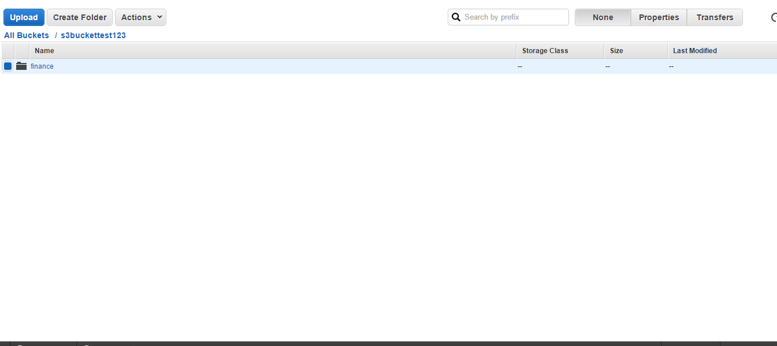

### Delete Folder

1. Select Folder you created and then click on **Actions** and select **Delete.**

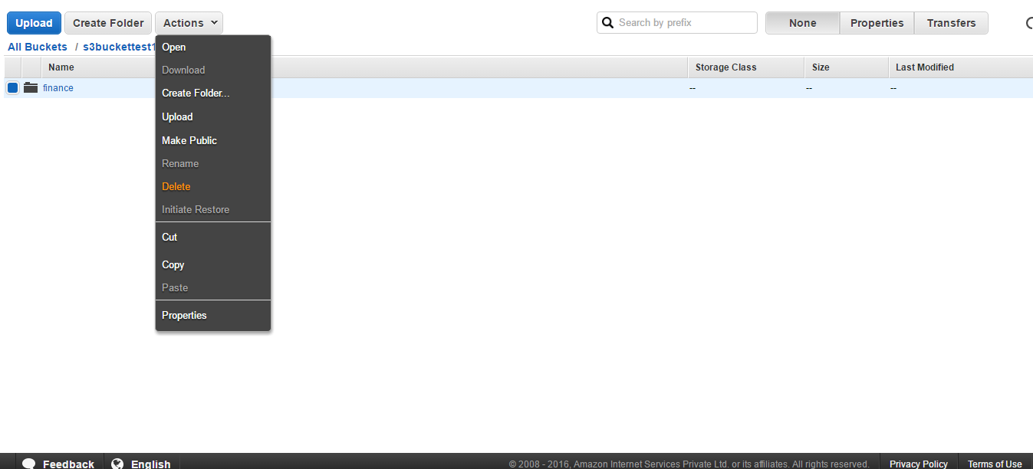

1. Click **yes** when prompted for Confirmation and then you can see that the folder named finance has been deleted.

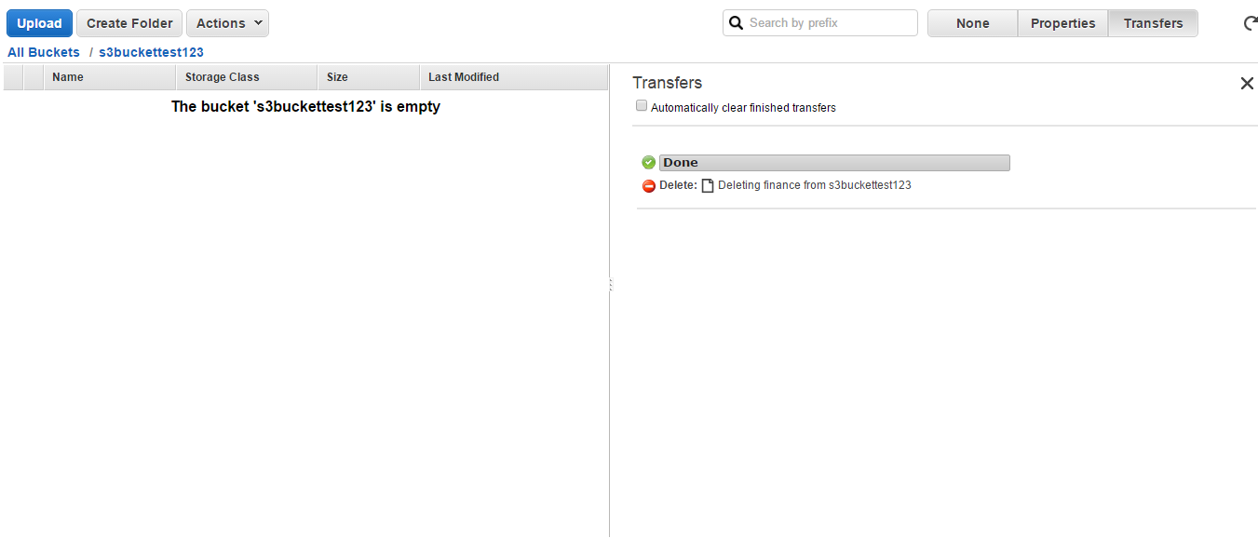

# EFS MANAGEMENT

## Configuration and management of EFS

## Mounting EFS to Linux EC2 instances

# CLOUD FORMATION

## Use of CloudFormation to facilitate support of MPS-supported AWS tasks (as defined in RACI)

# CLOUDWATCH MANAGEMENT

Amazon CloudWatch monitors your Amazon Web Services (AWS) resources and the applications you run on AWS in real time.

## Objective

To understand the process of AWS CloudWatch.

## Assumptions

* You’re having an AWS account.
* You're familiar with using the AWS CloudWatch console to launch instances.
* You have a default VPC in the region that you're using for this Getting Started exercise. If you don't have a default VPC, or if you want to mount your file system from a new VPC with new or existing security groups, you can still use this Getting Started exercise

## 11.3 Procedure

[Step 1: Enable Billing Alerts](http://docs.aws.amazon.com/AmazonCloudWatch/latest/monitoring/gs_monitor_estimated_charges_with_cloudwatch.html#gs_turning_on_billing_metrics)

[Step 2: Create a Billing Alarm](http://docs.aws.amazon.com/AmazonCloudWatch/latest/monitoring/gs_monitor_estimated_charges_with_cloudwatch.html#gs_creating_billing_alarm)

[Step 3: Check the Alarm Status](http://docs.aws.amazon.com/AmazonCloudWatch/latest/monitoring/gs_monitor_estimated_charges_with_cloudwatch.html#gs_checking_billing_alarm)

[Step 4: Edit a Billing Alarm](http://docs.aws.amazon.com/AmazonCloudWatch/latest/monitoring/gs_monitor_estimated_charges_with_cloudwatch.html#gs_editing_billing_alarm)

[Step 5: Delete a Billing Alarm](http://docs.aws.amazon.com/AmazonCloudWatch/latest/monitoring/gs_monitor_estimated_charges_with_cloudwatch.html#gs_deleting_billing_alarm)

### Enable Billing Alerts

* Enable billing alerts, so that we can monitor estimated AWS charges and create an alarm using billing metric data.
* After you enable billing alerts for the first time, it takes about 15 minutes before you can view billing data and set billing alarms.

**To enable monitoring of your estimated charges**

1. Open the Billing and Cost Management console at [https://console.aws.amazon.com/billing/home?#](https://console.aws.amazon.com/billing/home?#/).
2. In the navigation pane, choose **Preferences**.
3. Select **Receive Billing Alerts**.

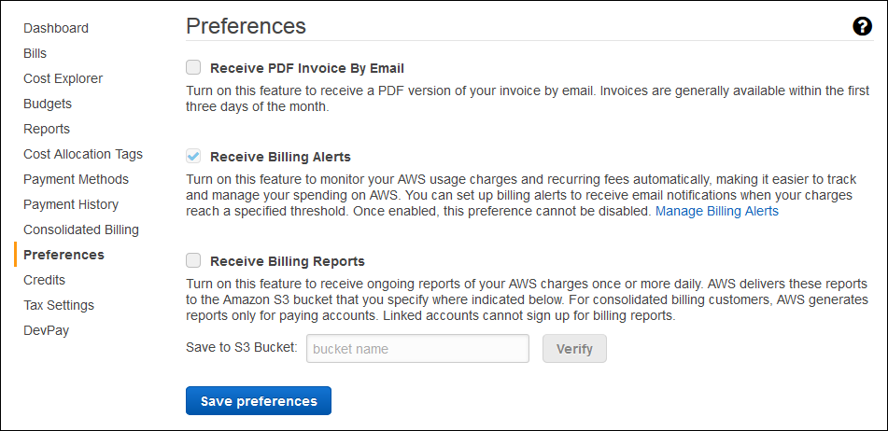

1. Choose **Save preferences**.

### Create a Billing Alarm

* After enabled billing alerts, create a billing alarm.
* An alarm will sends an email message when your estimated charges for AWS exceed a specified.

**To create a billing alarm**

1. Open the CloudWatch console at <https://console.aws.amazon.com/cloudwatch/>.
2. Change the region to US East (N. Virginia).
3. In the navigation pane, choose **Alarms**, **Billing**.
4. For **whenever my total AWS charges for the month exceed**, specify the monetary amount (for example, 200) that must be exceeded to trigger the alarm and send an email notification.

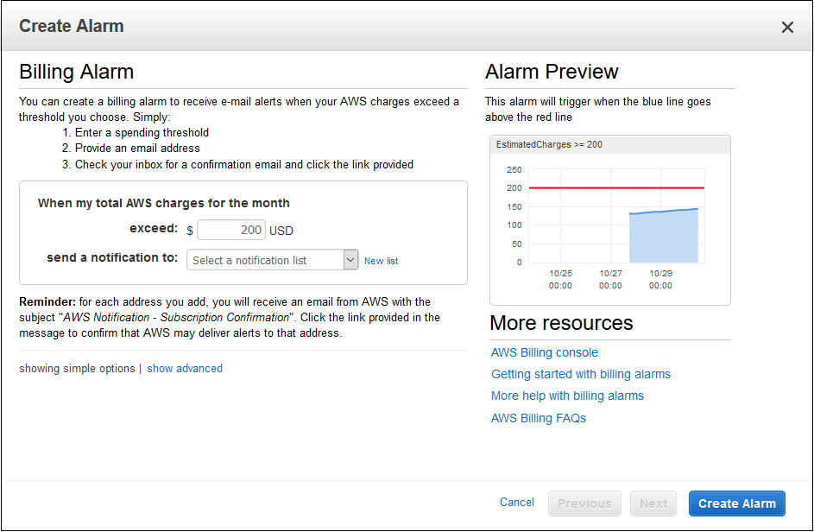

1. For **send a notification to**, choose an existing notification list or create a new one.
2. Choose **Create Alarm**.

## 11.3.3 Check the Alarm Status

* Check the status of the billing alarm that you just created.

**To check the alarm status**

1. Open the CloudWatch console at <https://console.aws.amazon.com/cloudwatch/>.
2. Change the region to US East (N. Virginia). Billing metric data is stored in this region and reflects worldwide charges.
3. In the navigation pane, choose **Alarms**, **Billing**.
4. Select the check box next to the alarm after the subscription is confirmed, refresh the console to show the updated status.

## Edit a Billing Alarm

1. Open the CloudWatch console at <https://console.aws.amazon.com/cloudwatch/>.
2. If necessary, change the region to US East (N. Virginia). Billing metric data is stored in this region and reflects worldwide charges.
3. In the navigation pane, choose **Alarms**, **Billing**.
4. Select the check box next to the alarm and then choose **Actions**, **Modify**.
5. For **whenever my total AWS charges for the month exceed**, specify the new amount that must be exceeded to trigger the alarm and send an email notification.
6. Choose **Save Changes**.

## Delete a Billing Alarm

You can delete your billing alarm if you no longer need it.

**To delete a billing alarm**

1. Open the CloudWatch console at <https://console.aws.amazon.com/cloudwatch/>.
2. If necessary, change the region to US East (N. Virginia). Billing metric data is stored in this region and reflects worldwide charges.
3. In the navigation pane, choose **Alarms**, **Billing**.
4. Select the check box next to the alarm and then choose **Actions**, **Delete**.
5. When prompted for confirmation, choose **Yes, Delete**.

# ROUTE 53 MANAGEMENT

## DNS Zone Management and Configuration

## Domain Registration through AWS

# CLOUDFRONT MANAGEMENT

Amazon Cloud Front is a web service that speeds up distribution of your static and dynamic web content, such as .html, .css, .php, and image files, to your users.

## Objective

To provide high level guidance’s to setup the AWS CloudFront on AWS Cloud.

## 14.2 Procedure

To setup a AWS Cloud Front, you need to complete the following steps:

Step 1: [Create a S3 Bucket with objects and grant public access](http://docs.aws.amazon.com/AmazonS3/latest/dev/HostingWebsiteOnS3Setup.html)

Step 2: [Create a Cloud Front Web Distribution](http://docs.aws.amazon.com/AmazonCloudFront/latest/DeveloperGuide/GettingStarted.html)

Step 3: [Test your Links](http://docs.aws.amazon.com/AmazonCloudFront/latest/DeveloperGuide/GettingStarted.html)

**Steps to follow**

Go to Services on the AWS Management Console and under Networking & Content Delivery select Cloud Front

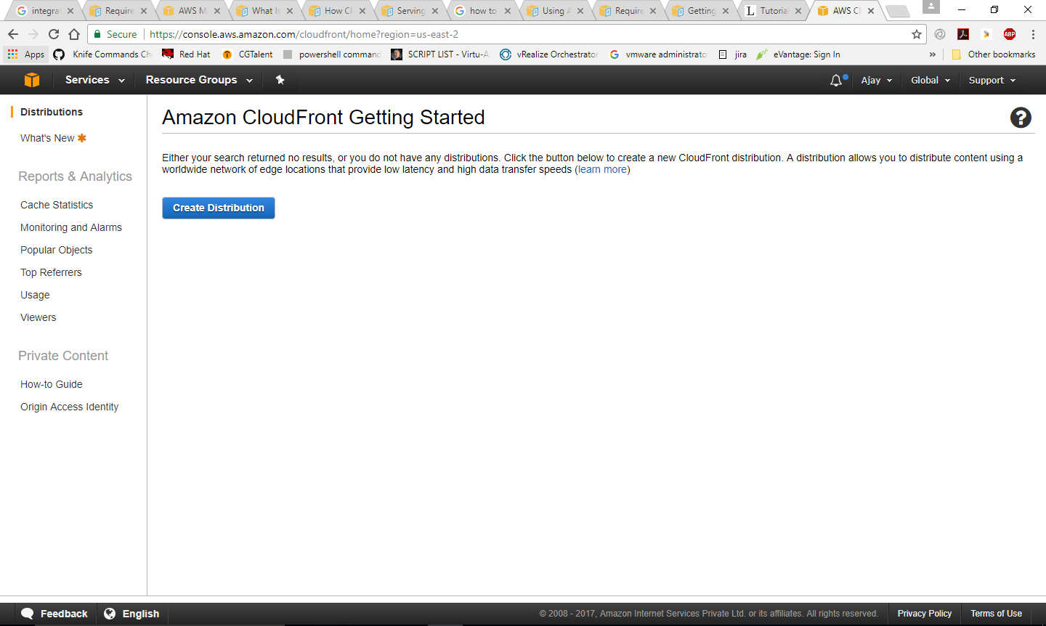

Select delivery method for content

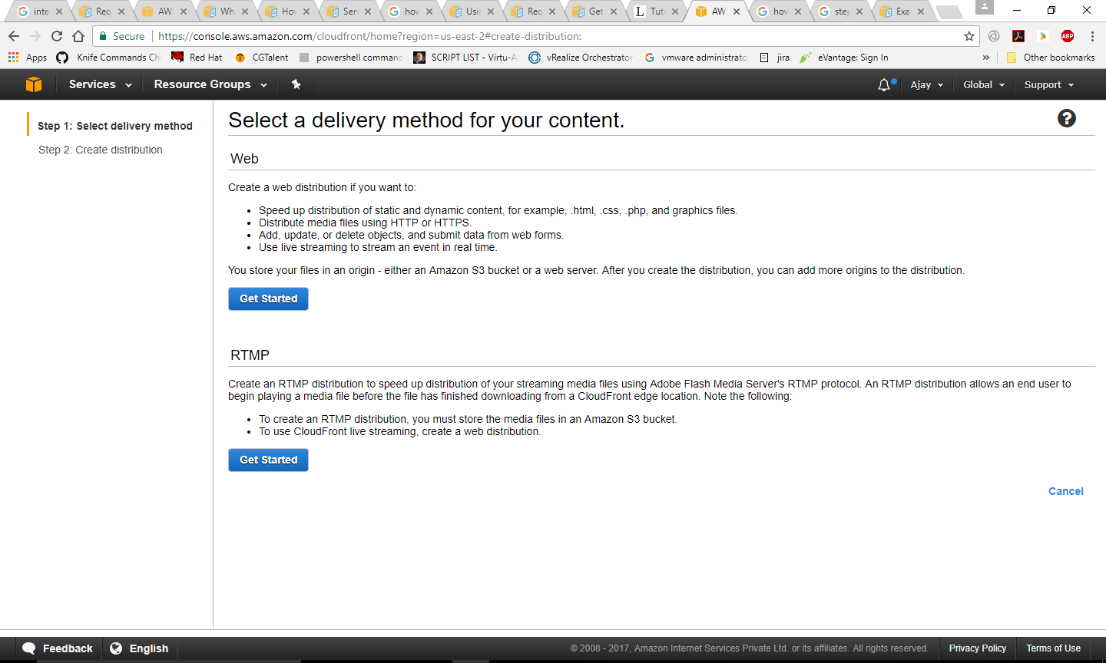

Give the origin domain name

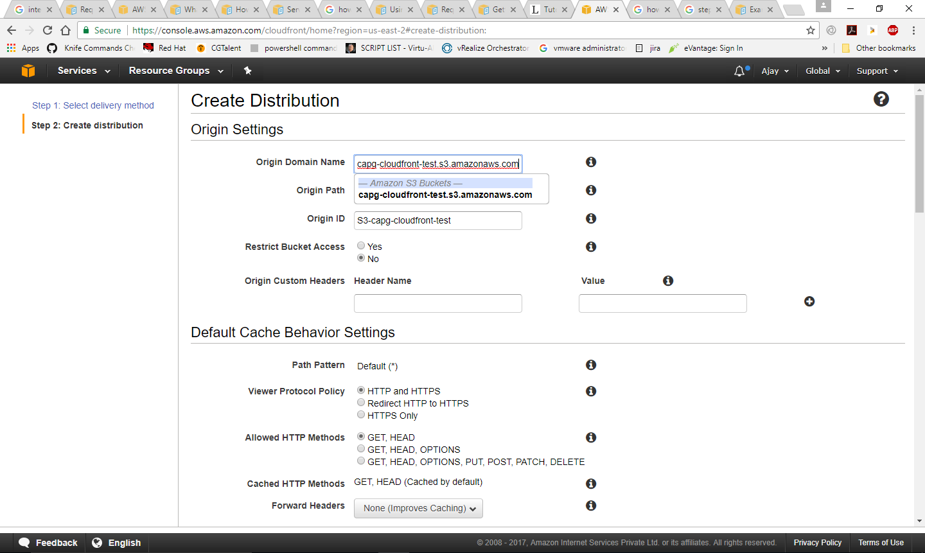

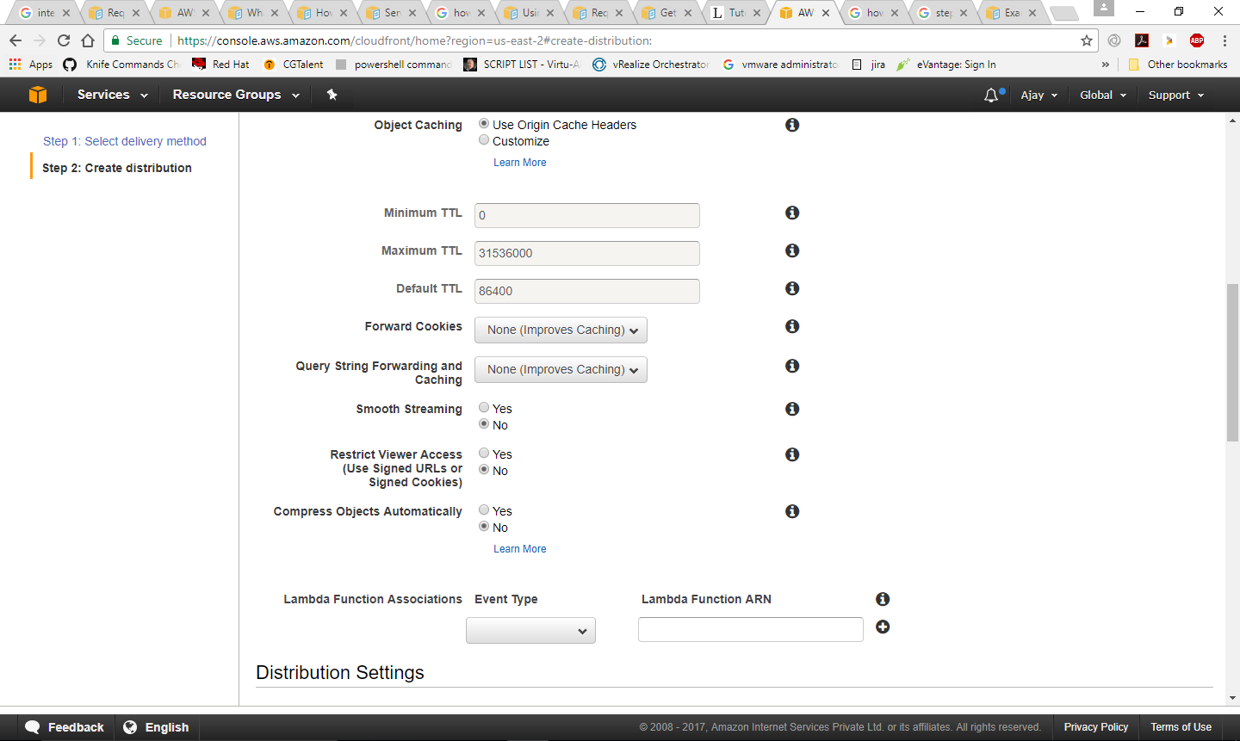

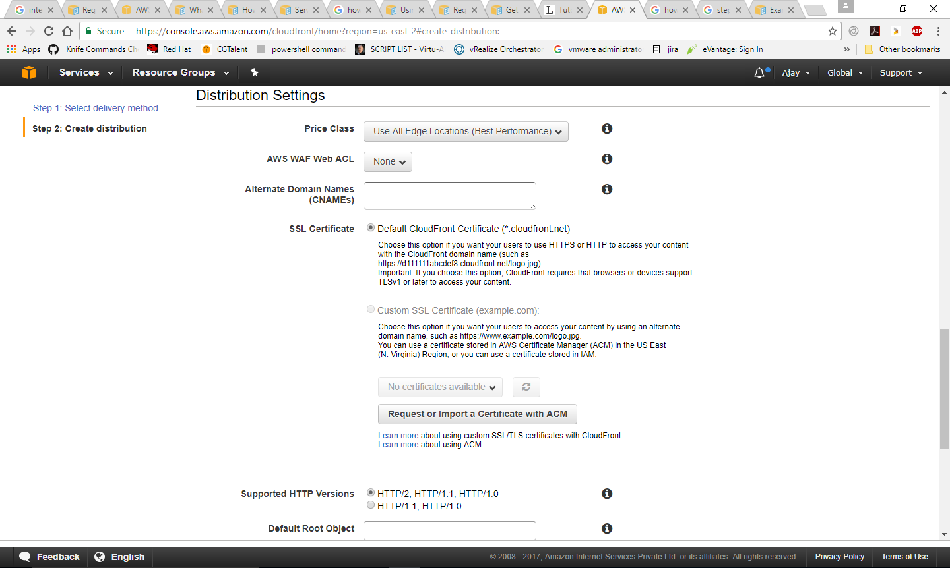

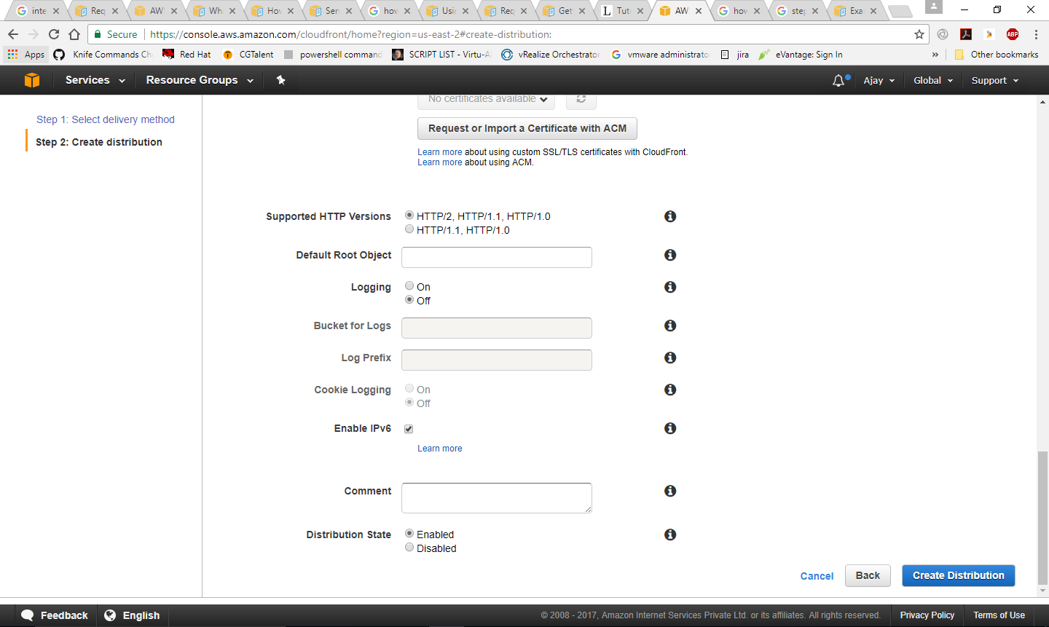

Wait till the status changes to Deployed from In Progress

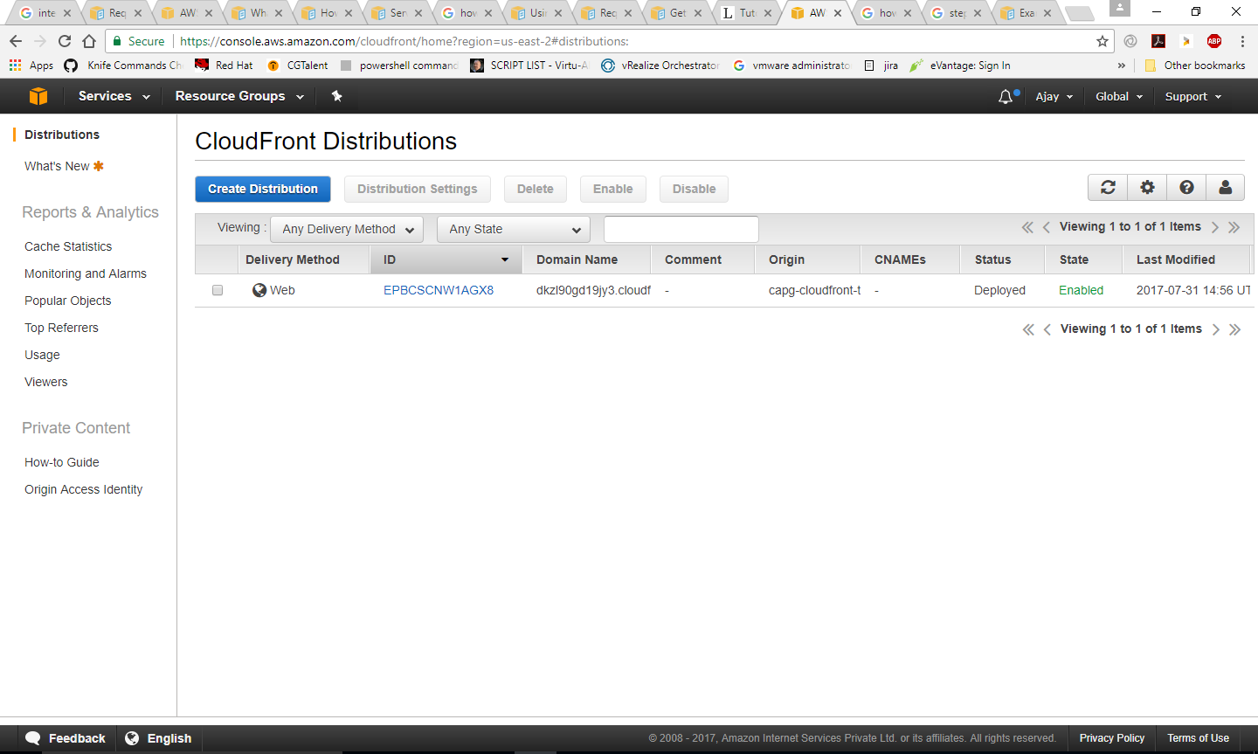

**Test Your Links**

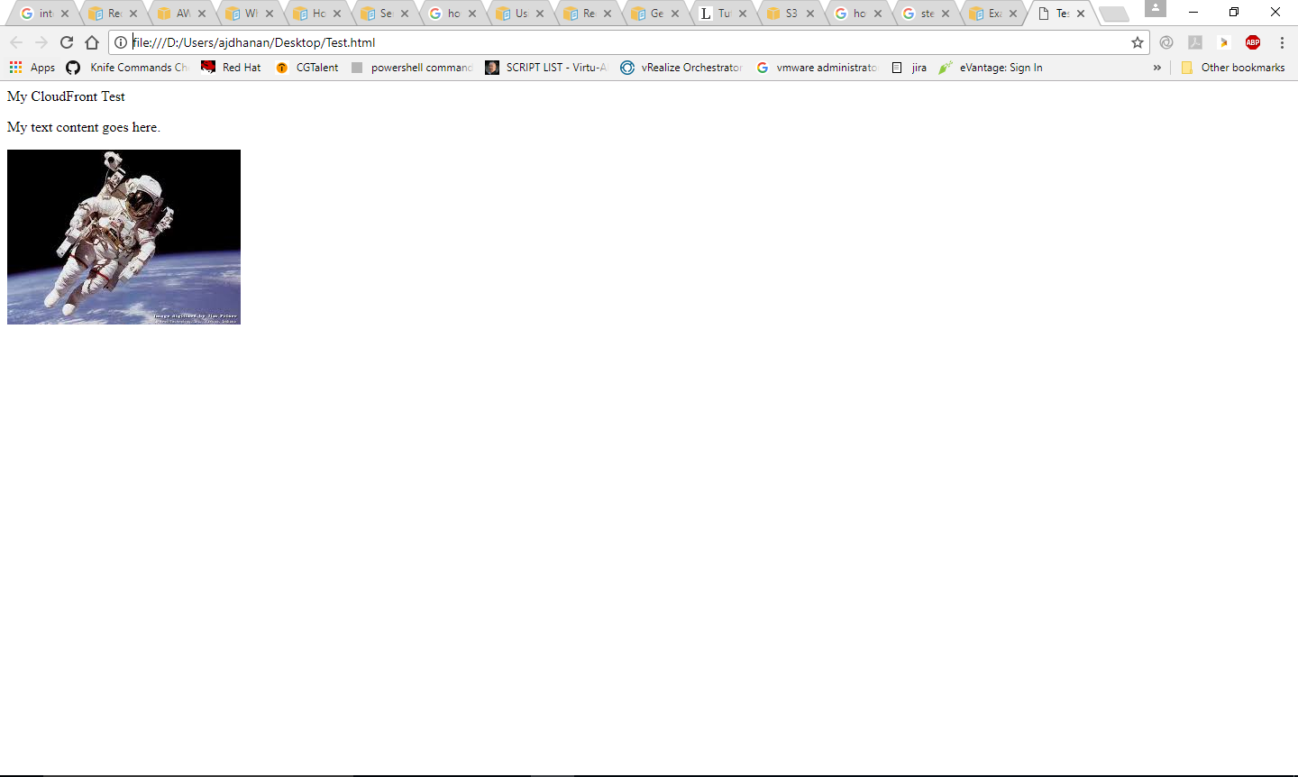

# OPSWORKS

## 15.1 AWS OpsWork (Chef Automate)

A Chef Automate server manages nodes in your environment, stores information about those nodes, and serves as a central repository for your Chef cookbooks.

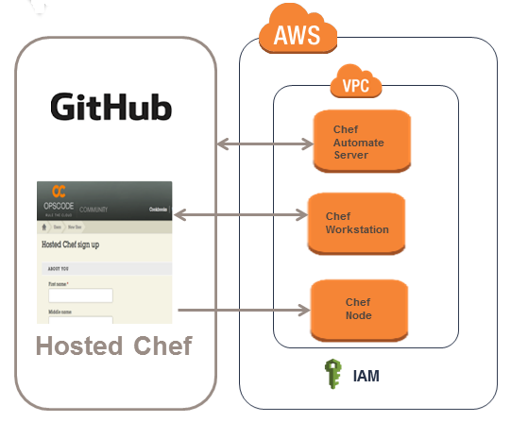

As per the above diagram, we have used AWS Chef Automated Server, Chef Workstation and Chef Node on AWS inside the VPC. Chef Automate server interacts as follows

* Opscode hosted Chef interacts with Chef Automated Server
* Chef Automated Server interacts with GitHub
* The Chef workstation interacts with the hosted chef used to manage the chef nodes.

### Objective

Understand the process to create AWS OpsWork (Chef Automate)

### 15.1.2 Pre-requisite

* AWS account, VPC configuration, EC2 Keypair and Security groups , IAM user access
* Chef servers, workstation and node 1 is already running

|  |  |  |
| --- | --- | --- |
| **Server Name** | **Instance Type** | **OS Type** |
| Chef Server | Hosted Chef Server |  |
| Chef Workstation | Micro instance | RHEL 7.2 |
| Node 1 | Micro instance | RHEL 7.2 |

* Git / GitHub

### Procedure

#### Create a Chef Automate Server

1. Open the AWS Management console
2. Click on **OpsWorks** under **Services**.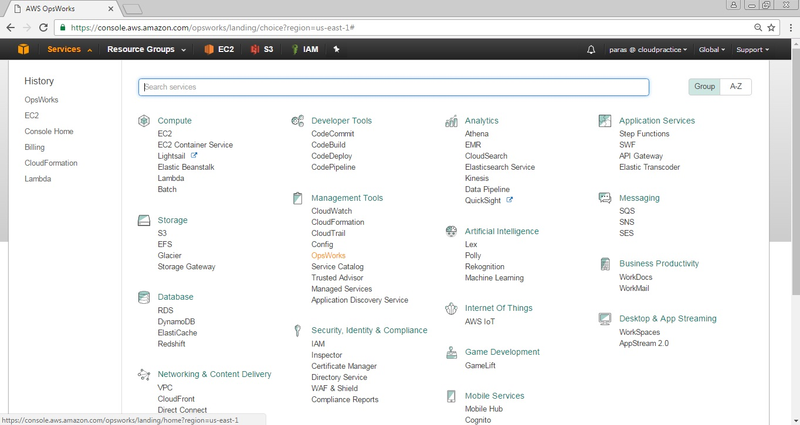
3. From **AWS OpsWork** console, click on **Go to OpsWorks for Chef Automate** button.

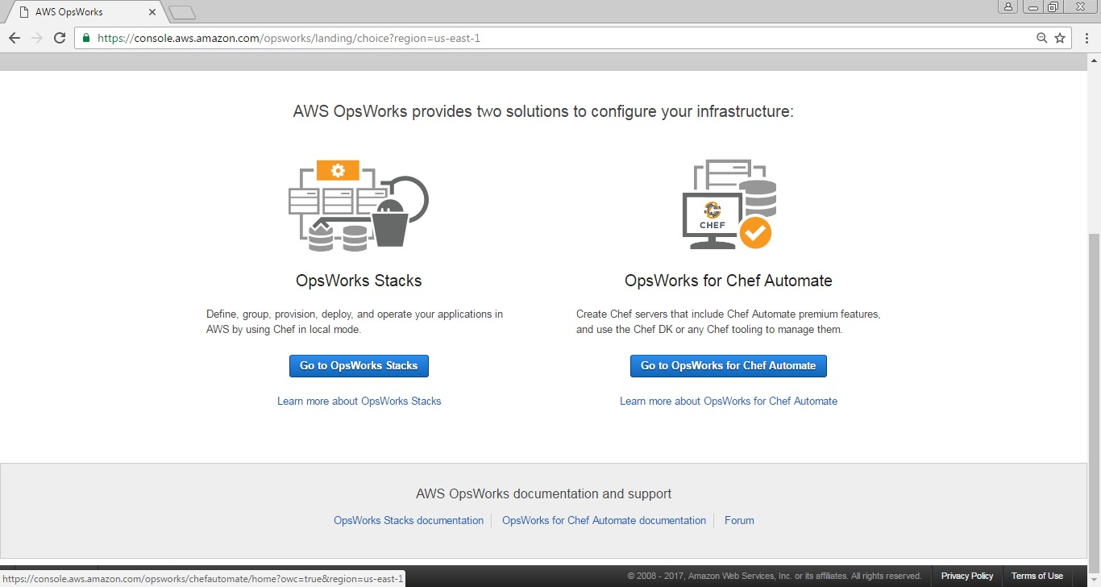

1. Provide the **Chef Automate server name,** select the **Chef Automate server region** where you want to host it, **EC2 intstance type (** select EC2 type as t2.medium as it supports upto 50 nodes **)** and click on **NEXT** button.

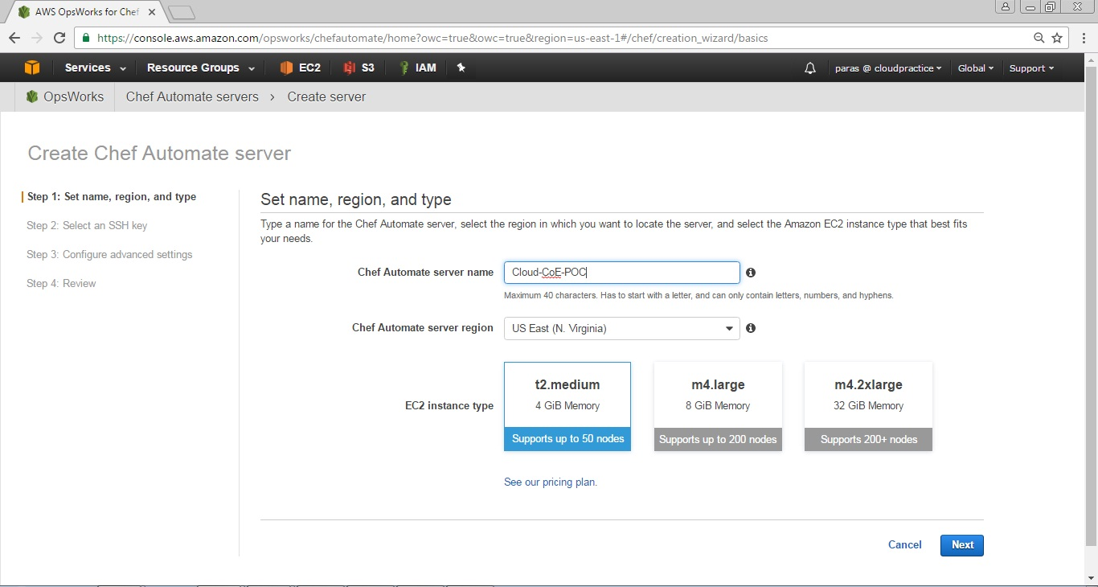

1. In the **SSH Key**, select the option **Use an existing EC2 Key pair.** In **EC2 key pair** select the key you want to use for Chef Automate Server ( Ex. awspoc key pair).

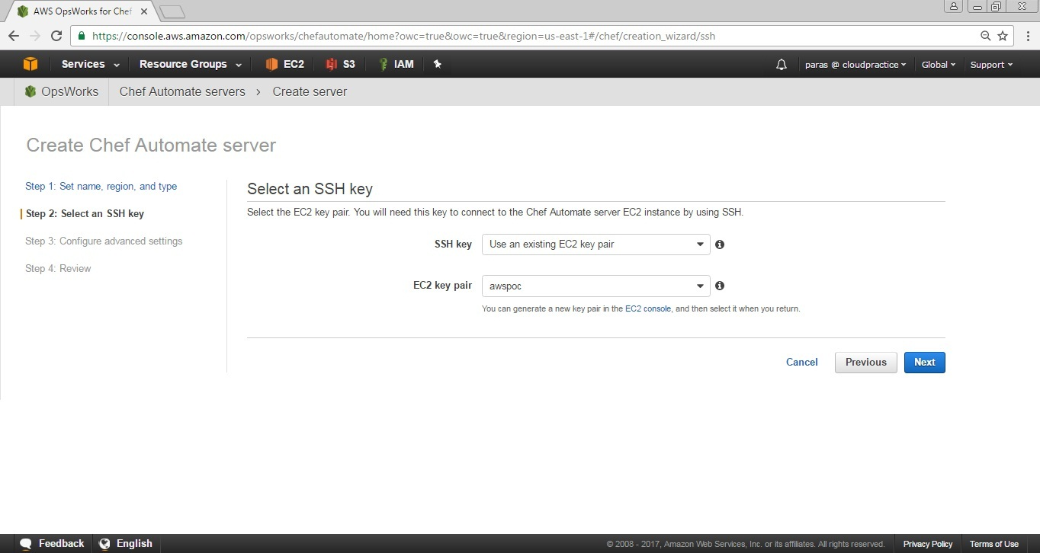

1. In **Configure advanced settings**, Under **Network and security** select your **VPC, Subnet, Security group** (like in my case it is default group that opens port 443 – https and port 22 -ssh), Select **Service role**  Generate a new one and the same applies to **Instance Profile**.

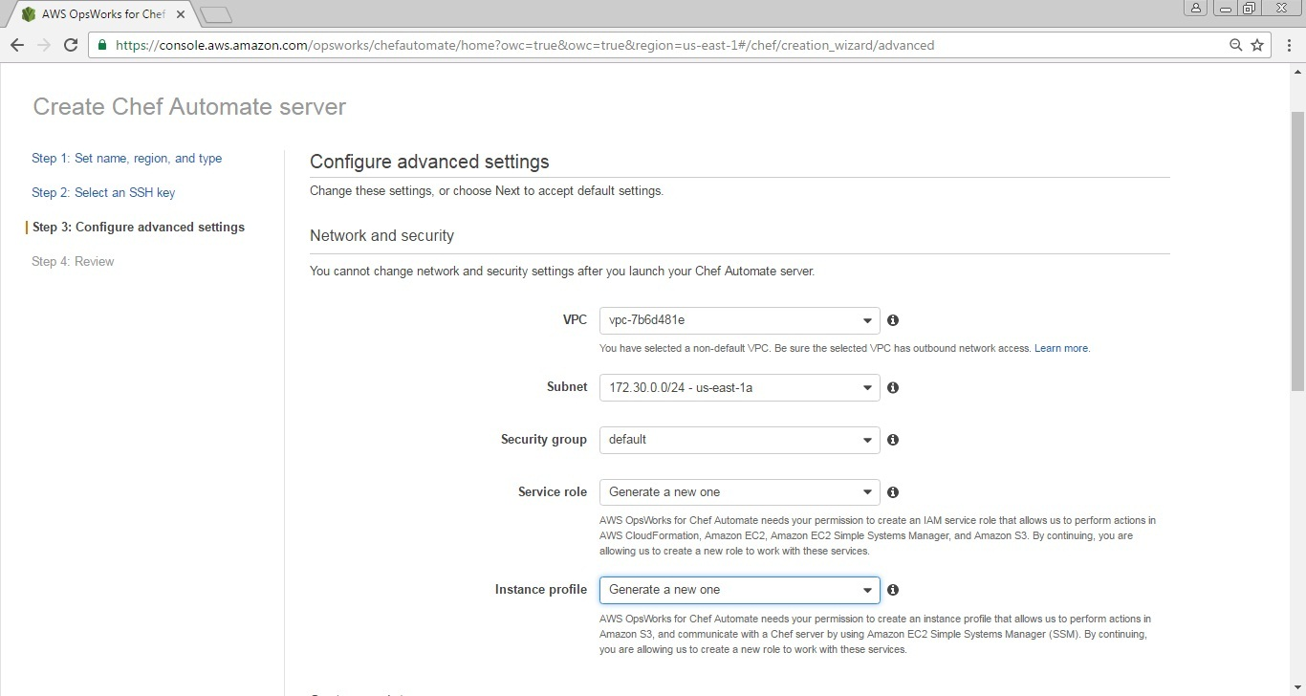

1. In **Configure advanced settings**, Under **System maintenance** selects the **Start day** and **Start time.** At the selected day and time your server will be offline.

Under **Automated backup,** Select **Yes** *(if required only)* radio button for **Enable automated backup,** select the **Frequency, Start time** and **Number of generations to keep.** Now click on **Next** button.

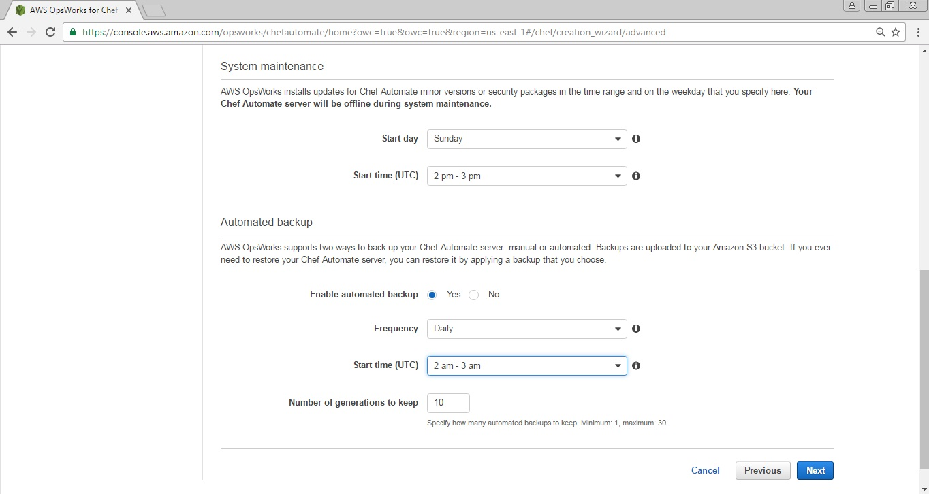

1. Review your configuration and click on **Launch** button

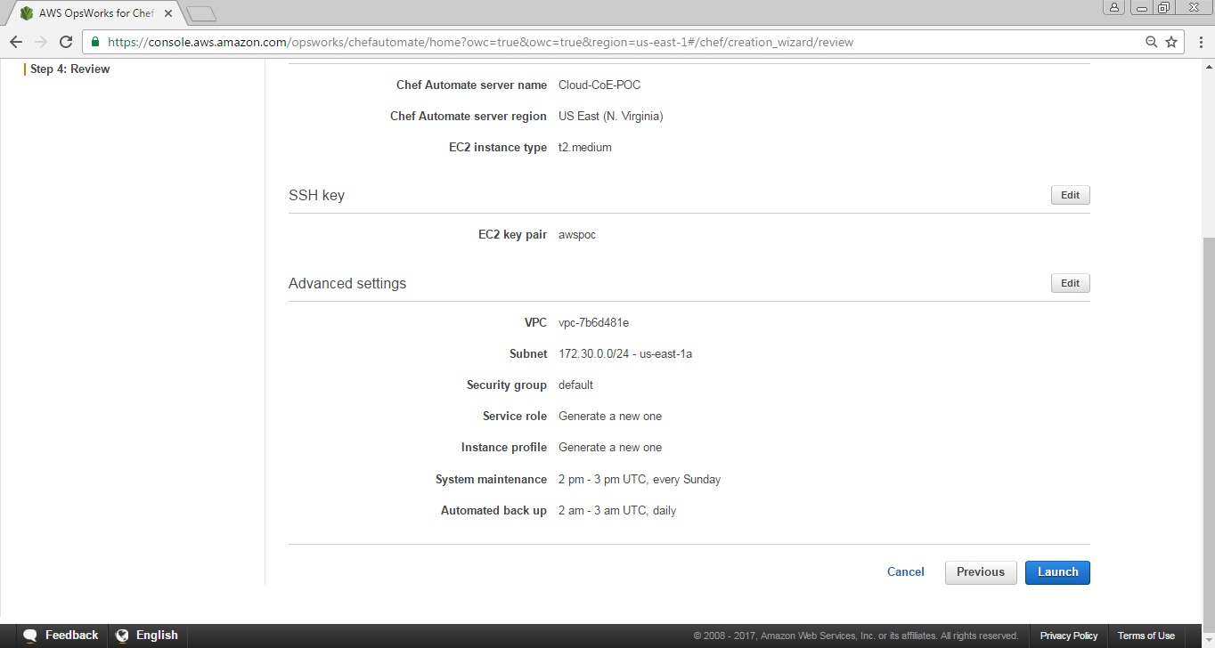

1. Your Chef Automated server has launched successfully. Now press ***Download Credentials*** and ***Download starter kit***.

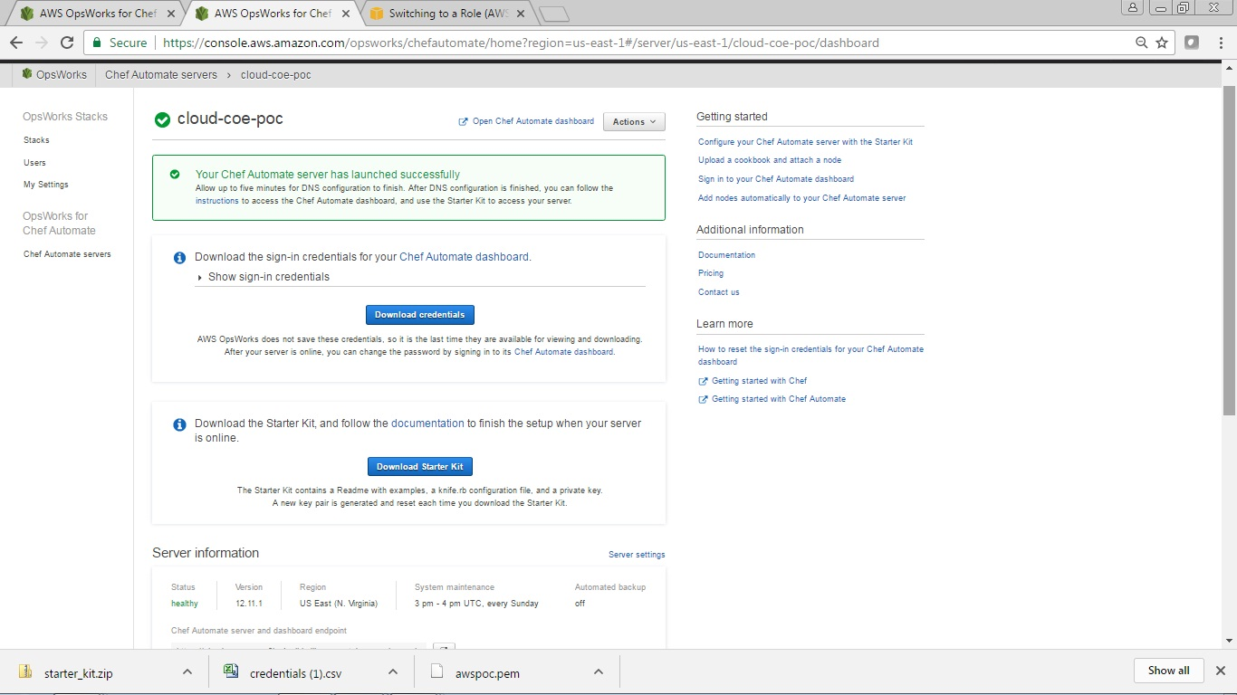

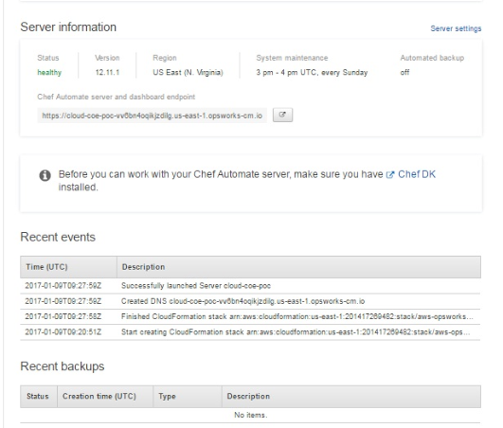

1. Open the Chef automation server using putty and login as ec2-user

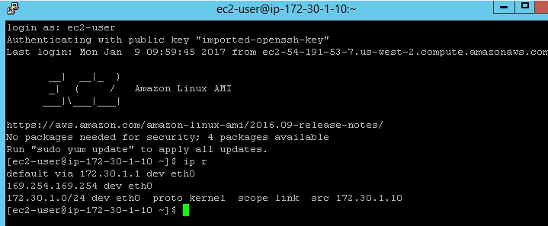

1. Use the downloaded starter kit and copy it in the Chef Automate Server

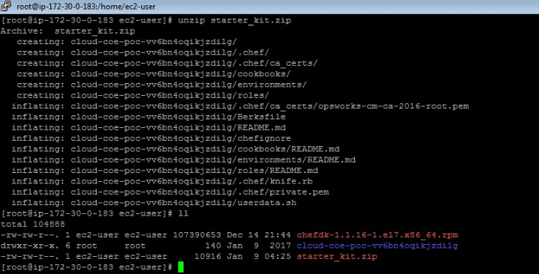

1. Verify the [ChefDK](https://downloads.chef.io/chef-dk/) installation using chef commands on the Terminal

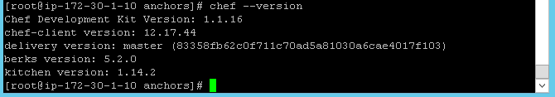

1. Open the browser and copy paste the URL provided in the above (step 9) inside the server information section

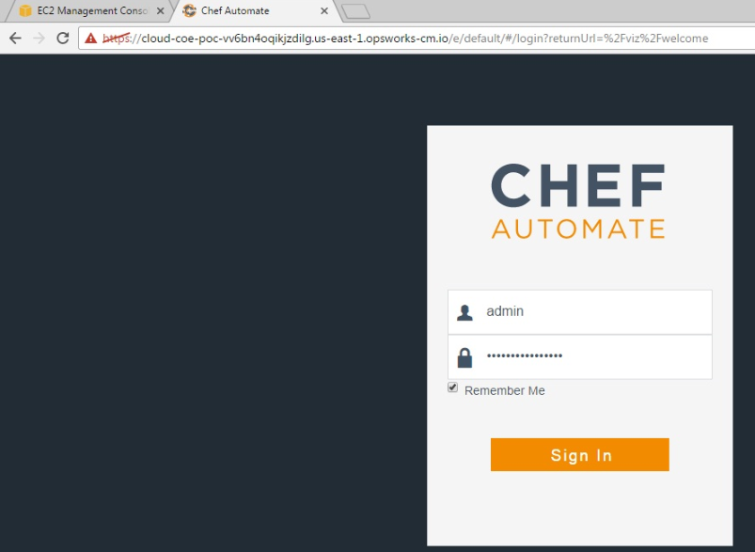

1. Open the browser and verify the Chef Automate on hosted Chef. Below screen shows default view

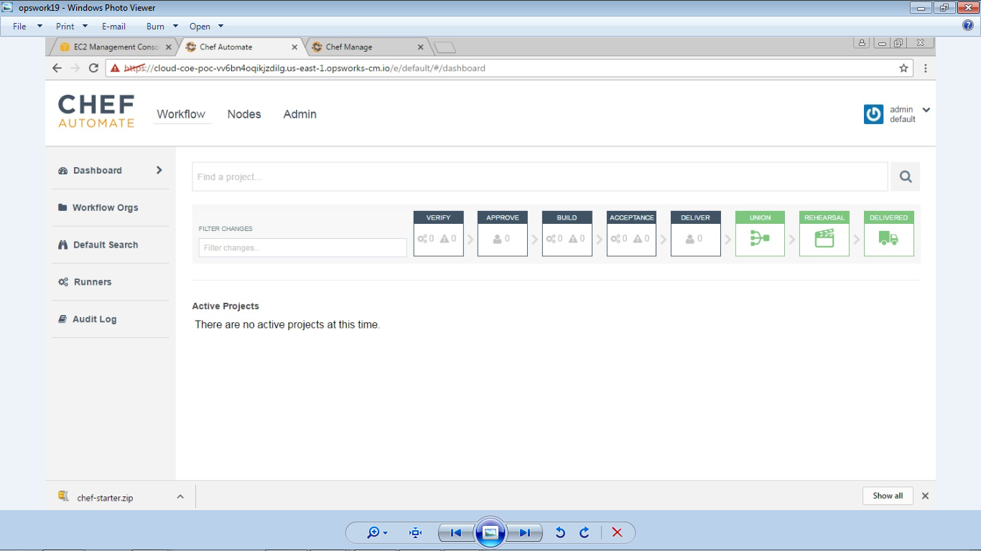

1. Open AWS Management console to view the AWS Chef automation server instance details

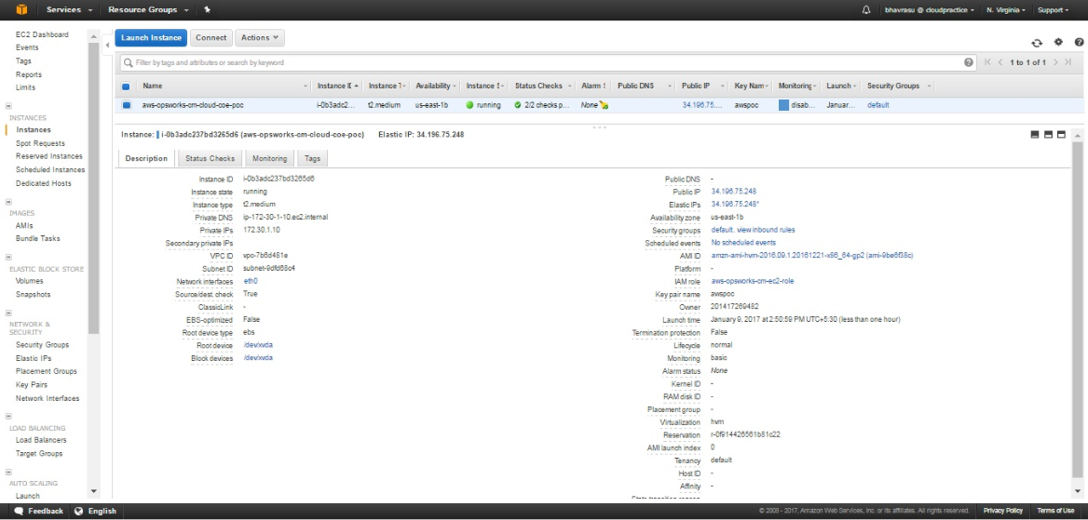

**Note:** You can integrate Chef Automate server using either Git / GitHub option

#### Integrating Git Repository with Chef Automate Server

1. Now install Git on the Chef automation server using following commands

**Commands**

* yum install git
* git
* delivery clone mytest --ent=default --org=imscloudcoe --user=admin --server=cloud-coe-poc-vv6bn4oqikjzdilg.us-east-1.opsworks-cm.io
* delivery

1. On the Chef Automate server generate the rsa key as follows

* ssh-keygen -t rsa -b 4096
* cd /root/.ssh/
* vim id_rsa.pub
* cd /root/
* vi id_rsa.pub

1. Open the Chef Automate web UI, make an admin user and copy the generated rsa key details in the SSH-Key text box. This will connect the chef automate server to the Chef Automate web

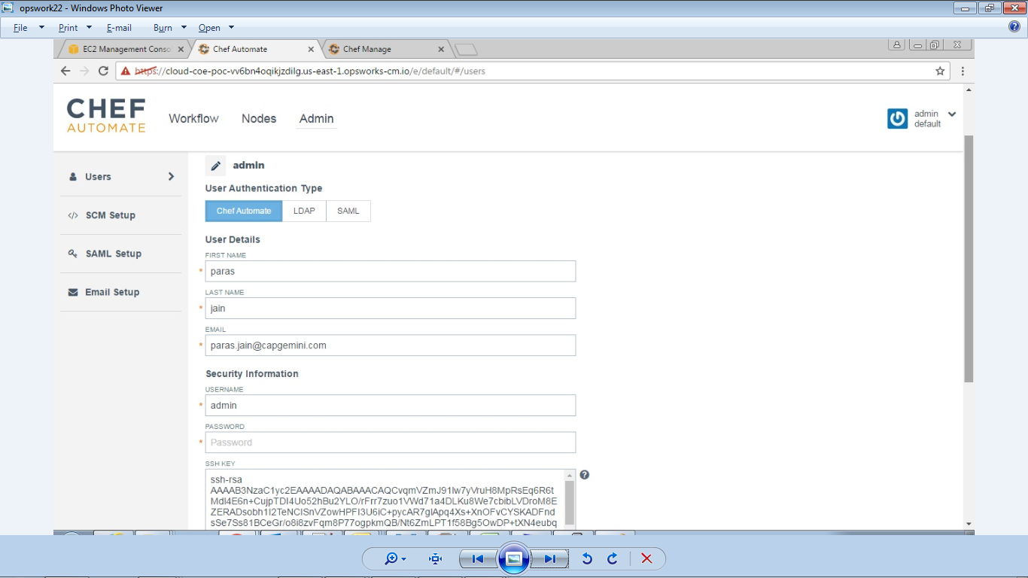

1. Execute the following commands in the chef automated server console

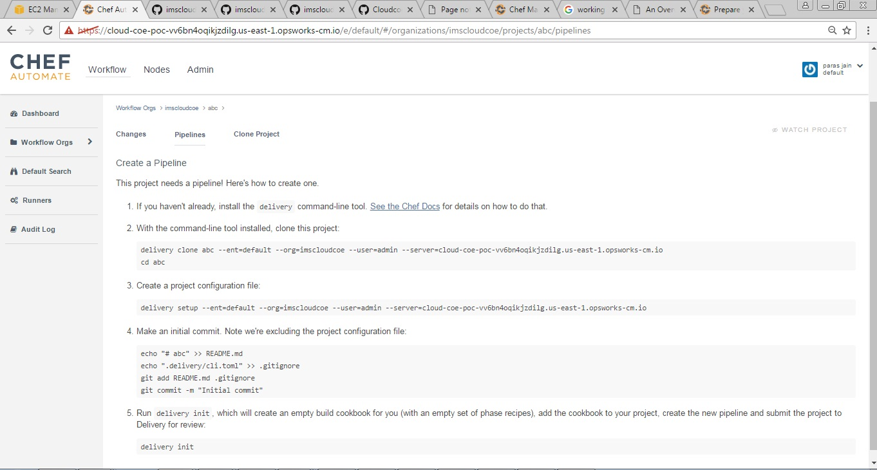

1. After running the above commands, you will get the first pipeline (*imscloudcoe*) step as shown below on the Chef Automate GUI

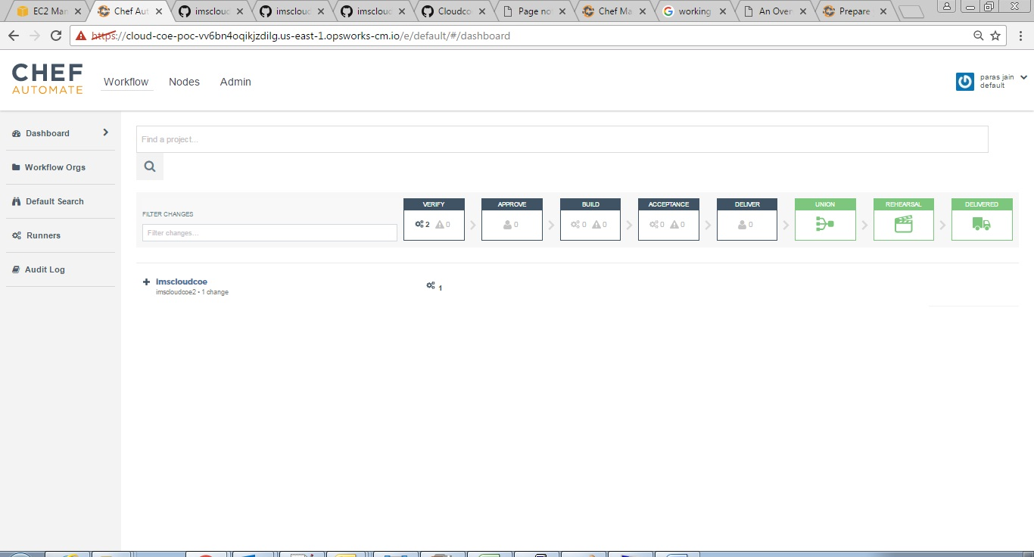

In this way, we can integrate the Git within the Chef Automate Server. We can also integrate the hosted GitHub with Chef automate Server as shown below.

**GitHub Access**

1. GitHub Details
2. Token Generation
3. Sample Project

#### Integrating GitHub Repository (Hosted) with Chef Automate Server

1. Go to Chef Automate web UI, Select **Admin** tab, click on SCM setup from the left panel, select GitHub tab and give your GitHub details as shown below

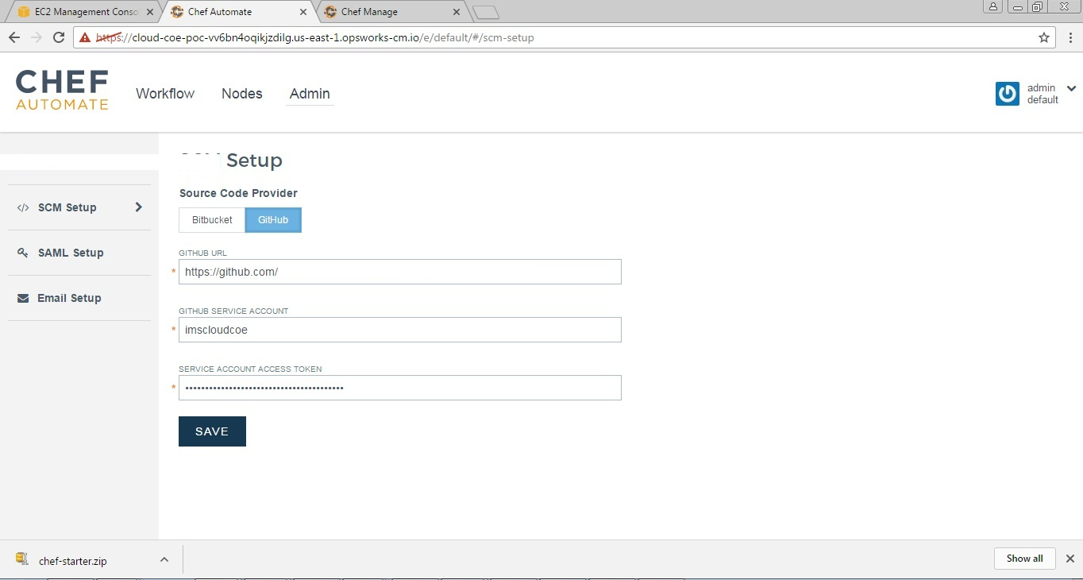

1. Click on Save button
2. Login to GitHub, download the certificate from your GitHub.
3. On the URL menu, Click on lock button (before https) a drop down menu will appear click on Details link.

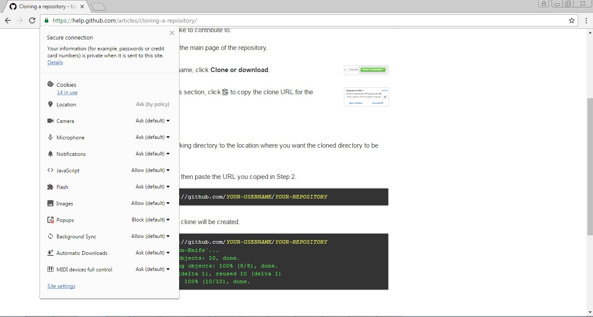

1. Click on View certificate button

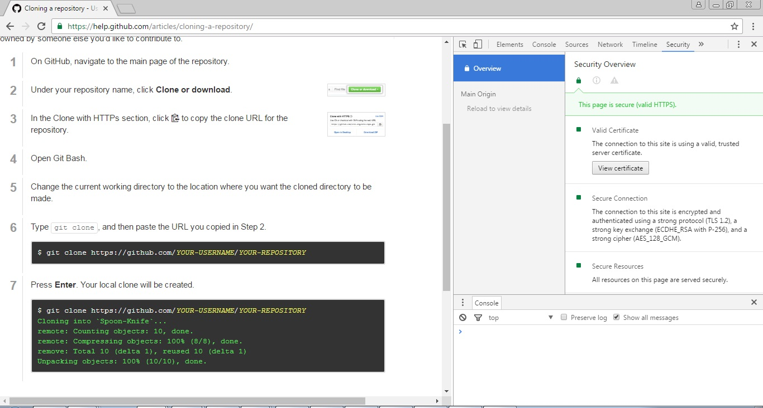

1. Now click on **Copy to file** button

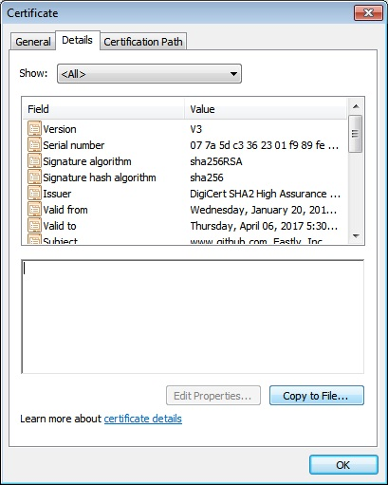

1. Select **Base-64 encoded X.509 (.CER)** radio button , click on **Next** button

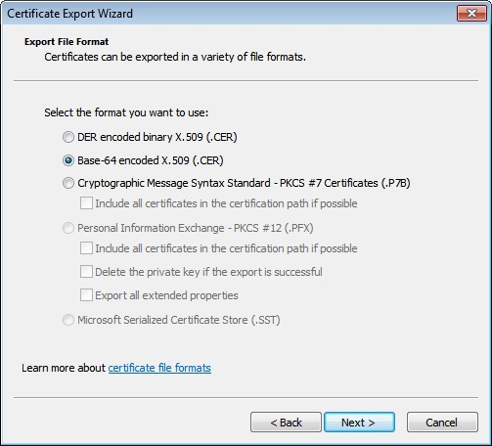

1. Click on **Browse** button and provide the location where you want to save it

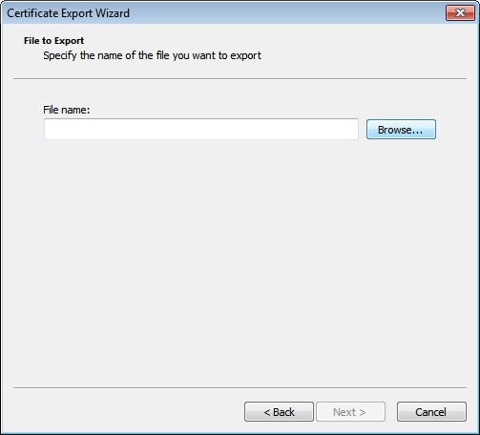

1. Provide the **Filename** and click on **Save** Button

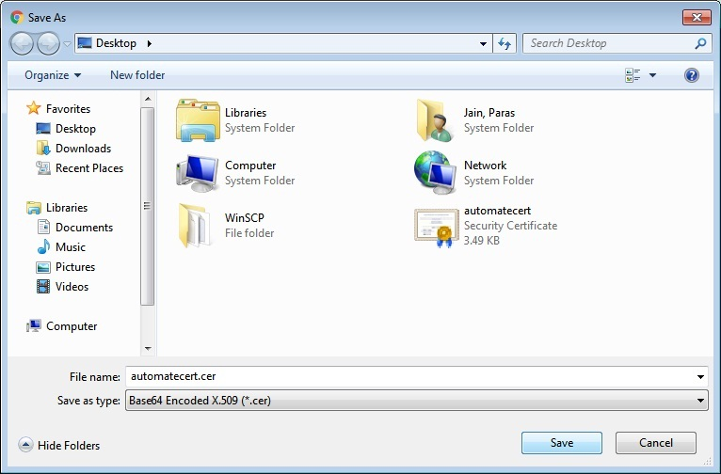

1. Now move the certificate to the following location in chef automate server **/etc/pki/ca-trust/source/anchors/**
2. Login into your chef automate server as a root user and run the following commands
   1. yum install ca-certificates
   2. update-ca-trust force-enable
   3. cd /etc/pki/ca-trust/source/anchors/
   4. update-ca-trust extract
3. Create a new GitHub-integrated project, the project repository in GitHub must have at least one commit
4. Run the following command in chef automate server
   1. git init

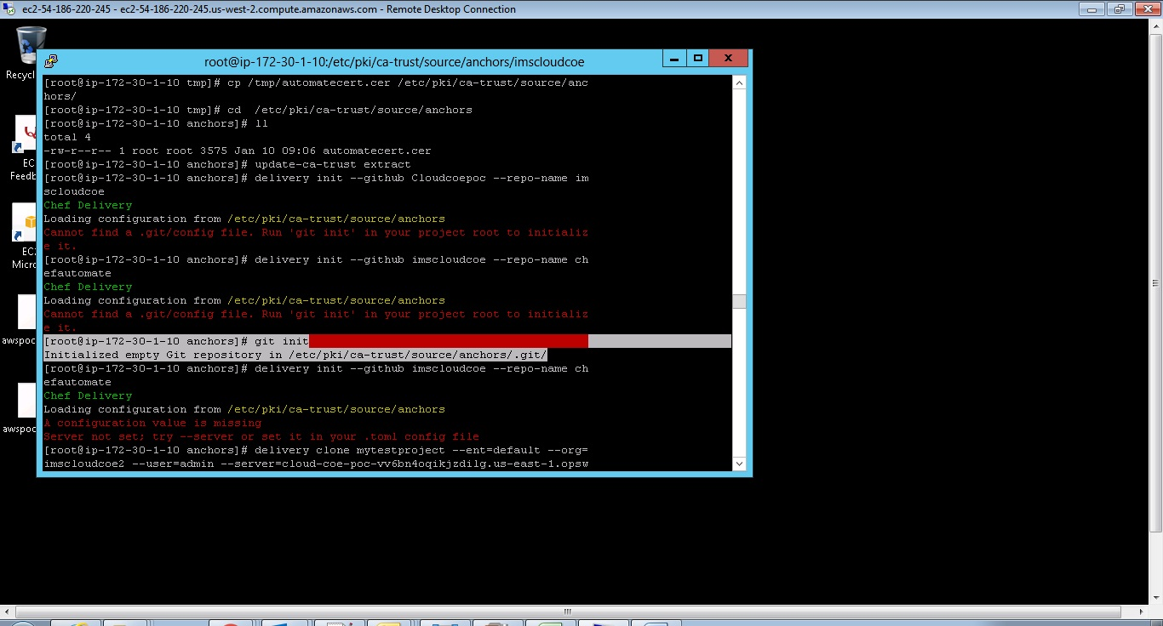

* 1. delivery clone mytestprotect --ent=default --org=imscloudcoe2 --user=admin --server=cloud-coe-poc-vv6bn4oqikjzdilg.us-east-1.opsworks-cm.io

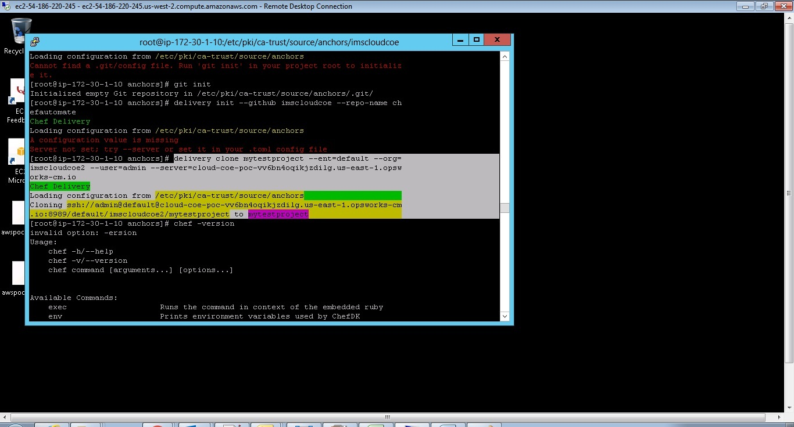

* 1. delivery setup --ent=default --org=imscloudcoe2 --user=admin --server=cloud-coe-poc-vv6bn4oqikjzdilg.us-east-1.opsworks-cm.io

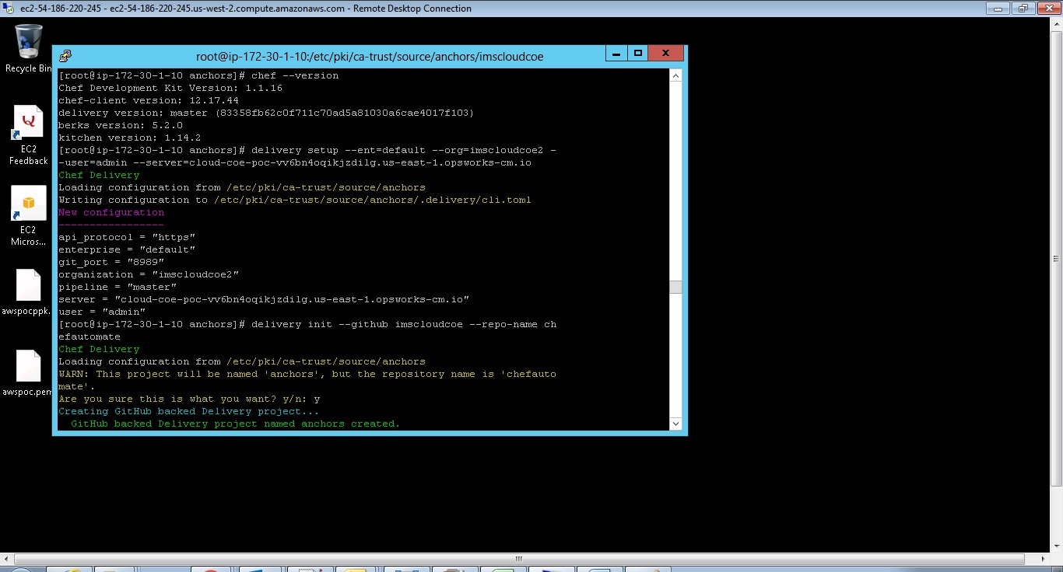

* 1. git clone <https://github.com/Cloudcoepoc/imscloudcoe.git>
  2. delivery init --github Cloudcoepoc --repo-name imscloudcoe

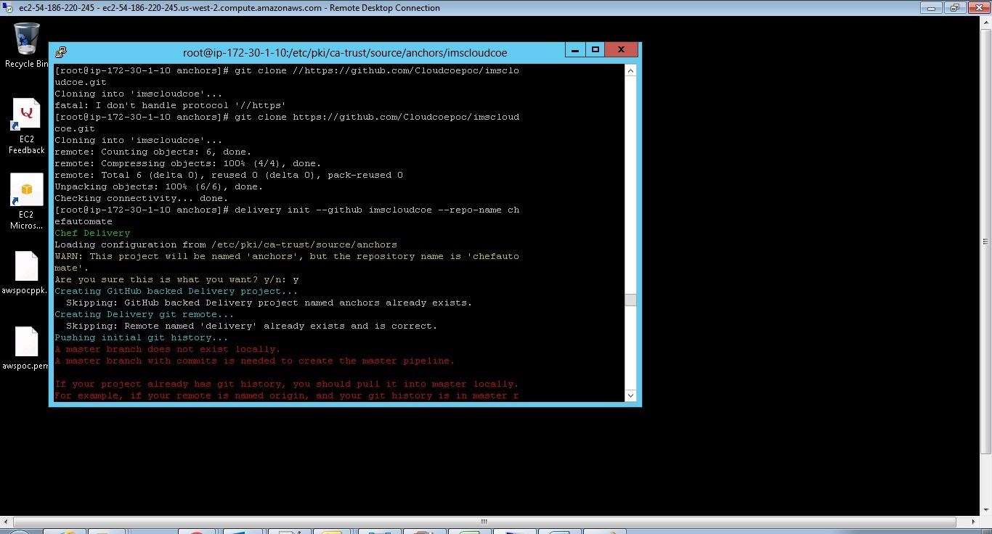

* 1. git status
  2. git add imscloudcoe
  3. git commit -m "imscoecloud"
  4. git push origin master

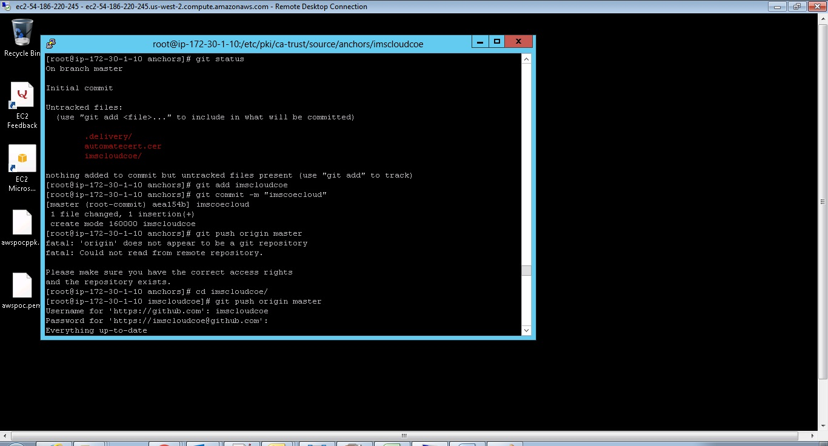

* 1. git status

Files are pushed to Chef Automated Server

#### Delete Chef Automate Server

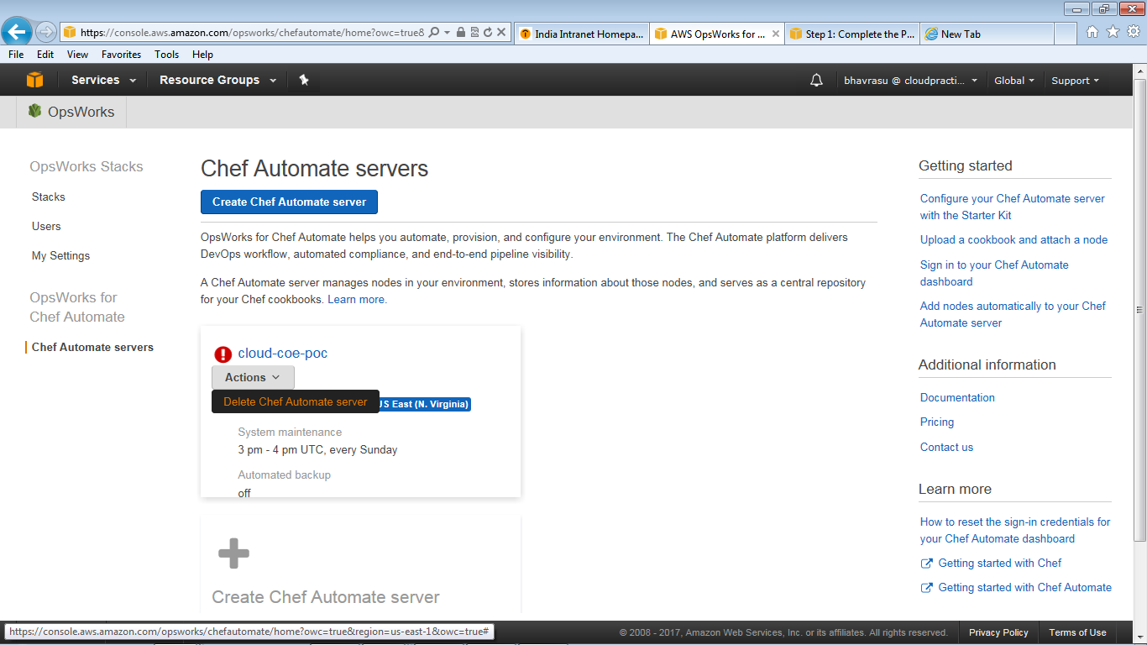

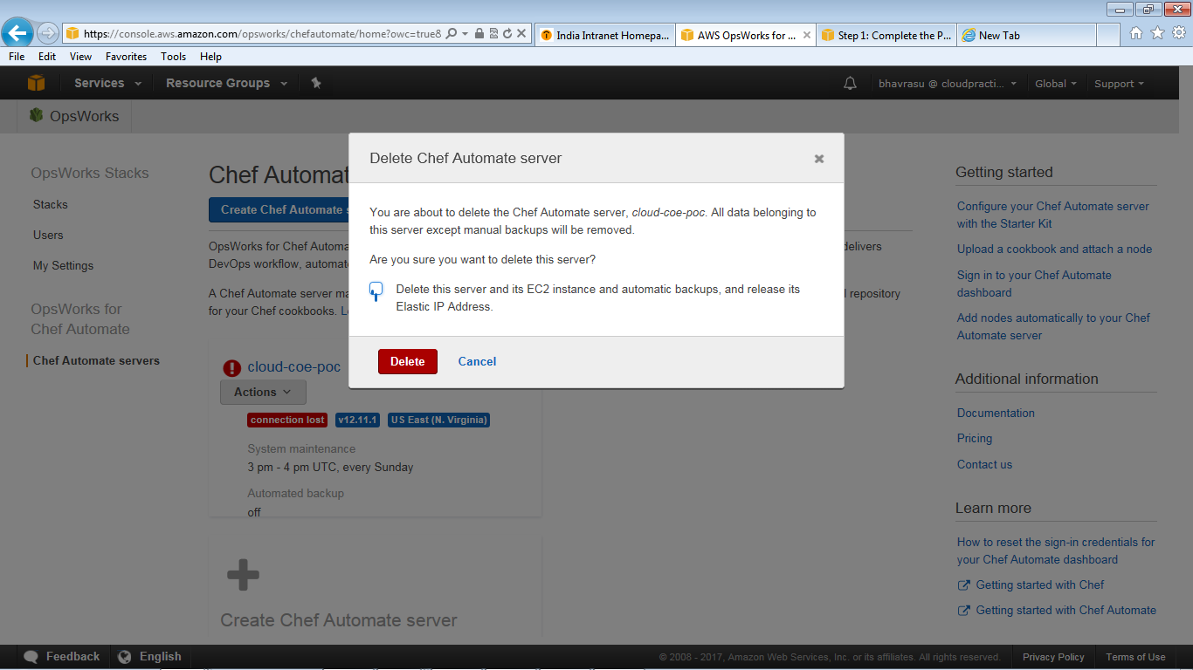

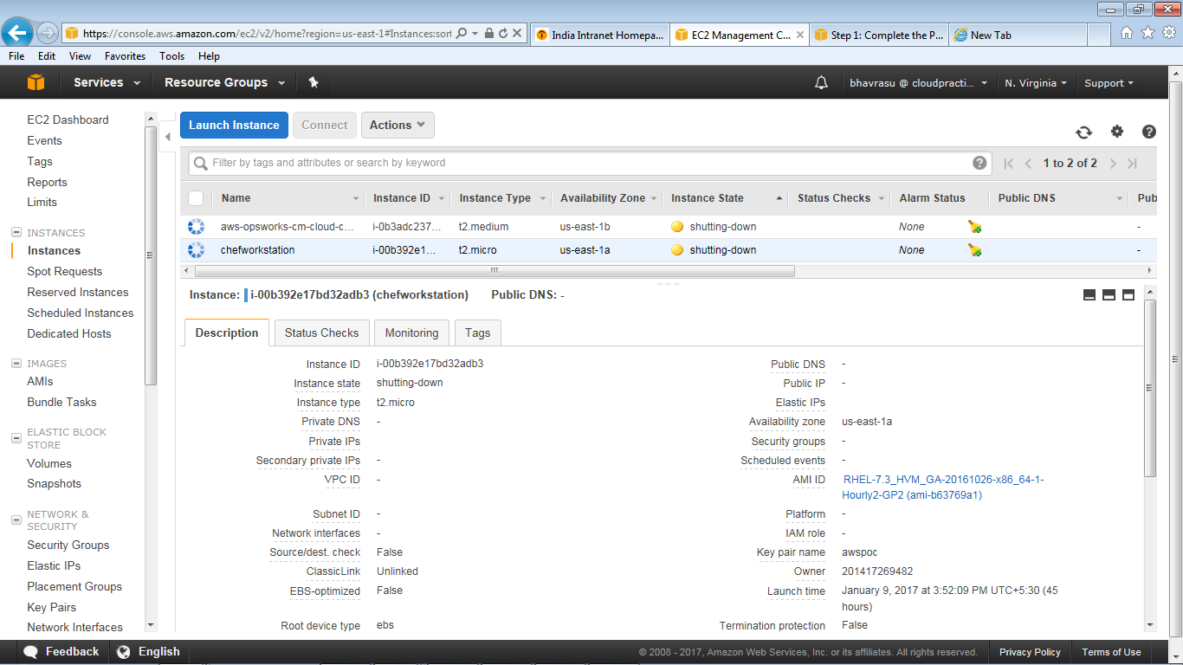

## AWS OpsWork Stacks

### Objective

Understand the process to create AWS OpsWork Stacks

### Pre-requisite

AWS account, VPC configuration, IAM user access (attach the AWSOpsWorksFullAccess and AmazonS3FullAccess)

### Procedure

#### 15.2.3 .1 Create a Create a Stack

1. Open the AWS Management console
2. Click on **OpsWorks** under **Services**.



1. From **AWS OpsWork** console, click on **Go to OpsWorks Stacks** button.



1. Click on **Add your first stack** button

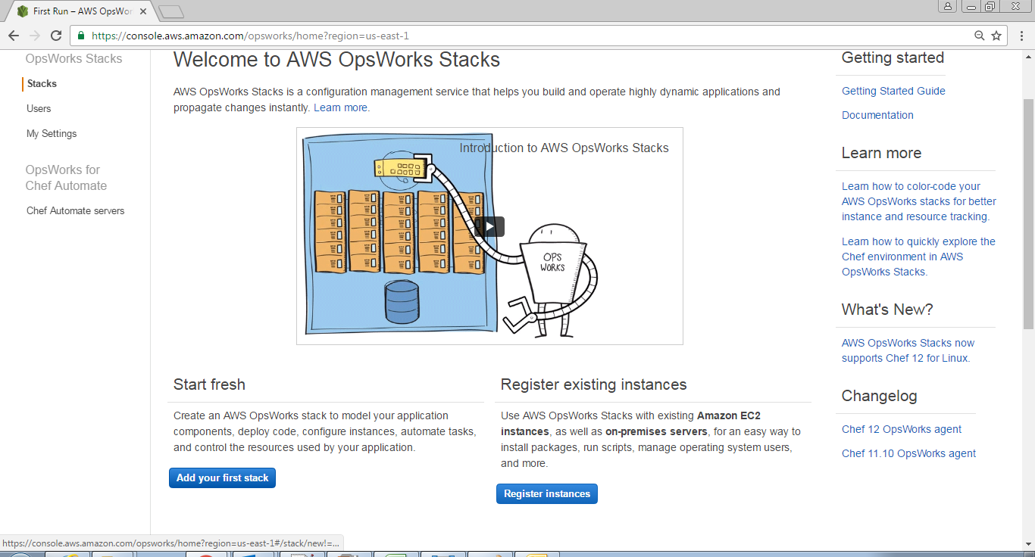

1. With the **Add stack** page displayed, choose **Chef 12 stack** if it is not already chosen for you.

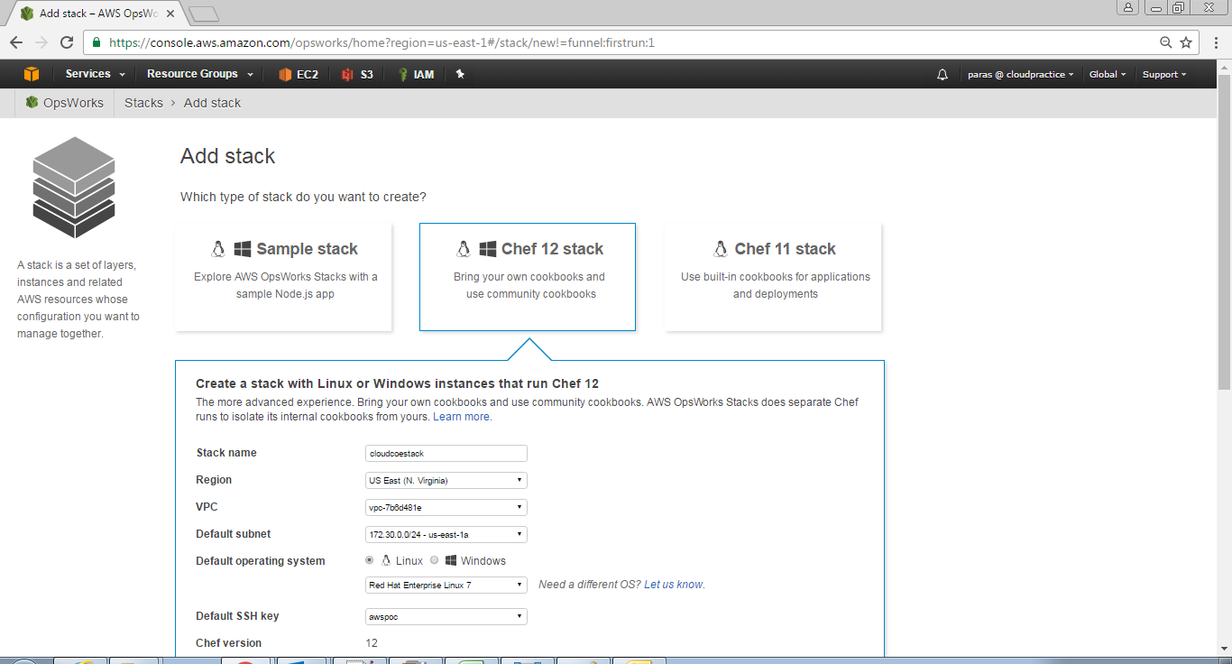

1. In the **Chef 12 stack** drop down box do the following configuration:
   1. In the **Stack name** box provide type the name, for example **cloudcoe**
   2. For **Region** choose US East (N. Virginia)
   3. For **VPC:** If a VPC is available, choose it else choose No VPC
   4. For **Default subnet** choose any subnet available in your VPC
   5. For **Default operating system**, choose **Linux** and from the drop down list choose **Red Hat Enterprise Linux 7**
   6. Default **SSH key**, choose **Do not use a default SSH key**
   7. For **Use custom Chef cookbooks**, choose **Yes**
   8. For **Repository type**, choose **Http Archive**
   9. For **Repository URL**, type [*https://s3.amazonaws.com/opsworks-demo-assets/opsworks-linux-demo-cookbooks-nodejs.tar.gz*](https://s3.amazonaws.com/opsworks-demo-assets/opsworks-linux-demo-cookbooks-nodejs.tar.gz)
   10. For **User name** and **Password** leave the textbox blank
   11. For **Stack color** choose **dark blue**

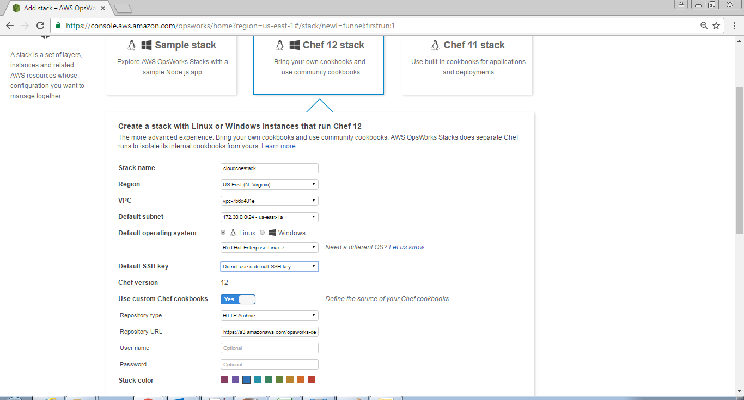

1. Choose **Advanced Options,** do the following
   1. For **Default root device type** select **EBS backed**
   2. For **IAM role**: If **aws-opsworks-service-role** is available choose it else choose **New IAM role**
   3. For **Default IAM instance profile:** If **aws-opsworks-ec2-role** is available, choose it else choose **New IAM instance profile**
   4. For **Hostname theme** select **Layer Dependent**
   5. For **OpsWorks Agent version** select most recent version
   6. For **Custom** **JSON** leave textbox blank
   7. For **Use OpsWorks security groups** select **Yes**
2. Click on **Add Stack** button

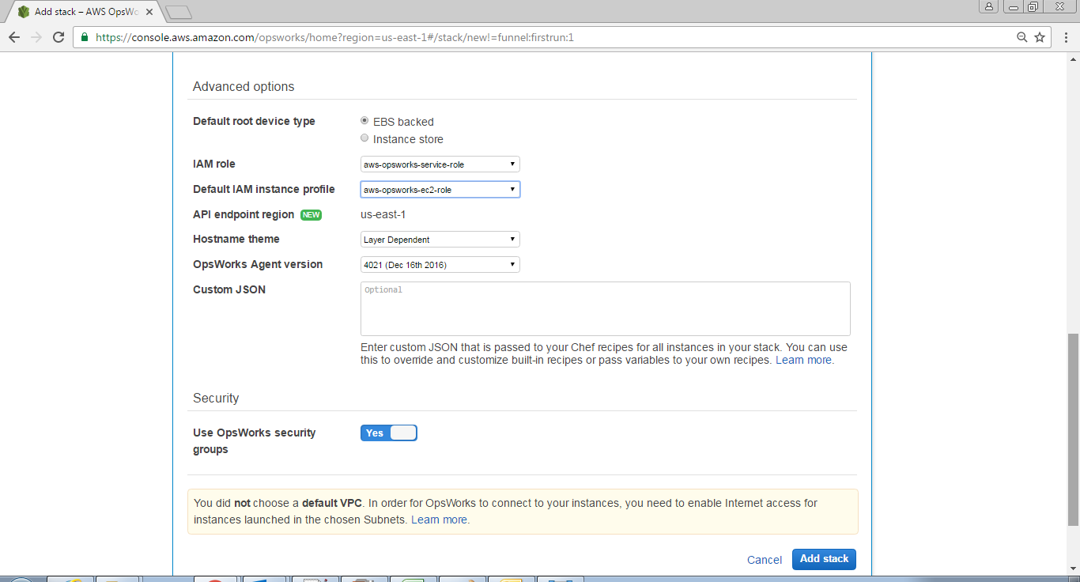

#### 15.2.3.2 Add a Layer to the Stack

1. You will get following screen showing cloudcoestack, click Add a layer

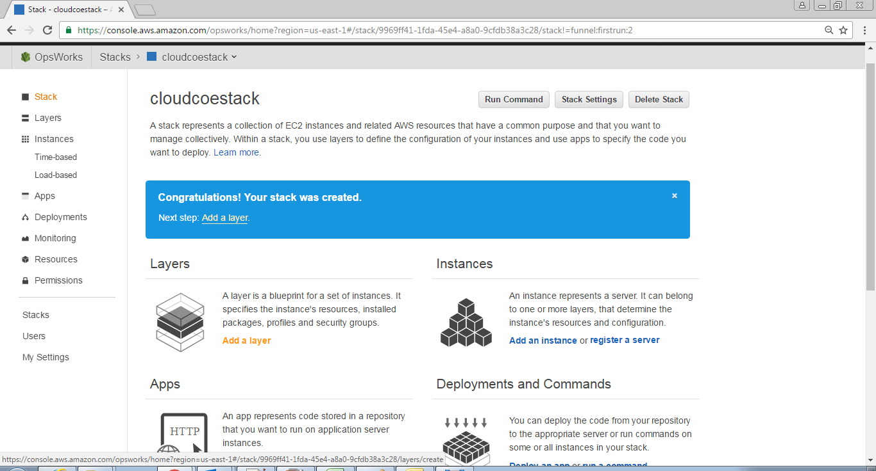

1. The Add Layer page is displayed. On the OpsWorks tab, for Name, type **Mydemolayer.** For **Short name,** type **demo** and click on **Add layer**

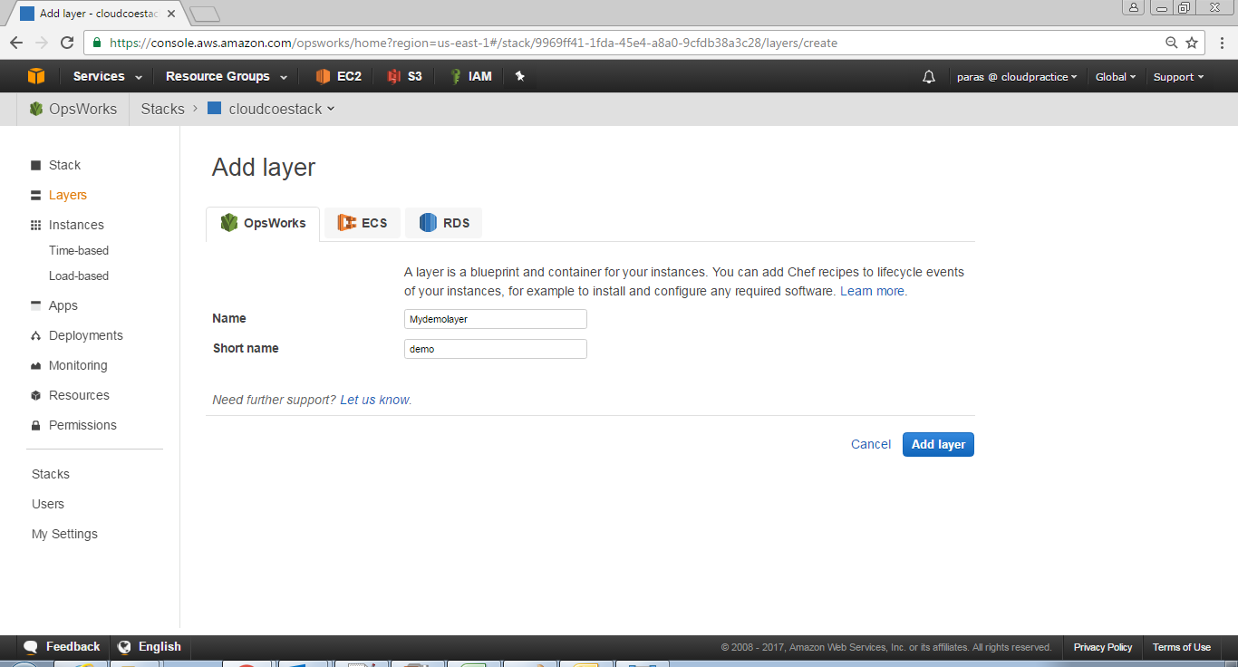

1. On the Layers page, for **MyDemoLayer**, choose **Network**

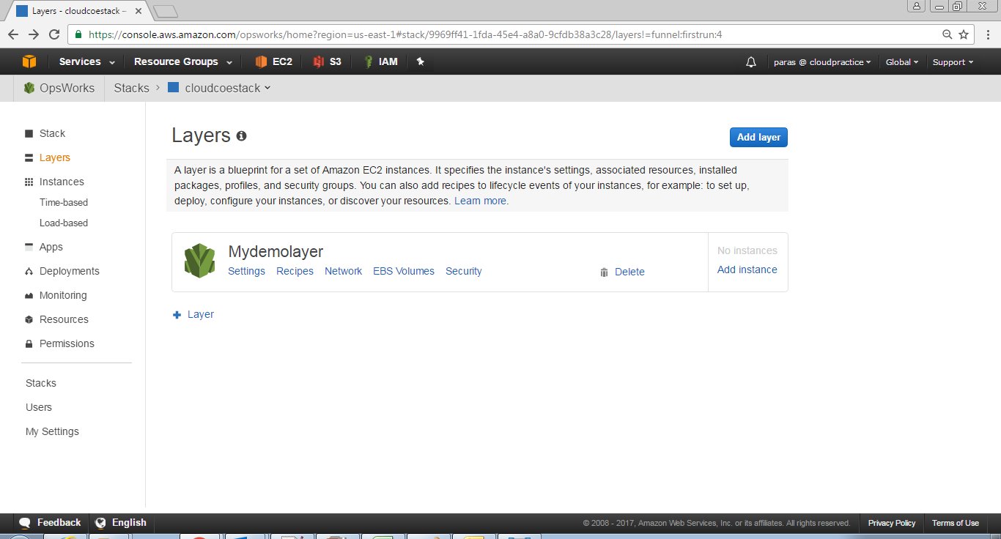

1. On the **Network** tab, under **Automatically Assign IP Addresses**, verify that **Public IP addresses** is set to yes. If you've made changes, click on **Save** button

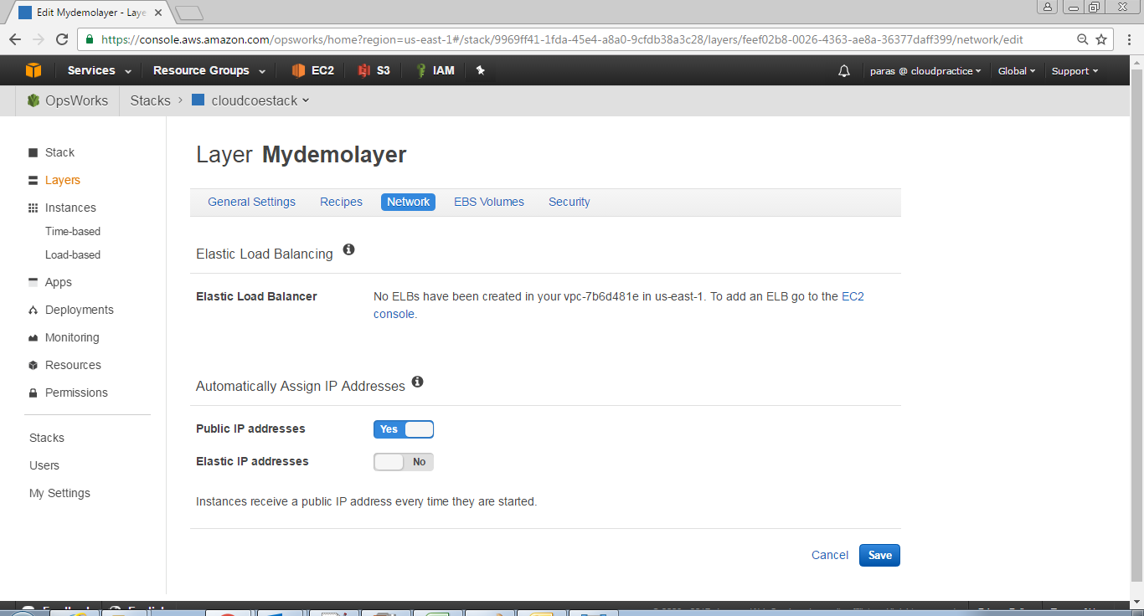

1. On the Layers page, choose **Security**. The Layer **MyDemoLayer** page is displayed with the Security tab open. For **Security groups**, choose **AWS-OpsWorks-WebApp**, and then click on **Save** button

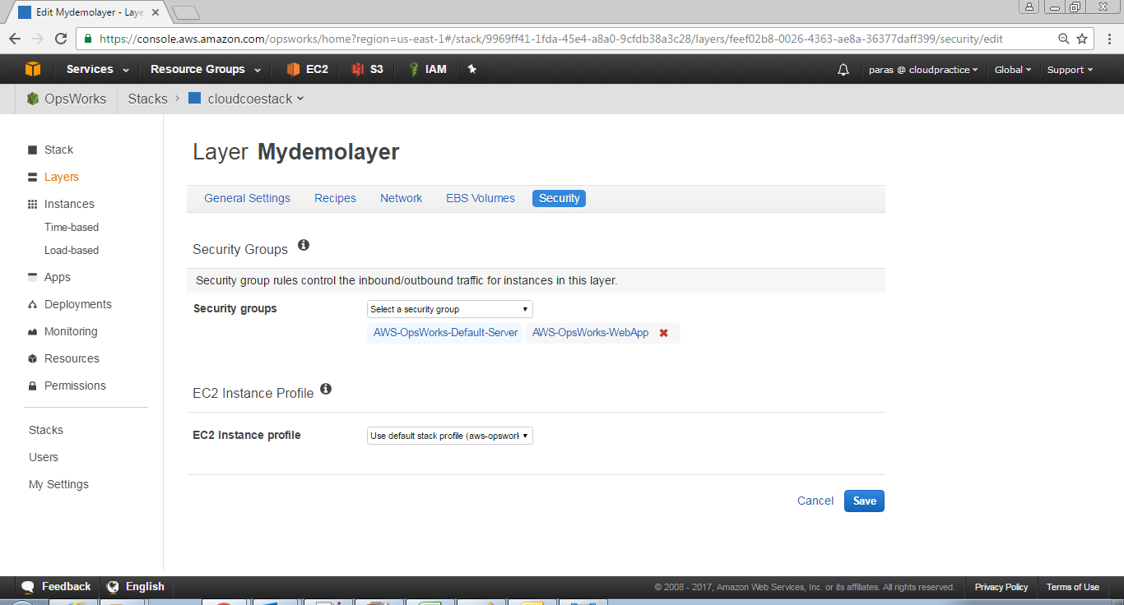

#### 15.2.3.3 Specify the App to Deploy to the Instance

1. In the service navigation pane, choose **Apps**. The **Apps** page is displayed. Click on **Add an app**. The Add App page is displayed

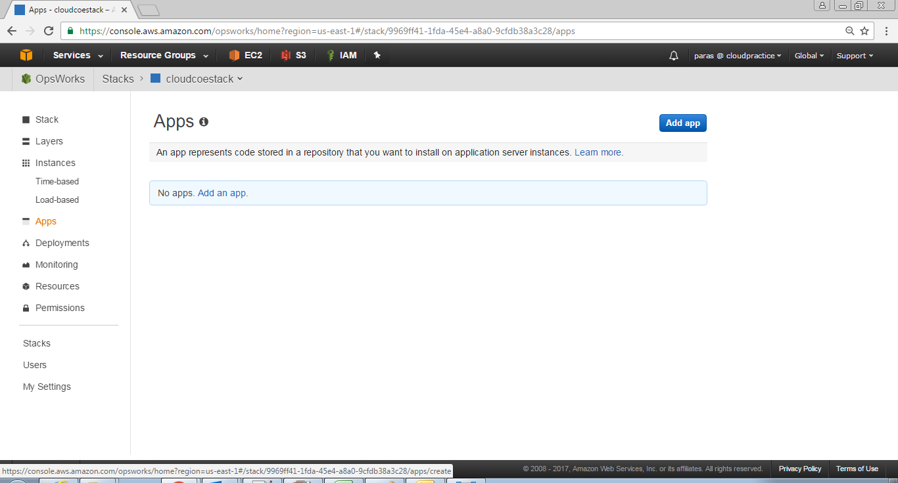

1. For Settings, do the following
   1. For **Name**, type **mydemolayer**
   2. For **Document root** leave blank
   3. For **Data** **Sources** select **None** **Data** **source** **type**
   4. For **Application Source ,** for **Repository** **type** select **Git**
   5. For **Application Source**, for **Repository URL**, type *https://github.com/awslabs/opsworks-windows-demo-nodejs.git*
   6. For **Repository SSH** **key** leave blank
   7. For **Branch/Revision** leave blank

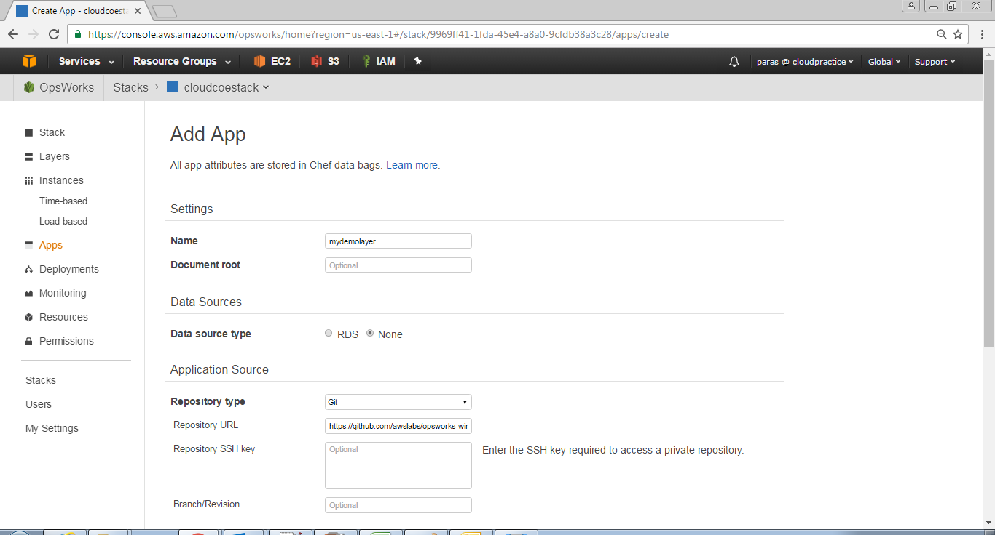

* 1. For **Environment Variables,** **KEY** leave blank, **VALUE** leave blank, unchecked **Protected Value**
  2. For **Add Domains**, **Domain Name** leave blank
  3. For **SSL Settings**, select **No for Enable SSL**
  4. Click on **Add App** button. AWS OpsWorks Stacks adds the app and displays the **Apps** page

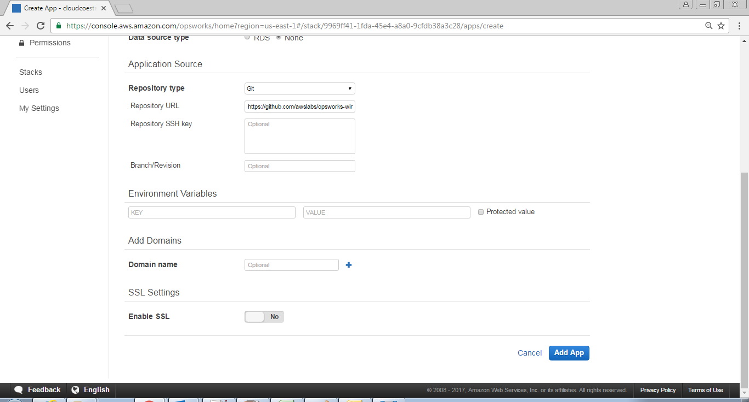

#### 15.2.3.4 Launch an Instance

1. In the service navigation pane, choose **Instances**. The Instances page is displayed. For **MyDemoLayer**, click **Add an instance**

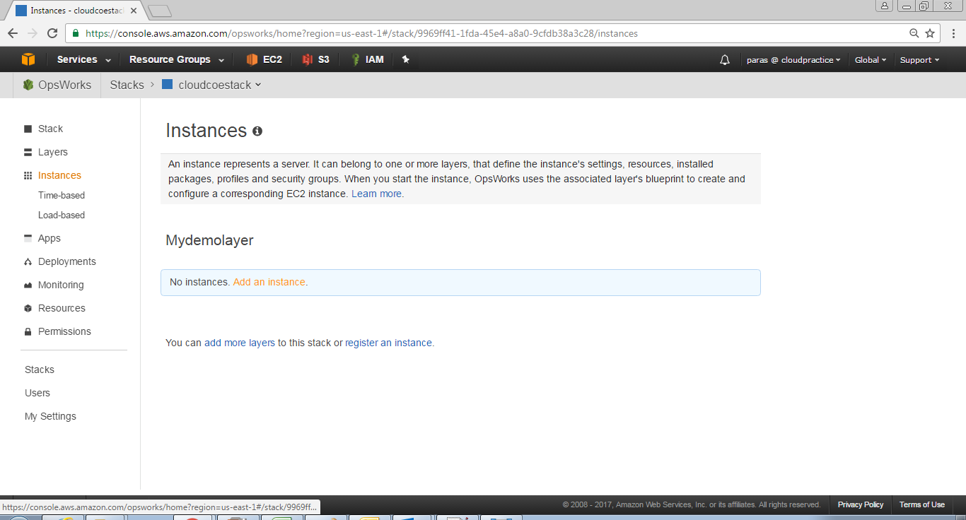

1. On the New tab, do the following
   1. For **Hostname** give a hostname for example demo1
   2. For **Size** choose **c3.large** *(default size)*
   3. For **Subnet** choose your subnet

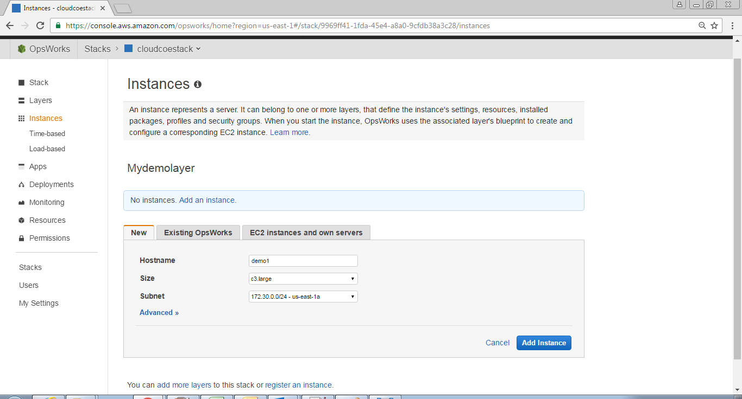

1. Choose Advanced, do the following configuration
   1. For **Scaling type** select **24/7**
   2. For **SSH key** select **Do not use a default SSH key**
   3. For **Operating system** select **Red Hat Enterprise Linux 7**
   4. For **OpsWorks Agent version** select **Inherit from stack**
   5. For **Tenancy** select **Default - Rely on VPC settings**
   6. For **Root device** **type** select **EBS backed**
   7. For **Volume type** select **General Purpose (SSD)**
   8. For **Volume size** select **10**
2. Click on **Add Instance**

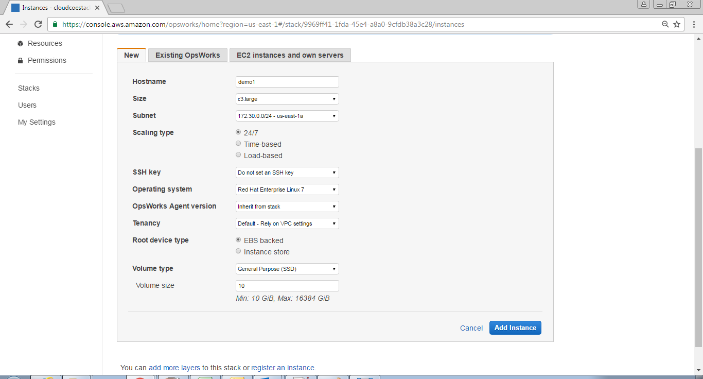

1. AWS OpsWorks Stacks adds the instance to the layer and displays the **Instances** page. For **MyDemoLayer**, for **demo1**, for **Actions**, click on **start**

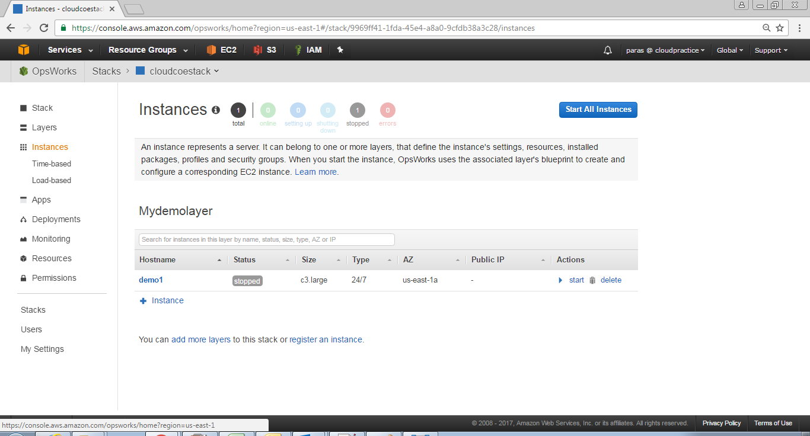

1. Over the course of several minutes. Status turns from stopped to requested, to pending, to booting, to running_setup, and then finally to online. Note that this process can take several minutes. Status is shown in the following screen shots

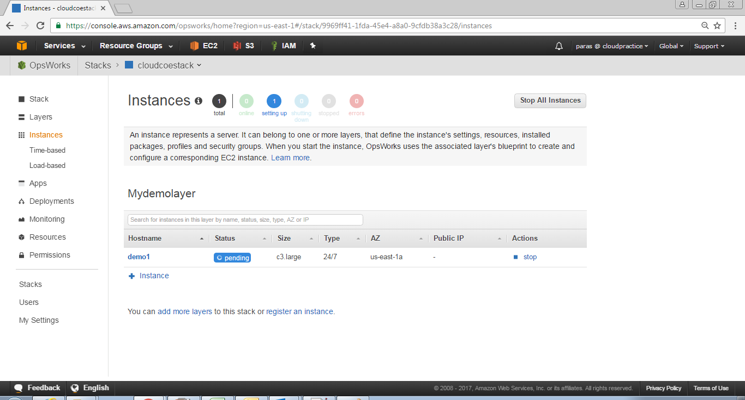

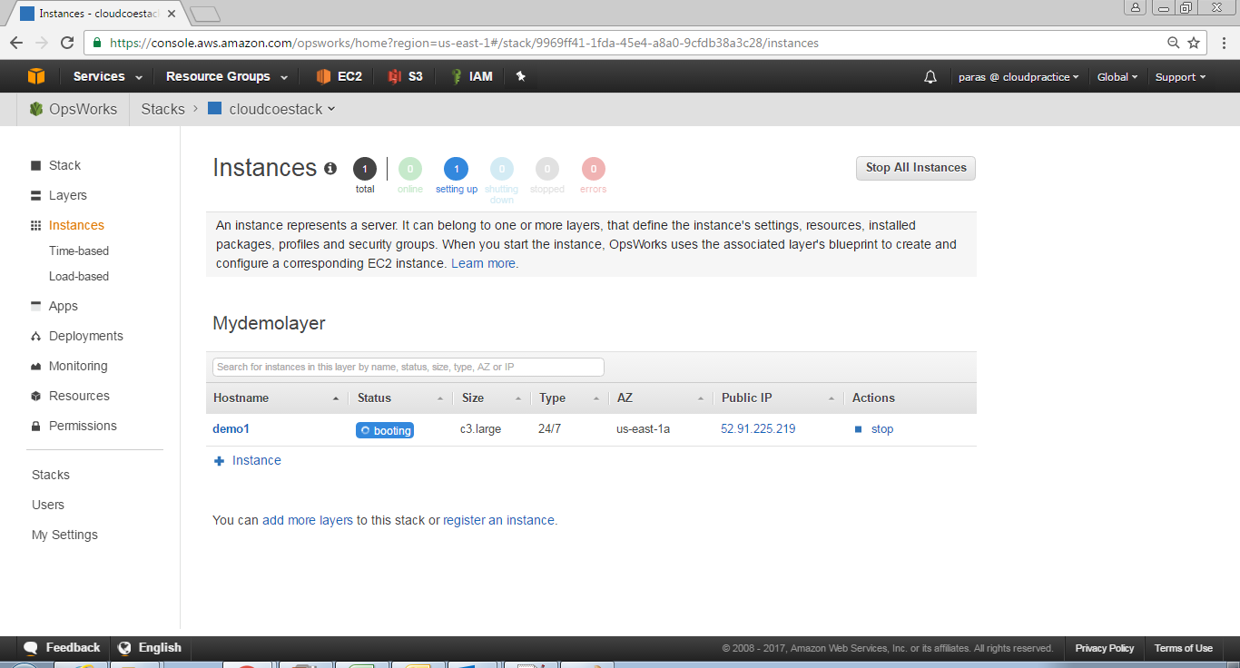

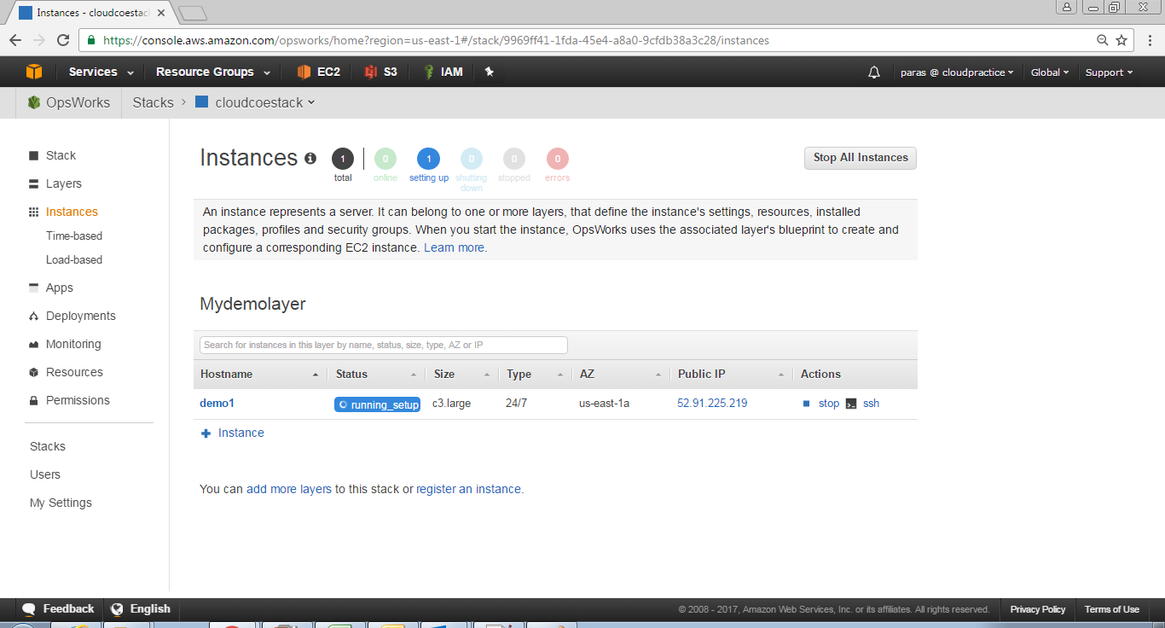

1. After **Status** changes to **online**, the **setting** **up** circle indicator changes from **1** to **0**, and the **online** circle changes from **0** to **1** and changes to bright green. Do not proceed until the **online** circle changes to bright green, and shows **1** instance online

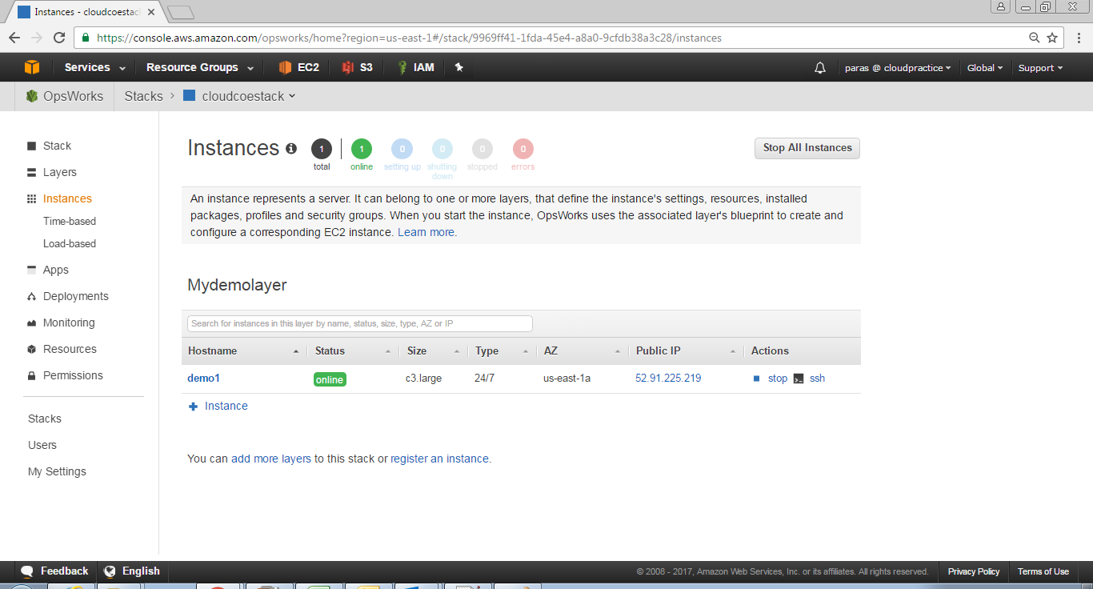

**Note:** You now have an instance that is ready for the app to be deployed to it

#### Deploy the App to the Instance

1. In the service navigation pane, choose **Layers**. The Layers page is displayed. For **MyDemoLayer**, choose **Recipes**

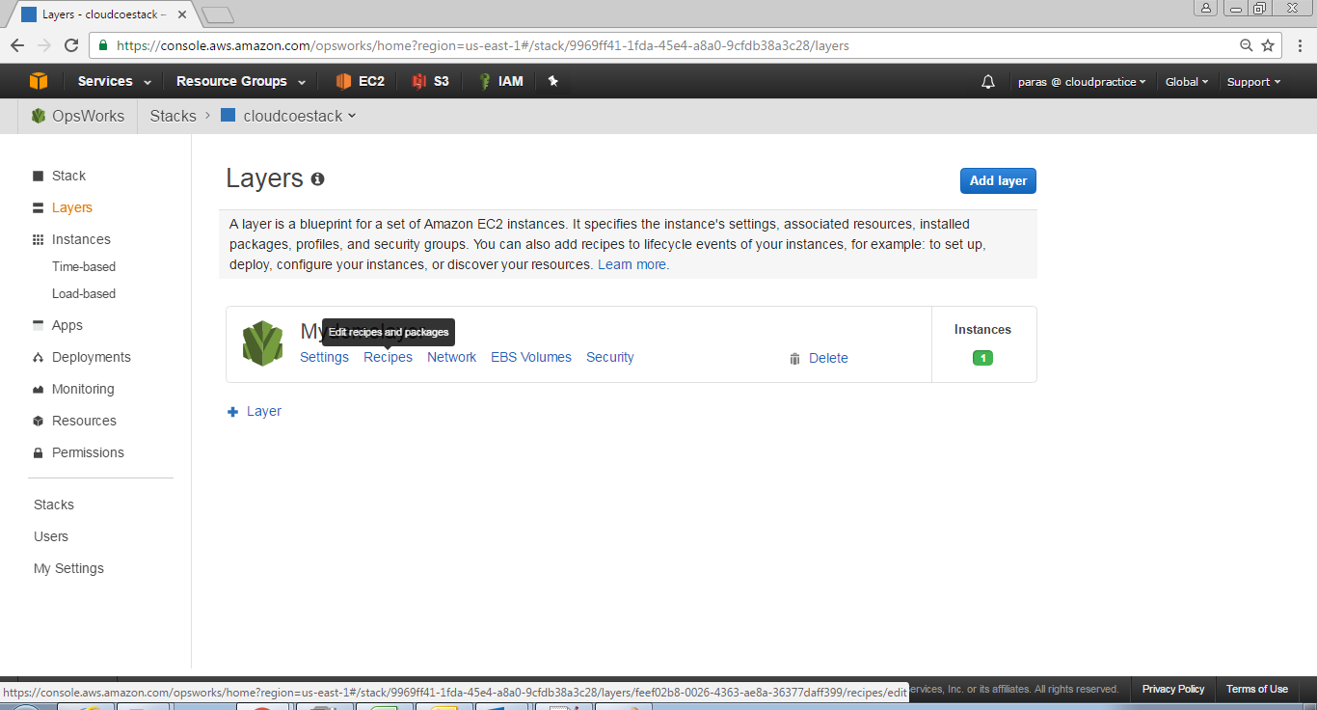

1. For **Custom Chef Recipes**, for **Deploy**, type *nodejs_demo::default*, and then press **Enter** (Here nodejs_demo is the name of the cookbook and default is the name of the target recipe within the cookbook). Click on **Save** button

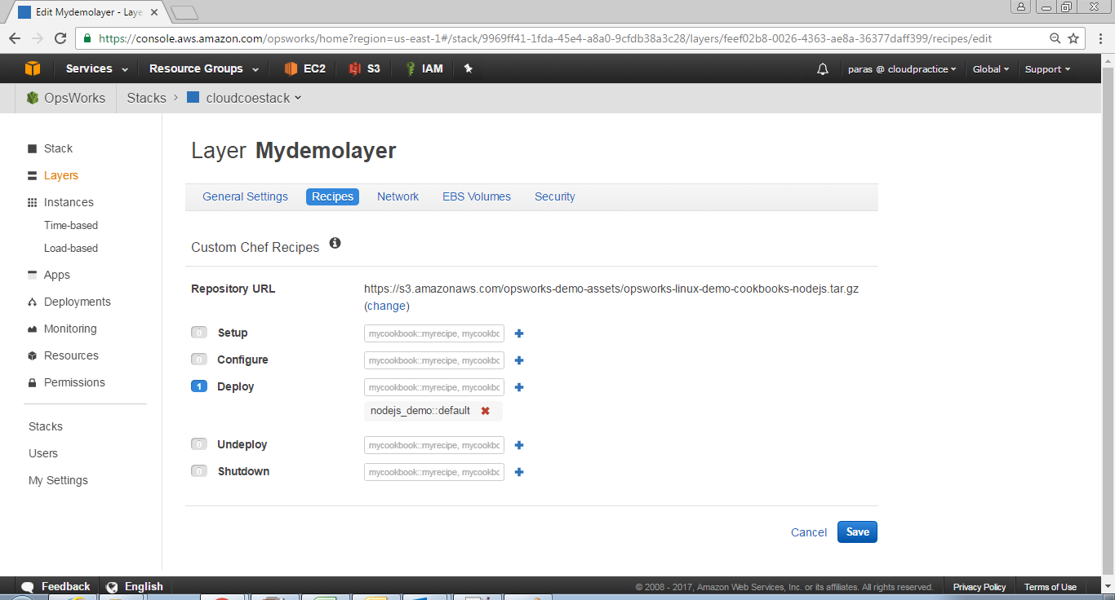

1. **To deploy the app to the instance,**
   1. In the service navigation pane, choose **Apps**. The Apps page display
   2. For **MyDemolayer**, for **Actions**, choose **deploy**

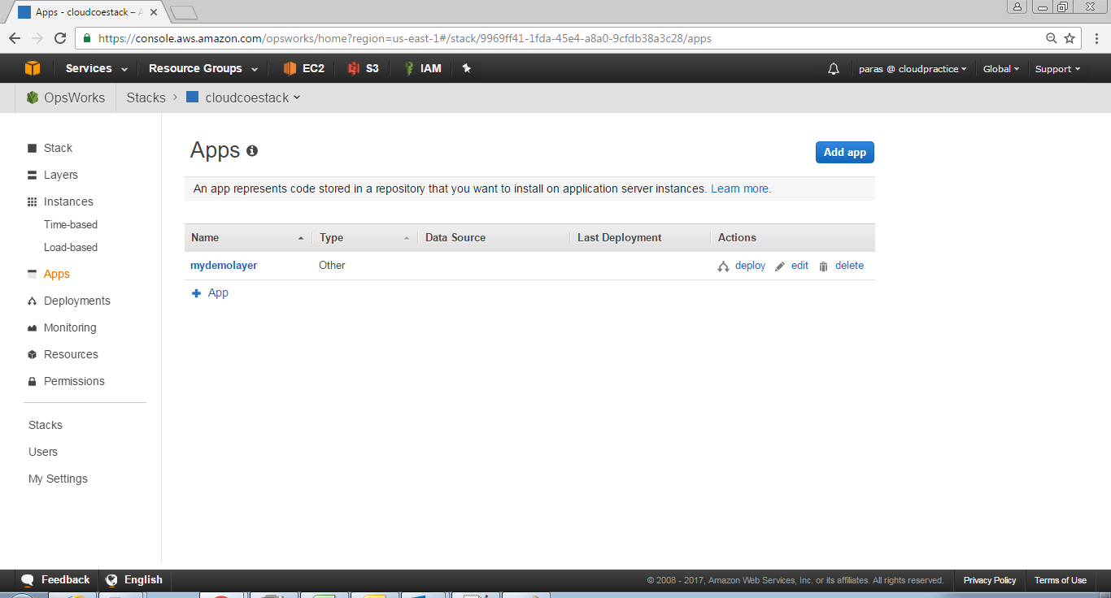

* 1. On the Deploy App page, do the following configuration
     1. For **Command** select **Deploy**
     2. For **Comment** leave blank
     3. For **Settings**, **Custom Chef JSON** leave blank
     4. For **Instances**, checked **Select all**, checked **MyDemoLayer**, checked **demo1**

1. Click on **Deploy** button

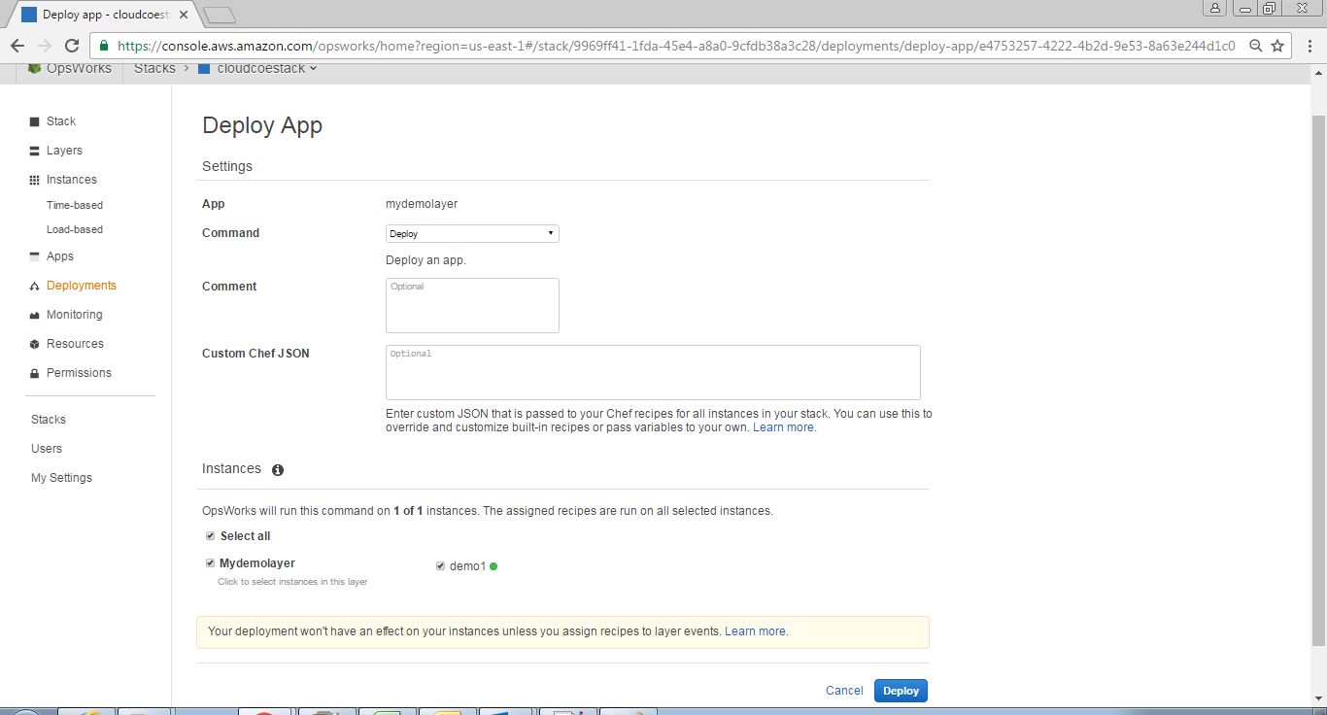

1. The **Deployment MyDemolayer – deploy** page is displayed. **Status** changes from **running** to **successful**. A spinning circle displays next to **demo1**, which then changes to a green check mark. Note that this process can take several minutes. Do not proceed until you see both a **Status** of **successful** and the green check mark icon.

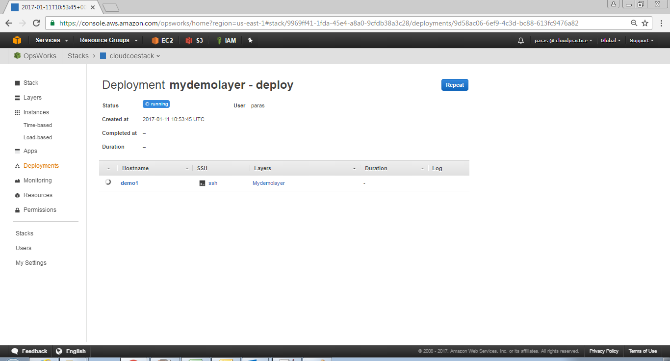

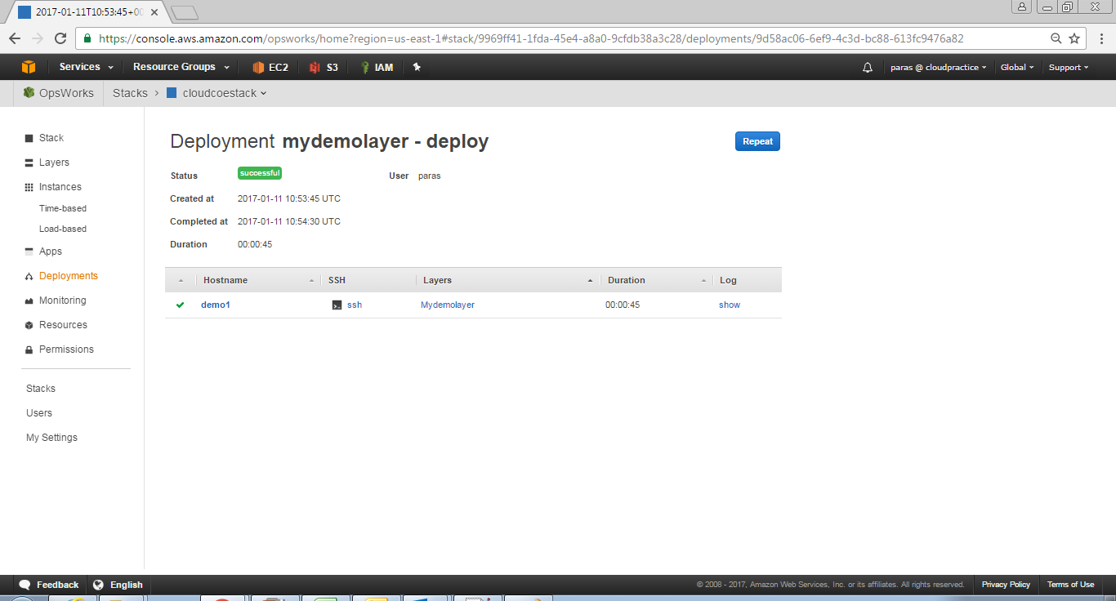

1. To see the Logs, You can click on **show** under **Log** (inside the table). A new link will open showing you the logs

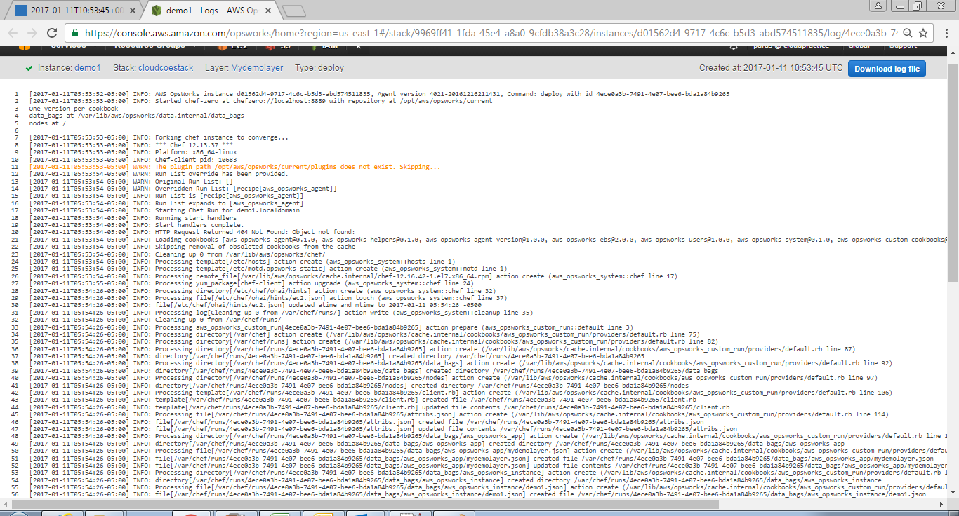

#### 15.2.3.6 Test the Deployed App on the Instance

1. To test the deployment on the instance, In the service navigation pane, choose **Instances**. The **Instances** page is displayed. For **MyDemoLayer**, for **demo1**, for **Public IP**, choose the **IP address**
2. On the congratulatory web page, in the Leave a comment text box, type a comment, and then choose Send to test the app. The app adds your comment to the web page

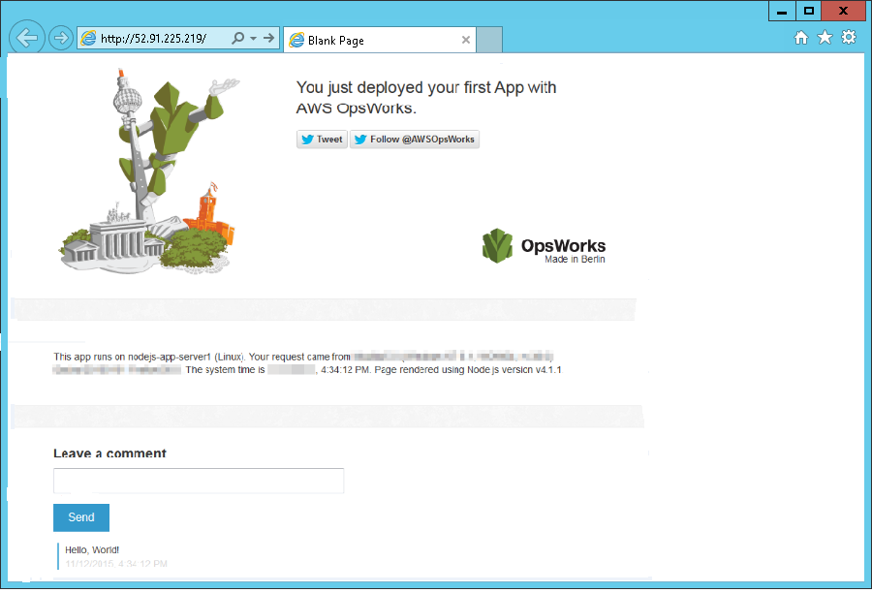

NOTE: You have now successfully tested the deployed app on the instance

1. To delete the app from the stack. In the service navigation pane, choose **Apps**. The **Apps** page is displayed. For **MyDemolayer**, for **Actions**, choose **delete**. When the confirmation message is displayed, choose **Delete**. AWS OpsWorks Stacks deletes the app

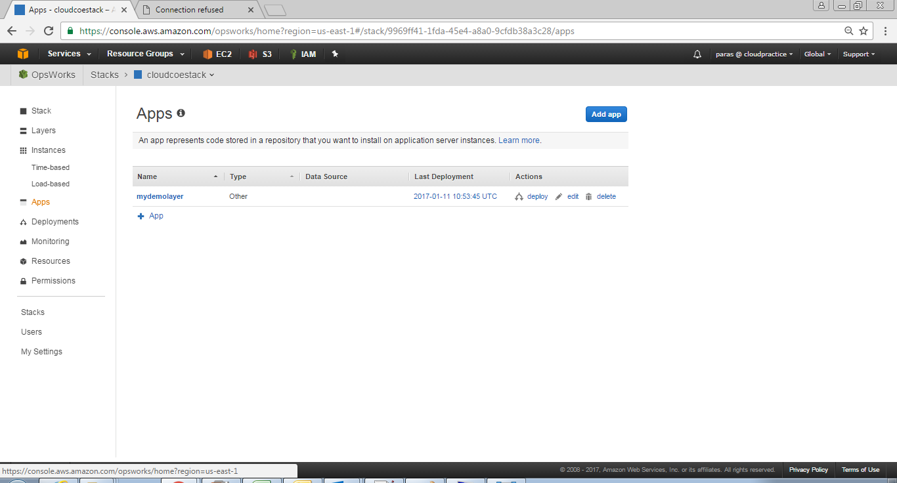

1. To delete the instance for the stack. In the service navigation pane, choose **Instances**. The Instances page is displayed. For **MyDemoLayer**, for **demo1**, for **Actions**, choose **stop**. When you see the confirmation message, choose **Stop.**

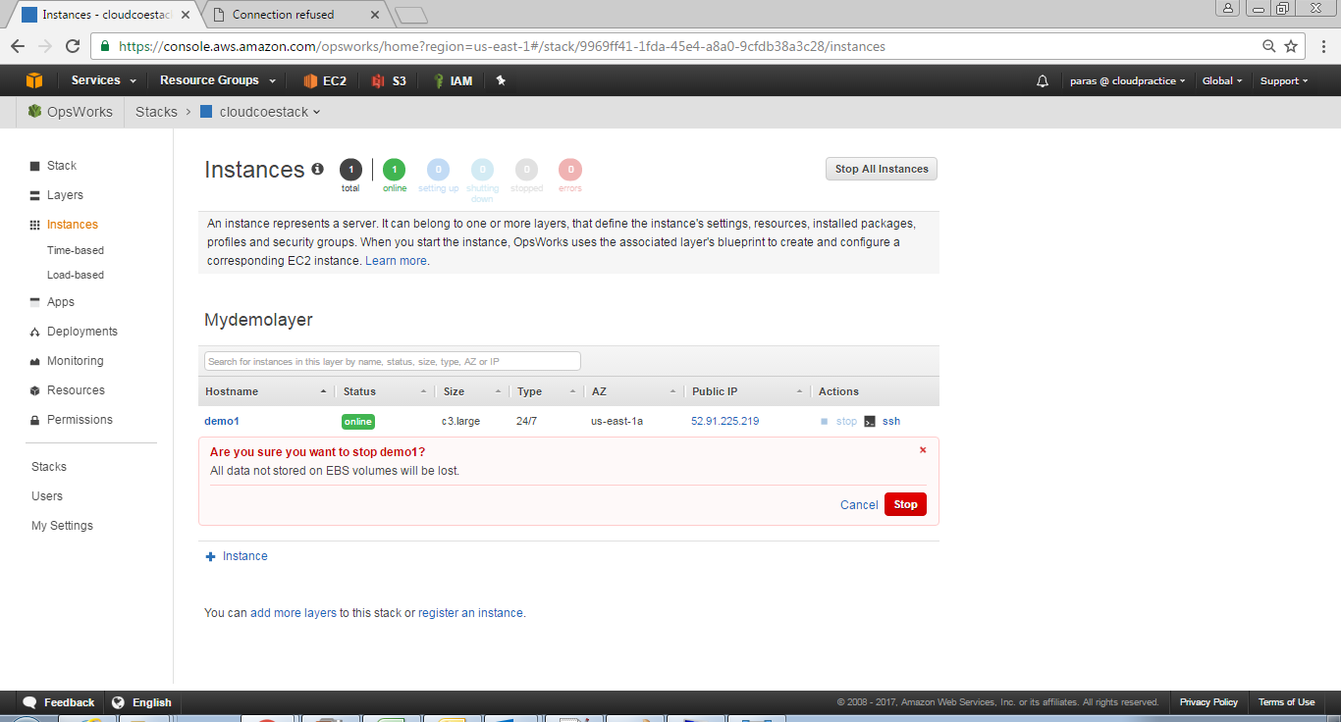

1. When the instance is stopped in the **Actions**, click on **delete.** When you see the confirmation message, click on **Delete** button

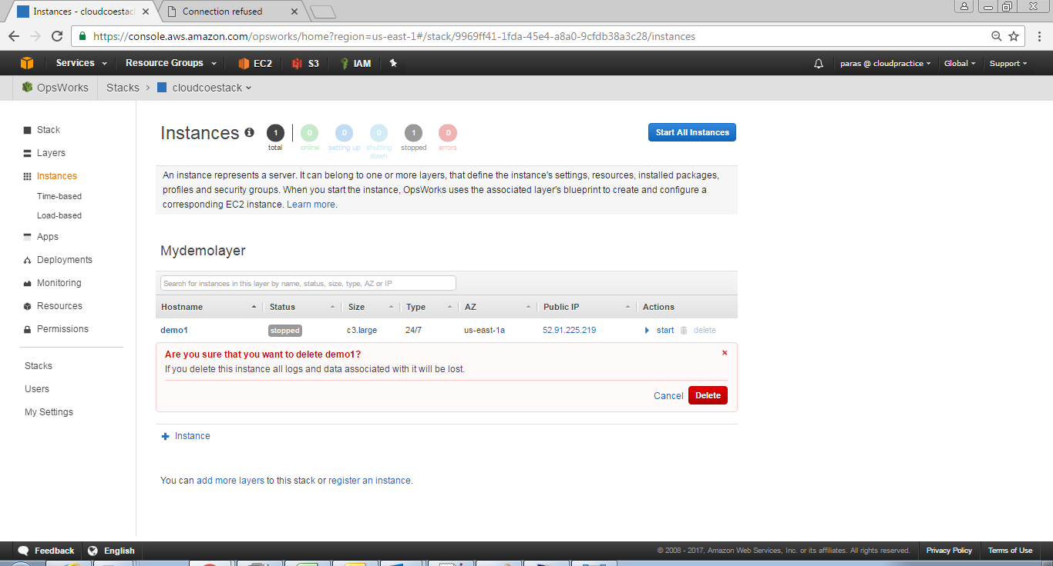

1. To delete the stack. In the service navigation pane, choose **Stack**. The **cloudcoestack** page is displayed. Click on **Delete Stack**. When you see the confirmation message, click on **Delete.**

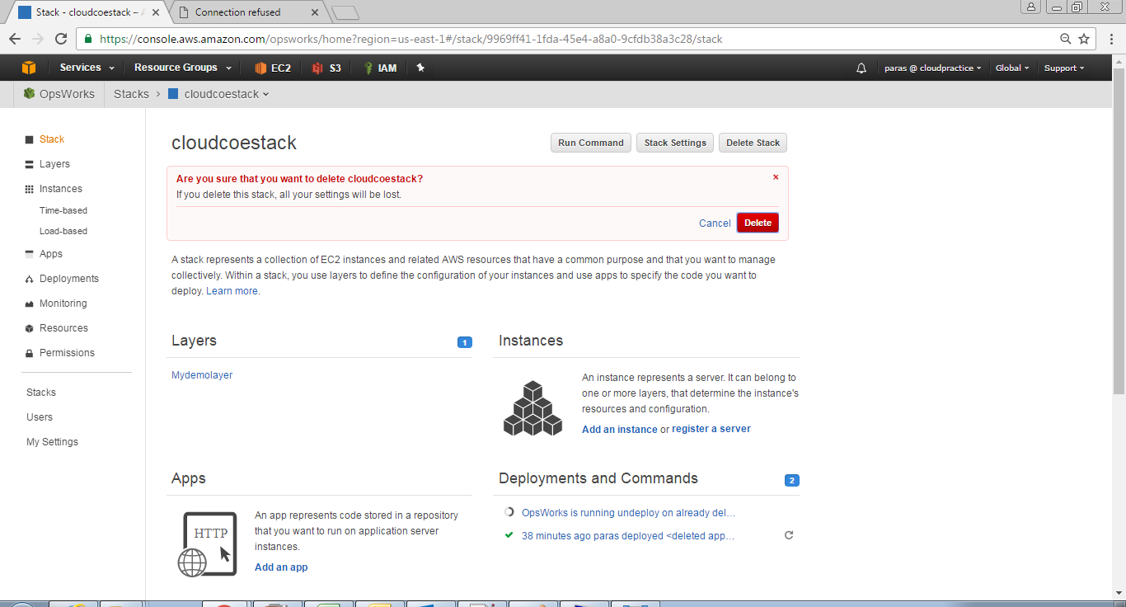

# AWS ACCOUNT MANAGEMENT

## Executing orders of reserved instances

## Recommend best practices for supported services

## Provide strategic insight to address business needs and challenges

# APPLICATION & DEVELOPER TOOL SUPPORT

## Application development, deployment, and backups

## Troubleshooting of application performance issues related to the code (e.g. high memory usage by a website)

## CodeCommit Repository

## CodeBuild Project Creation

## CodePipeline Pipeline Creation

## 